Data Pendukung
Instrumen Penelitian
Kisi-Kisi Angket Validasi Ahli Materi
Komponen yang divalidasi | Indikator
Kesesuaian uraian materi dengan tema | - Kesesuaian materi dengan CP  - Kelengkapan materi  - Keluasan materi
Keakuratan materi | - Materi sesuai dengan keterangan yang dijabarkan  - Klasifikasi sejarah lokal  - Deskripsi sejarah madiun  - Deskripsi ciri tempat sejarah di Madiun
Materi pendukung pembelajaran | - Kesesuaian pengembangan dengan IPTEK  - Kekinian, fitur, contoh, don rujukan
Kisi-Kisi Angket Validasi Ahli Media dan Desain
Komponen yang divalidasi | Indikator
Teknik penyajian | - Sistematis penyajian  - Keruntutan penyajian
Kelayakan penyajian | - Desain cover  - Bagian pendahuluan  - Bagian isi  - Bagian penutup
Kelayakan kegrafikan | - Letak gambar dan keterangan konsisten  - Gambar original dan menunjukkan secara detail  - Kesesuaian huruf  - Tipografi huruf
Kisi-Kisi Angket Peserta Didik
Indikator | Pernyataan
- Ketertarikan | - Tampilan ensiklopedia digital menarik
 | - Dokumentasi dalam ensiklopedia jelas
 | - Ensiklopedia sejarah Madiun ini membuat saya lebih bersemangat dalam belajar sejarah
 | - Menggunakan ensiklopedia sejarah Madiun ini dapat membuat saya belajar sejarah tidak membosankan
 | - Ensiklopedia sejarah Madiun ini mendukung saya dalam pelajaran sejarah
- Materi | - Materi yang disajikan dalam ensiklopedia sejarah Madiun berbasis digital mudah saya pahami
 | - Materi yang disajikan jelas dan rinci
- Bahasa | - Kalimat yang digunakan jelas dan mudah dipahami
 | - Bahasa yang digunakan sederhana dan mudah dimengerti
 | - Huruf yang digunakan sederhana dan mudah dibaca

Dokumentasi Hasil Penelitian
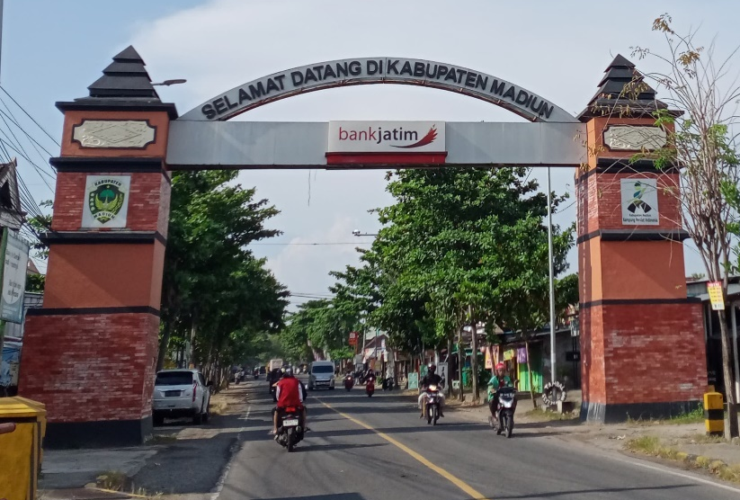
Perbatasan Kabupaten Madiun

 | Nama Situs | Lokasi | Periode
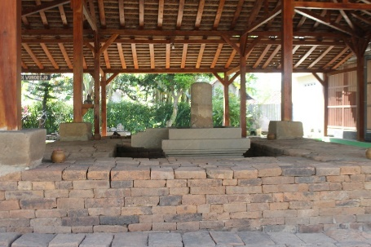 | Candi Wonorejo | Wonorejo, Kec. Mejayan | Hindu Budha
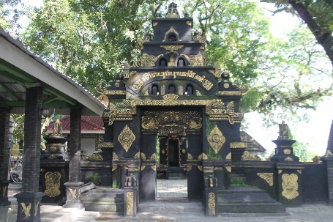 | Lambang Kuning | Desa Nglambangan, Kec. Wungu | Hindu Budha
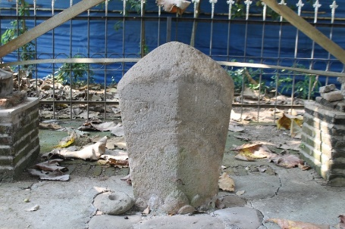 | Prasasti Mruwak | Desa Mruwak, Kec. Dagangan | Hindu Budha
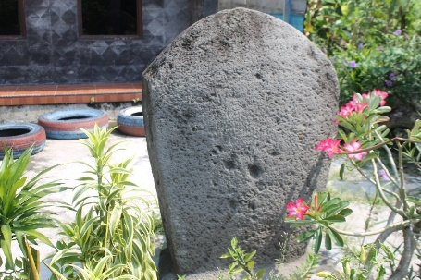 | Prasasti Bibrik | Desa Bibrik, Kec. Jiwan | Hindu Budha
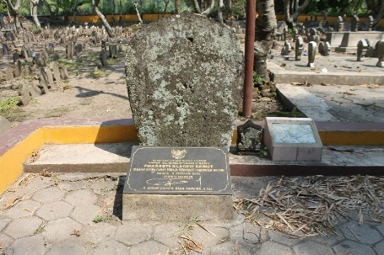 | Prasasti Klagen Serut | Desa Klagen Serut, Jiwan | Hindu Budha
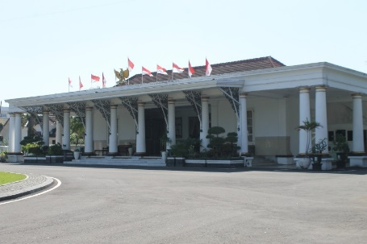 | Bekas Gedung Residen Belanda | Jl. Pahlawan, No.31 | Kolonial
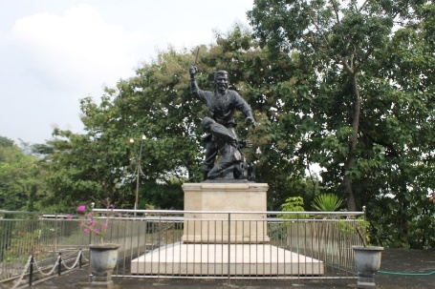 | Monumen Kresek | Desa Kresek, Kec. Wungu | Kolonial
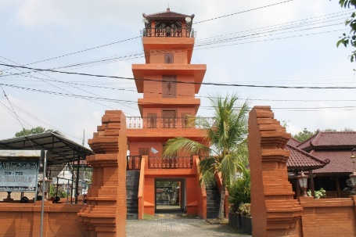 | Masjid Kuncen | Desa Kuncen, Kota Madiun | Kerajaan Islam
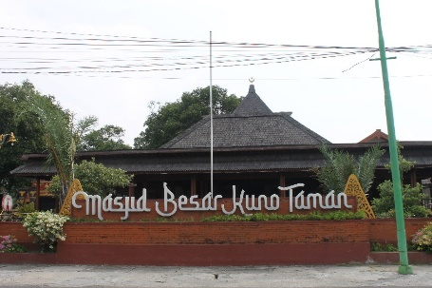 | Masjid Kuno Taman | Jl Asahan, No 46, Kec. Taman | Kerajaan Islam
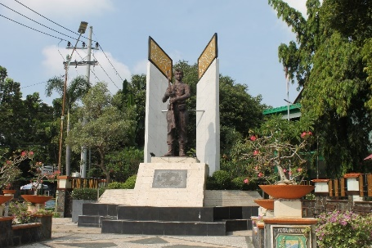 | Monumen Mastrip | Jl. Mastrip, No. 25, Kota Madiun | Kolonial

Desain Ensiklopedia Sejarah Madiun
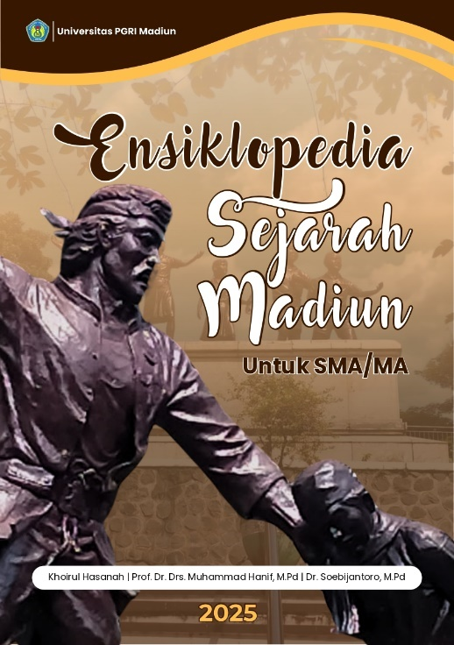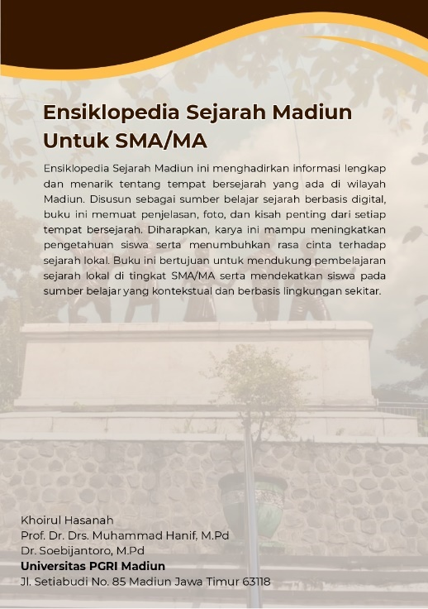
Desain Cover Ensiklopedia Digital
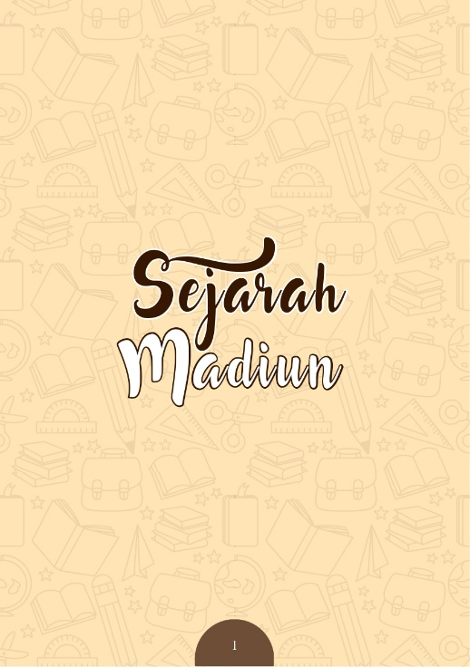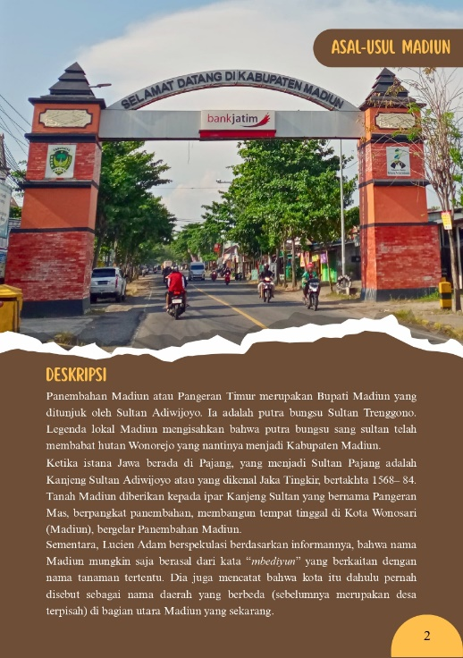
Desain Layout
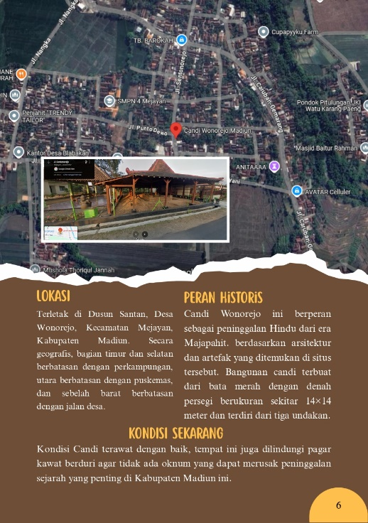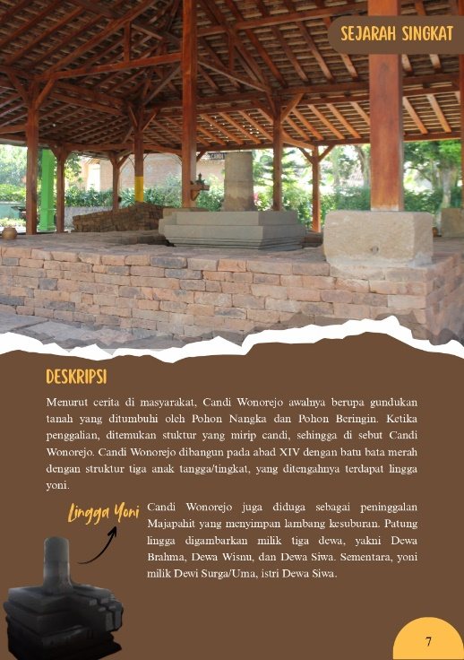
Desain Materi Inti
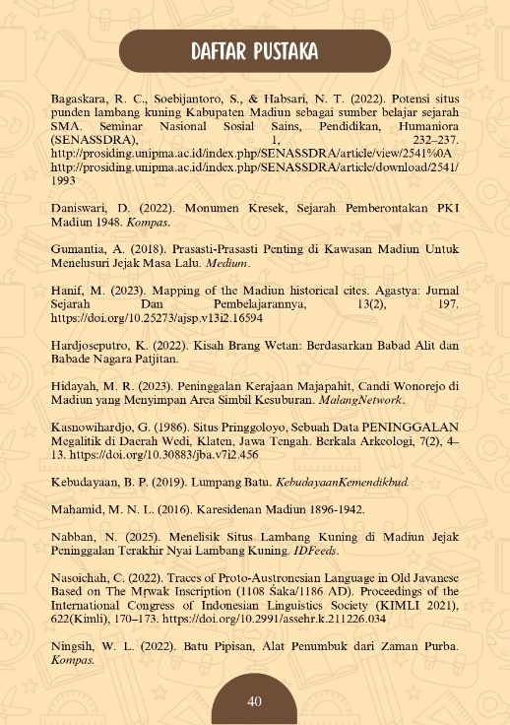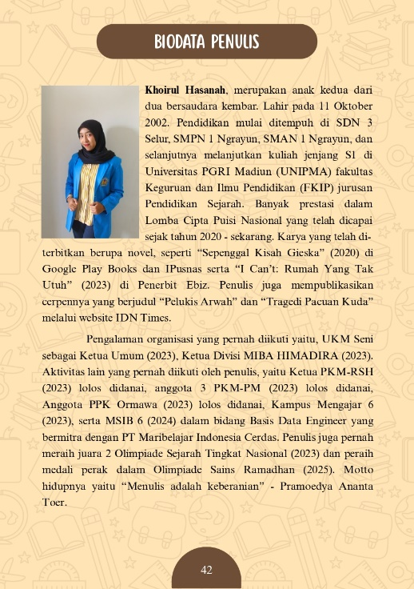
Daftar Pustaka dan Biodata Penulis

Hasil Validasi Ahli
Validasi Ahli Materi 1
Nama Validator | No | Hasil Validasi
Anjar Mukti Wibowo, S.Sn., S,Pd., M.Pd | 1 | 3
Anjar Mukti Wibowo, S.Sn., S,Pd., M.Pd | 2 | 4
Anjar Mukti Wibowo, S.Sn., S,Pd., M.Pd | 3 | 2
Anjar Mukti Wibowo, S.Sn., S,Pd., M.Pd | 4 | 4
Anjar Mukti Wibowo, S.Sn., S,Pd., M.Pd | 5 | 3
Anjar Mukti Wibowo, S.Sn., S,Pd., M.Pd | 6 | 3
Anjar Mukti Wibowo, S.Sn., S,Pd., M.Pd | 7 | 3
Anjar Mukti Wibowo, S.Sn., S,Pd., M.Pd | 8 | 4
Anjar Mukti Wibowo, S.Sn., S,Pd., M.Pd | 9 | 4
Total Skor Validator |  | 30
Persentase |  | 67%
Validasi Ahli Materi 2
Nama Validator | No | Hasil Validasi
Novi Triana Habsari, M.Pd | 1 | 5
Novi Triana Habsari, M.Pd | 2 | 5
Novi Triana Habsari, M.Pd | 3 | 5
Novi Triana Habsari, M.Pd | 4 | 5
Novi Triana Habsari, M.Pd | 5 | 5
Novi Triana Habsari, M.Pd | 6 | 5
Novi Triana Habsari, M.Pd | 7 | 4
Novi Triana Habsari, M.Pd | 8 | 5
Novi Triana Habsari, M.Pd | 9 | 5
Total Skor Validator |  | 44
Persentase |  | 98%
Validasi Ahli Media dan Desain 1
Nama Validator | No | Hasil Validasi
Dr. Yudi Hartono, M.Pd | 1 | 5
Dr. Yudi Hartono, M.Pd | 2 | 5
Dr. Yudi Hartono, M.Pd | 3 | 5
Dr. Yudi Hartono, M.Pd | 4 | 4
Dr. Yudi Hartono, M.Pd | 5 | 5
Dr. Yudi Hartono, M.Pd | 6 | 4
Dr. Yudi Hartono, M.Pd | 7 | 5
Dr. Yudi Hartono, M.Pd | 8 | 5
Dr. Yudi Hartono, M.Pd | 9 | 4
Dr. Yudi Hartono, M.Pd | 10 | 4
Total Skor Validator |  | 46
Persentase |  | 92%

Tabel Validasi Ahli Materi dan Desain 2
Nama Validator | No | Hasil Validasi
Prof. Dr. Drs. Muhammad Hanif, M.M., M.Pd | 1 | 5
Prof. Dr. Drs. Muhammad Hanif, M.M., M.Pd | 2 | 5
Prof. Dr. Drs. Muhammad Hanif, M.M., M.Pd | 3 | 5
Prof. Dr. Drs. Muhammad Hanif, M.M., M.Pd | 4 | 4
Prof. Dr. Drs. Muhammad Hanif, M.M., M.Pd | 5 | 4
Prof. Dr. Drs. Muhammad Hanif, M.M., M.Pd | 6 | 5
Prof. Dr. Drs. Muhammad Hanif, M.M., M.Pd | 7 | 5
Prof. Dr. Drs. Muhammad Hanif, M.M., M.Pd | 8 | 5
Prof. Dr. Drs. Muhammad Hanif, M.M., M.Pd | 9 | 5
Prof. Dr. Drs. Muhammad Hanif, M.M., M.Pd | 10 | 5
Total Skor Validator |  | 48
Persentase |  | 96%

Hasil Uji Skala Kecil dan Skala Besar
Uji Skala Kecil Kepada Peserta Didik
Responen | Aspek |  |  |  |  |  |  |  |  |  | Total Skor | Skor Maksimal
Responen | A | B | C | D | E | F | G | H | I | J | Total Skor | Skor Maksimal
1 | 5 | 5 | 5 | 4 | 5 | 4 | 5 | 5 | 5 | 5 | 48 | 50
2 | 5 | 5 | 4 | 4 | 5 | 5 | 5 | 5 | 5 | 4 | 47 | 50
3 | 5 | 3 | 4 | 5 | 5 | 5 | 4 | 5 | 5 | 5 | 46 | 50
4 | 4 | 3 | 4 | 4 | 3 | 4 | 3 | 5 | 4 | 4 | 38 | 50
5 | 5 | 5 | 5 | 5 | 5 | 5 | 5 | 5 | 5 | 5 | 50 | 50
6 | 5 | 5 | 4 | 5 | 4 | 4 | 4 | 4 | 4 | 5 | 44 | 50
7 | 4 | 3 | 4 | 3 | 4 | 5 | 4 | 5 | 5 | 3 | 40 | 50
8 | 5 | 4 | 3 | 3 | 3 | 3 | 3 | 3 | 3 | 4 | 34 | 50
9 | 4 | 3 | 5 | 5 | 4 | 3 | 5 | 2 | 3 | 2 | 36 | 50
10 | 5 | 5 | 4 | 4 | 5 | 5 | 5 | 5 | 5 | 5 | 48 | 50
11 | 4 | 4 | 4 | 4 | 4 | 4 | 4 | 4 | 4 | 4 | 40 | 50
12 | 4 | 4 | 4 | 4 | 4 | 4 | 4 | 4 | 4 | 4 | 40 | 50
13 | 5 | 4 | 4 | 5 | 5 | 4 | 4 | 4 | 4 | 4 | 43 | 50
14 | 5 | 5 | 5 | 5 | 5 | 5 | 5 | 5 | 5 | 5 | 50 | 50
15 | 5 | 4 | 3 | 3 | 4 | 5 | 4 | 4 | 4 | 5 | 41 | 50
16 | 3 | 4 | 3 | 3 | 4 | 5 | 4 | 4 | 4 | 5 | 39 | 50
17 | 5 | 5 | 5 | 5 | 5 | 5 | 5 | 5 | 5 | 5 | 50 | 50
18 | 5 | 4 | 4 | 3 | 3 | 4 | 4 | 5 | 4 | 4 | 40 | 50
19 | 5 | 5 | 4 | 5 | 4 | 5 | 5 | 5 | 5 | 5 | 48 | 50
20 | 5 | 4 | 4 | 4 | 5 | 5 | 5 | 5 | 4 | 5 | 46 | 50
21 | 2 | 4 | 3 | 3 | 3 | 4 | 3 | 4 | 3 | 3 | 32 | 50
22 | 4 | 4 | 4 | 4 | 3 | 4 | 4 | 4 | 4 | 4 | 39 | 50
23 | 5 | 5 | 5 | 5 | 5 | 5 | 5 | 5 | 5 | 5 | 50 | 50
24 | 4 | 5 | 5 | 5 | 4 | 5 | 5 | 4 | 5 | 5 | 47 | 50
25 | 5 | 4 | 3 | 4 | 3 | 4 | 5 | 5 | 5 | 4 | 42 | 50
Jumlah |  |  |  |  |  |  |  |  |  |  | 1078 | 1250

Hasil Uji Skala Besar di Kelas XA
Responden | Aspek |  |  |  |  |  |  |  |  |  | Total Skor | Skor Maksimal
Responden | A | B | C | D | E | F | G | H | I | J | Total Skor | Skor Maksimal
1 | 5 | 5 | 5 | 5 | 5 | 5 | 5 | 5 | 5 | 5 | 50 | 50
2 | 4 | 5 | 3 | 4 | 4 | 5 | 4 | 4 | 5 | 5 | 43 | 50
3 | 5 | 5 | 5 | 5 | 5 | 5 | 5 | 5 | 5 | 5 | 50 | 50
4 | 5 | 5 | 3 | 3 | 3 | 4 | 5 | 5 | 3 | 4 | 40 | 50
5 | 5 | 5 | 5 | 5 | 5 | 5 | 4 | 4 | 4 | 4 | 46 | 50
6 | 5 | 4 | 4 | 5 | 4 | 5 | 5 | 5 | 5 | 5 | 47 | 50
7 | 5 | 5 | 4 | 5 | 4 | 4 | 5 | 5 | 5 | 4 | 46 | 50
8 | 5 | 5 | 5 | 5 | 5 | 5 | 5 | 5 | 5 | 5 | 50 | 50
9 | 5 | 5 | 3 | 3 | 3 | 4 | 5 | 5 | 3 | 4 | 40 | 50
10 | 5 | 4 | 4 | 4 | 4 | 3 | 5 | 4 | 4 | 4 | 41 | 50
11 | 5 | 4 | 4 | 4 | 5 | 5 | 5 | 5 | 5 | 5 | 47 | 50
12 | 4 | 4 | 3 | 3 | 4 | 4 | 4 | 4 | 4 | 5 | 39 | 50
13 | 5 | 5 | 4 | 4 | 4 | 4 | 4 | 3 | 3 | 3 | 39 | 50
14 | 5 | 4 | 4 | 3 | 4 | 5 | 5 | 4 | 4 | 4 | 42 | 50
15 | 5 | 5 | 5 | 5 | 5 | 5 | 5 | 5 | 5 | 5 | 50 | 50
16 | 5 | 5 | 5 | 4 | 4 | 5 | 3 | 5 | 4 | 4 | 44 | 50
17 | 5 | 5 | 4 | 4 | 5 | 5 | 5 | 5 | 5 | 5 | 48 | 50
18 | 5 | 4 | 5 | 5 | 5 | 5 | 5 | 4 | 4 | 4 | 46 | 50
19 | 4 | 5 | 5 | 4 | 4 | 5 | 5 | 5 | 4 | 5 | 46 | 50
20 | 5 | 5 | 5 | 5 | 5 | 5 | 5 | 5 | 5 | 5 | 44 | 50
21 | 5 | 5 | 5 | 5 | 5 | 5 | 5 | 5 | 5 | 5 | 50 | 50
22 | 5 | 5 | 5 | 5 | 4 | 5 | 5 | 5 | 5 | 5 | 50 | 50
23 | 3 | 4 | 5 | 4 | 3 | 2 | 3 | 3 | 4 | 5 | 49 | 50
24 | 5 | 5 | 4 | 5 | 4 | 4 | 5 | 5 | 5 | 4 | 36 | 50
25 | 5 | 5 | 4 | 4 | 4 | 5 | 5 | 5 | 4 | 4 | 46 | 50
26 | 5 | 5 | 5 | 5 | 5 | 5 | 5 | 5 | 5 | 5 | 50 | 50
Jumlah |  |  |  |  |  |  |  |  |  |  | 1179 | 1300

Uji Skala Besar di Kelas XC
Responden | Aspek |  |  |  |  |  |  |  |  |  | Total Skor | Skor Maksimal
Responden | A | B | C | D | E | F | G | H | I | J | Total Skor | Skor Maksimal
1 | 4 | 5 | 5 | 5 | 4 | 4 | 5 | 5 | 4 | 5 | 46 | 50
2 | 5 | 5 | 3 | 4 | 5 | 5 | 5 | 4 | 4 | 5 | 45 | 50
3 | 5 | 4 | 4 | 4 | 4 | 5 | 5 | 5 | 5 | 5 | 46 | 50
4 | 4 | 4 | 3 | 3 | 3 | 4 | 4 | 4 | 4 | 4 | 37 | 50
5 | 3 | 4 | 3 | 2 | 4 | 3 | 2 | 5 | 3 | 4 | 33 | 50
6 | 5 | 3 | 5 | 5 | 4 | 4 | 5 | 5 | 5 | 5 | 46 | 50
7 | 4 | 3 | 5 | 3 | 4 | 5 | 5 | 5 | 4 | 5 | 43 | 50
8 | 4 | 4 | 4 | 5 | 4 | 4 | 4 | 5 | 5 | 5 | 44 | 50
9 | 5 | 4 | 5 | 4 | 4 | 5 | 5 | 4 | 5 | 5 | 46 | 50
10 | 5 | 5 | 4 | 5 | 5 | 5 | 5 | 4 | 4 | 5 | 47 | 50
11 | 5 | 3 | 4 | 5 | 3 | 5 | 4 | 5 | 5 | 5 | 44 | 50
12 | 4 | 5 | 4 | 4 | 5 | 5 | 4 | 5 | 5 | 5 | 46 | 50
13 | 5 | 5 | 4 | 5 | 5 | 5 | 4 | 4 | 5 | 5 | 47 | 50
14 | 2 | 4 | 3 | 3 | 3 | 5 | 5 | 3 | 3 | 3 | 34 | 50
15 | 3 | 4 | 5 | 4 | 4 | 5 | 3 | 4 | 4 | 5 | 41 | 50
16 | 4 | 4 | 5 | 3 | 4 | 4 | 4 | 3 | 3 | 3 | 37 | 50
17 | 4 | 4 | 3 | 3 | 3 | 4 | 4 | 4 | 4 | 4 | 37 | 50
18 | 5 | 5 | 5 | 5 | 5 | 5 | 5 | 5 | 5 | 5 | 50 | 50
19 | 4 | 4 | 5 | 5 | 5 | 4 | 4 | 5 | 5 | 4 | 45 | 50
20 | 5 | 5 | 3 | 4 | 3 | 4 | 4 | 4 | 4 | 4 | 40 | 50
21 | 4 | 5 | 4 | 4 | 5 | 5 | 4 | 5 | 5 | 5 | 46 | 50
22 | 5 | 5 | 4 | 5 | 5 | 5 | 5 | 4 | 3 | 5 | 46 | 50
23 | 4 | 4 | 3 | 3 | 3 | 3 | 4 | 4 | 3 | 3 | 34 | 50
24 | 5 | 4 | 4 | 5 | 4 | 5 | 4 | 4 | 5 | 5 | 45 | 50
25 | 4 | 4 | 3 | 4 | 3 | 3 | 4 | 4 | 5 | 5 | 39 | 50
26 | 4 | 4 | 5 | 2 | 3 | 4 | 3 | 2 | 2 | 2 | 31 | 50
Jumlah |  |  |  |  |  |  |  |  |  |  | 1095 | 1300

Uji Skala Besar di Kelas XD
Responden | Aspek |  |  |  |  |  |  |  |  |  | Total Skor | Skor Maksimal
Responden | A | B | C | D | E | F | G | H | I | J | Total Skor | Skor Maksimal
1 | 5 | 4 | 3 | 5 | 4 | 4 | 5 | 4 | 4 | 4 | 42 | 50
2 | 4 | 3 | 3 | 3 | 4 | 3 | 4 | 4 | 4 | 4 | 36 | 50
3 | 5 | 4 | 5 | 5 | 4 | 4 | 4 | 4 | 4 | 4 | 43 | 50
4 | 5 | 4 | 4 | 4 | 4 | 5 | 4 | 4 | 5 | 5 | 44 | 50
5 | 5 | 5 | 4 | 3 | 4 | 5 | 4 | 5 | 5 | 5 | 45 | 50
6 | 5 | 5 | 5 | 4 | 5 | 5 | 4 | 5 | 5 | 5 | 48 | 50
7 | 5 | 5 | 3 | 4 | 4 | 5 | 5 | 5 | 5 | 5 | 46 | 50
8 | 4 | 3 | 4 | 3 | 5 | 4 | 4 | 4 | 5 | 4 | 40 | 50
9 | 5 | 4 | 4 | 3 | 4 | 3 | 4 | 3 | 3 | 3 | 36 | 50
10 | 5 | 5 | 4 | 4 | 5 | 5 | 4 | 5 | 5 | 5 | 47 | 50
11 | 5 | 5 | 4 | 3 | 4 | 5 | 4 | 5 | 5 | 5 | 45 | 50
12 | 5 | 5 | 4 | 3 | 4 | 5 | 5 | 4 | 5 | 5 | 45 | 50
13 | 5 | 4 | 4 | 4 | 4 | 5 | 5 | 5 | 4 | 4 | 44 | 50
14 | 5 | 5 | 5 | 4 | 4 | 5 | 5 | 3 | 5 | 5 | 46 | 50
15 | 4 | 5 | 3 | 3 | 3 | 4 | 5 | 4 | 5 | 4 | 40 | 50
16 | 5 | 5 | 4 | 3 | 5 | 5 | 5 | 4 | 5 | 5 | 46 | 50
17 | 3 | 4 | 4 | 5 | 2 | 4 | 3 | 3 | 4 | 4 | 36 | 50
18 | 5 | 4 | 5 | 5 | 4 | 5 | 5 | 4 | 5 | 5 | 47 | 50
19 | 4 | 5 | 4 | 4 | 4 | 5 | 5 | 4 | 5 | 4 | 44 | 50
20 | 5 | 5 | 4 | 5 | 4 | 4 | 5 | 4 | 5 | 5 | 46 | 50
21 | 5 | 5 | 4 | 5 | 4 | 5 | 5 | 4 | 5 | 4 | 46 | 50
22 | 5 | 5 | 5 | 5 | 4 | 5 | 5 | 5 | 5 | 5 | 49 | 50
23 | 5 | 4 | 4 | 4 | 5 | 5 | 4 | 5 | 5 | 5 | 46 | 50
24 | 5 | 4 | 5 | 4 | 4 | 4 | 5 | 5 | 5 | 4 | 45 | 50
Jumlah |  |  |  |  |  |  |  |  |  |  | 1052 | 1200

Uji Skala Besar di Kelas XE
Responden | Aspek |  |  |  |  |  |  |  |  |  | Total Skor | Skor Maksimal
Responden | A | B | C | D | E | F | G | H | I | J | Total Skor | Skor Maksimal
1 | 4 | 3 | 3 | 4 | 4 | 4 | 4 | 3 | 4 | 4 | 37 | 50
2 | 4 | 4 | 4 | 4 | 3 | 3 | 4 | 3 | 4 | 4 | 37 | 50
3 | 4 | 3 | 4 | 4 | 4 | 3 | 3 | 3 | 4 | 4 | 36 | 50
4 | 3 | 5 | 5 | 5 | 5 | 4 | 4 | 4 | 4 | 4 | 43 | 50
5 | 5 | 5 | 5 | 4 | 5 | 5 | 4 | 5 | 5 | 5 | 48 | 50
6 | 5 | 4 | 5 | 5 | 4 | 5 | 4 | 4 | 4 | 4 | 44 | 50
7 | 5 | 4 | 4 | 5 | 4 | 4 | 5 | 4 | 5 | 5 | 45 | 50
8 | 4 | 3 | 4 | 4 | 3 | 3 | 3 | 4 | 4 | 4 | 36 | 50
9 | 4 | 5 | 4 | 4 | 4 | 5 | 5 | 4 | 5 | 5 | 45 | 50
10 | 5 | 4 | 5 | 3 | 4 | 3 | 4 | 4 | 4 | 4 | 40 | 50
11 | 5 | 5 | 4 | 4 | 4 | 5 | 4 | 5 | 5 | 5 | 46 | 50
12 | 5 | 5 | 4 | 5 | 4 | 5 | 5 | 5 | 5 | 5 | 48 | 50
13 | 4 | 5 | 3 | 5 | 5 | 4 | 5 | 5 | 4 | 5 | 45 | 50
14 | 4 | 5 | 3 | 4 | 4 | 5 | 5 | 4 | 5 | 4 | 43 | 50
15 | 5 | 5 | 5 | 4 | 5 | 5 | 5 | 4 | 4 | 4 | 46 | 50
16 | 4 | 4 | 5 | 4 | 4 | 5 | 3 | 5 | 5 | 5 | 44 | 50
17 | 4 | 5 | 4 | 4 | 4 | 5 | 5 | 5 | 5 | 5 | 46 | 50
18 | 4 | 3 | 3 | 3 | 4 | 4 | 4 | 3 | 4 | 3 | 35 | 50
19 | 5 | 5 | 4 | 4 | 4 | 5 | 4 | 5 | 4 | 5 | 45 | 50
20 | 4 | 5 | 4 | 4 | 5 | 5 | 5 | 4 | 5 | 5 | 46 | 50
21 | 5 | 5 | 3 | 4 | 5 | 5 | 5 | 4 | 5 | 5 | 46 | 50
22 | 4 | 5 | 4 | 4 | 3 | 4 | 5 | 5 | 4 | 4 | 42 | 50
Jumlah |  |  |  |  |  |  |  |  |  |  | 943 | 1100

Hasil Revisi Desain Ensiklopedia
Tabel Desain Hasil Revisi
No | Saran | Hasil Revisi
No | Saran | Sebelum | Sesudah
1 | Kurangnya bukti dan deskripsi sejarah dari responden |  | 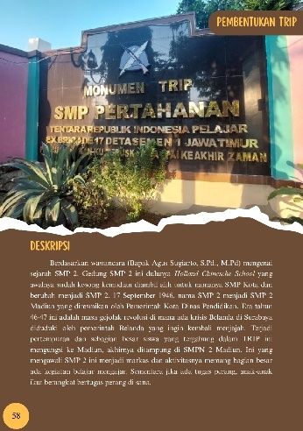
2 | Harus ditambahi tentang masa Indonesia Kuno, madya baru | 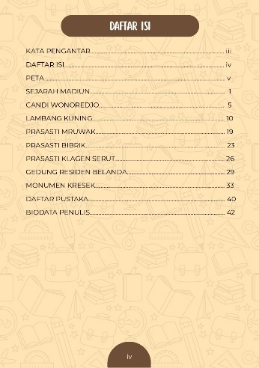 | 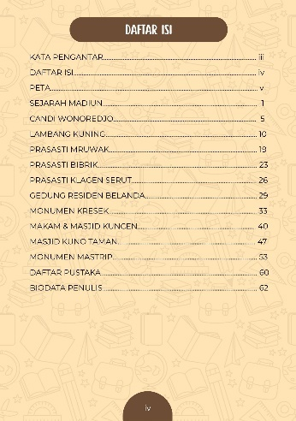
3 | Ganti cover dengan gambar yang tidak menyudutkan Madiun | 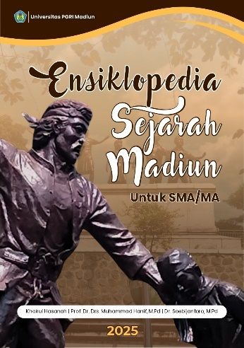 | 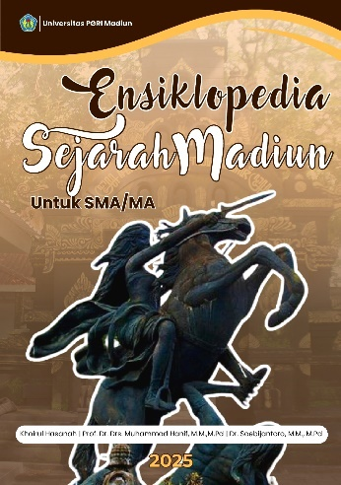
4 | Maps dibuat pop up agar lebih menarik dan kekinian | 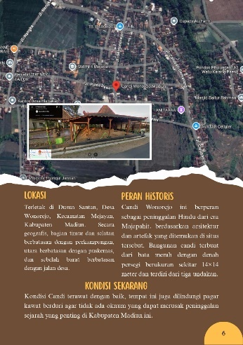 | 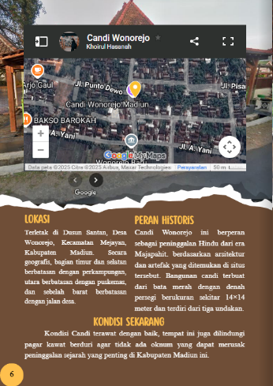
5 | Awal paragraf dibuat menjorok | 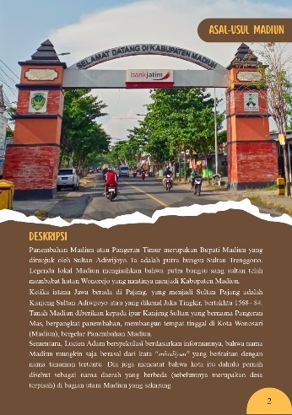 | 