Normalitas Shapiro

Tests of Normality
 | Kolmogorov-Smirnovª |  |  | Shapiro-Wilk
 | Statistic | df | Sig. | Statistic | df | Sig.
4C | .186 | 30 | .009 | .933 | 30 | .058
LITERASI | .144 | 30 | .113 | .942 | 30 | .102
HASIL BELAJAR | .164 | 30 | .039 | .944 | 30 | .114
a. Lilliefors Significance Correction

Linearitas
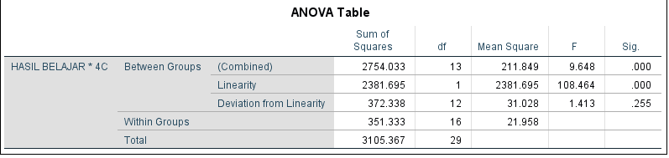
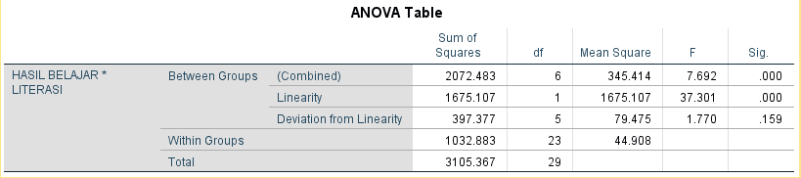

Korelasi
Correlations
 |  | 4C | LITERASI | HASIL BELAJAR
4C | Pearson Correlation | 1 | .647** | .876**
4C | Sig. (2-tailed) |  | .000 | .000
4C | N | 30 | 30 | 30
LITERASI | Pearson Correlation | .647** | 1 | .734**
LITERASI | Sig. (2-tailed) | .000 |  | .000
LITERASI | N | 30 | 30 | 30
HASIL BELAJAR | Pearson Correlation | .876** | .734** | 1
HASIL BELAJAR | Sig. (2-tailed) | .000 | .000
HASIL BELAJAR | N | 30 | 30 | 30
**. Correlation is significant at the 0.01 level (2-tailed).
Regresi berganda

Model |  | Unstandardized Coefficients |  | Standardized Coefficients | t | Sig.
 |  | B | Std. Error | Beta | t | Sig.
1 | (Constant) | -63.244 | 23.420 |  | -2.700 | .012
1 | 4C | 1.201 | .189 | .689 | 6.351 | .000
1 | LITERASI | 1.680 | .632 | .288 | 2.658 | .013

Model |  | Sum of Squares | df | Mean Square | F | Sig.
1 | Regression | 2531.815 | 2 | 1265.908 | 59.593 | .000^{b}
1 | Residual | 573.552 | 27 | 21.243
1 | Total | 3105.367 | 29

Model | R | R Square | Adjusted R Square | Std. Error of the Estimate
1 | .903ª | .815 | .802 | 4.609

