Ujicoba 1 (support 5%, confidence 90%)

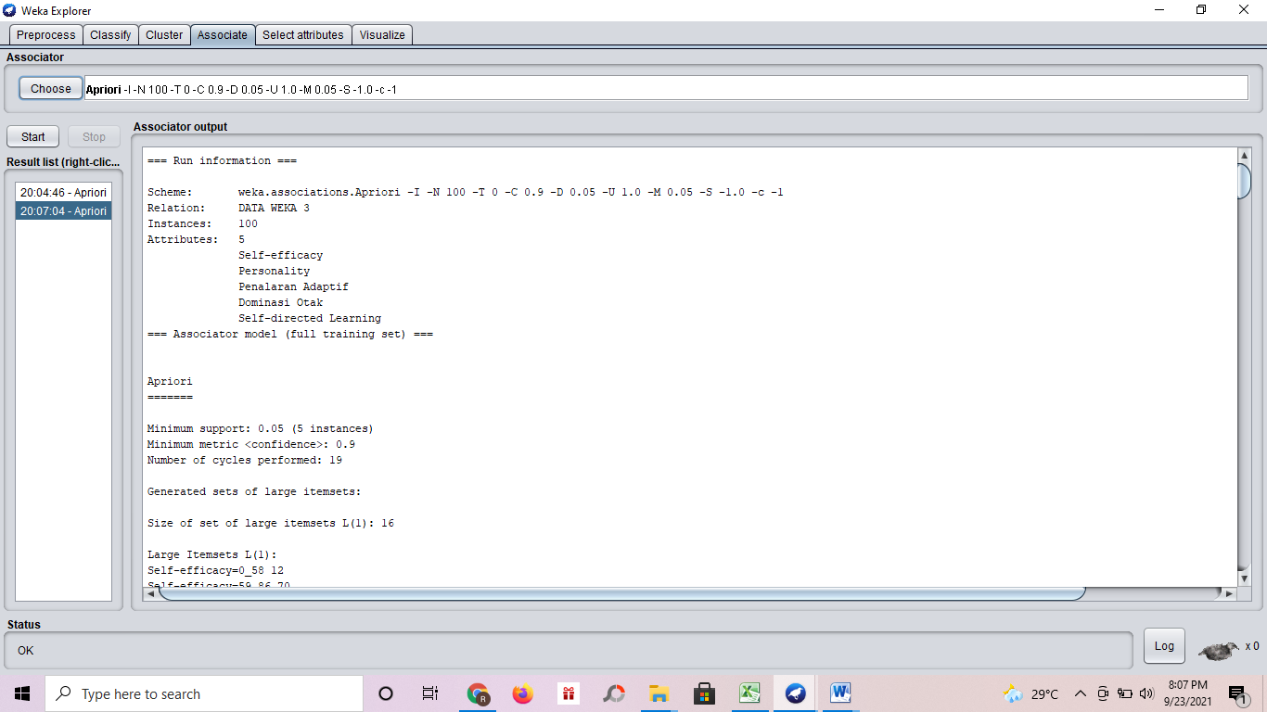

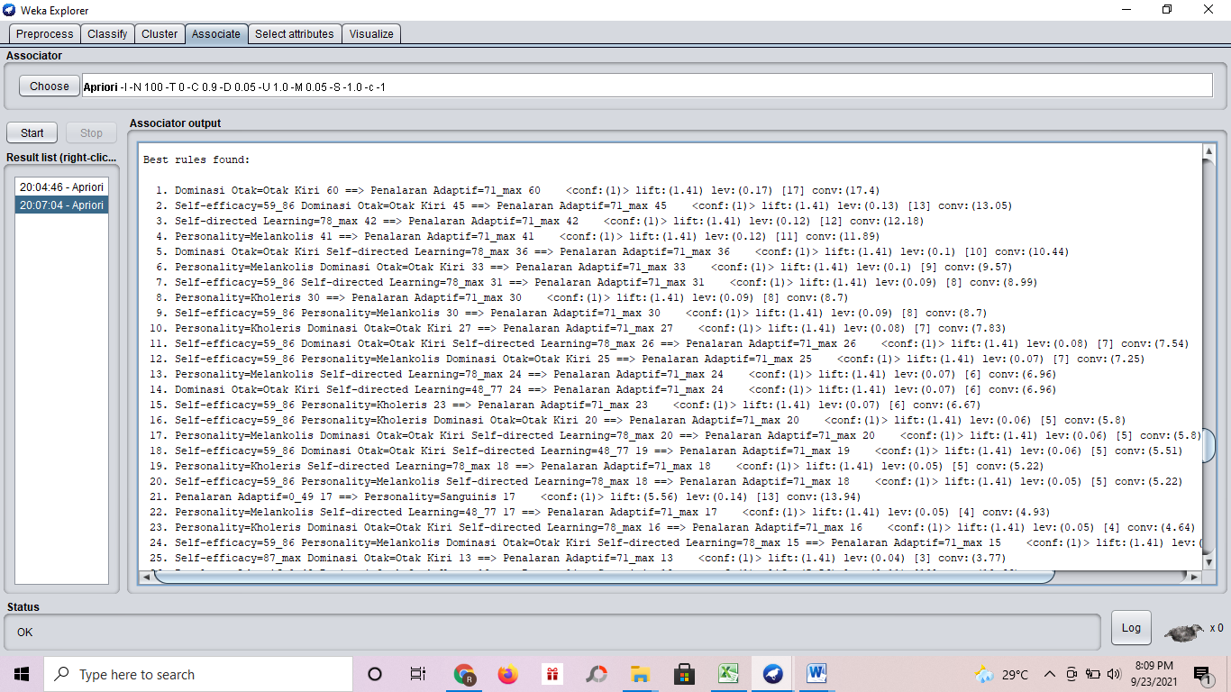

=== Run information ===

Scheme: weka.associations.Apriori -I -N 100 -T 0 -C 0.9 -D 0.05 -U 1.0 -M 0.05 -S -1.0 -c -1
Relation: DATA WEKA 3
Instances: 100
Attributes: 5
Self-efficacy
Personality
Penalaran Adaptif
Dominasi Otak
Self-directed Learning
=== Associator model (full training set) ===

Apriori
=======

Minimum support: 0.05 (5 instances)
Minimum metric <confidence>: 0.9
Number of cycles performed: 19

Generated sets of large itemsets:

Size of set of large itemsets L(1): 16

Large Itemsets L(1):
Self-efficacy=0_58 12
Self-efficacy=59_86 70
Self-efficacy=87_max 18
Personality=Sanguinis 18
Personality=Kholeris 30
Personality=Melankolis 41
Personality=Phlegmatis 11
Penalaran Adaptif=0_49 17
Penalaran Adaptif=71_max 71
Penalaran Adaptif=50_70 12
Dominasi Otak=Otak Kanan 24
Dominasi Otak=Otak Kiri 60
Dominasi Otak=Seimbang 16
Self-directed Learning=0_47 17
Self-directed Learning=78_max 42
Self-directed Learning=48_77 41

Size of set of large itemsets L(2): 56

Large Itemsets L(2):
Self-efficacy=0_58 Personality=Sanguinis 6
Self-efficacy=0_58 Penalaran Adaptif=0_49 6
Self-efficacy=0_58 Dominasi Otak=Otak Kanan 7
Self-efficacy=0_58 Self-directed Learning=0_47 5
Self-efficacy=0_58 Self-directed Learning=48_77 6
Self-efficacy=59_86 Personality=Sanguinis 10
Self-efficacy=59_86 Personality=Kholeris 23
Self-efficacy=59_86 Personality=Melankolis 30
Self-efficacy=59_86 Personality=Phlegmatis 7
Self-efficacy=59_86 Penalaran Adaptif=0_49 9
Self-efficacy=59_86 Penalaran Adaptif=71_max 53
Self-efficacy=59_86 Penalaran Adaptif=50_70 8
Self-efficacy=59_86 Dominasi Otak=Otak Kanan 14
Self-efficacy=59_86 Dominasi Otak=Otak Kiri 45
Self-efficacy=59_86 Dominasi Otak=Seimbang 11
Self-efficacy=59_86 Self-directed Learning=0_47 10
Self-efficacy=59_86 Self-directed Learning=78_max 31
Self-efficacy=59_86 Self-directed Learning=48_77 29
Self-efficacy=87_max Personality=Kholeris 6
Self-efficacy=87_max Personality=Melankolis 9
Self-efficacy=87_max Penalaran Adaptif=71_max 15
Self-efficacy=87_max Dominasi Otak=Otak Kiri 13
Self-efficacy=87_max Self-directed Learning=78_max 10
Self-efficacy=87_max Self-directed Learning=48_77 6
Personality=Sanguinis Penalaran Adaptif=0_49 17
Personality=Sanguinis Dominasi Otak=Otak Kanan 14
Personality=Sanguinis Self-directed Learning=0_47 13
Personality=Sanguinis Self-directed Learning=48_77 5
Personality=Kholeris Penalaran Adaptif=71_max 30
Personality=Kholeris Dominasi Otak=Otak Kiri 27
Personality=Kholeris Self-directed Learning=78_max 18
Personality=Kholeris Self-directed Learning=48_77 12
Personality=Melankolis Penalaran Adaptif=71_max 41
Personality=Melankolis Dominasi Otak=Otak Kiri 33
Personality=Melankolis Dominasi Otak=Seimbang 8
Personality=Melankolis Self-directed Learning=78_max 24
Personality=Melankolis Self-directed Learning=48_77 17
Personality=Phlegmatis Penalaran Adaptif=50_70 11
Personality=Phlegmatis Dominasi Otak=Otak Kanan 10
Personality=Phlegmatis Self-directed Learning=48_77 7
Penalaran Adaptif=0_49 Dominasi Otak=Otak Kanan 13
Penalaran Adaptif=0_49 Self-directed Learning=0_47 12
Penalaran Adaptif=0_49 Self-directed Learning=48_77 5
Penalaran Adaptif=71_max Dominasi Otak=Otak Kiri 60
Penalaran Adaptif=71_max Dominasi Otak=Seimbang 11
Penalaran Adaptif=71_max Self-directed Learning=78_max 42
Penalaran Adaptif=71_max Self-directed Learning=48_77 29
Penalaran Adaptif=50_70 Dominasi Otak=Otak Kanan 11
Penalaran Adaptif=50_70 Self-directed Learning=0_47 5
Penalaran Adaptif=50_70 Self-directed Learning=48_77 7
Dominasi Otak=Otak Kanan Self-directed Learning=0_47 14
Dominasi Otak=Otak Kanan Self-directed Learning=48_77 10
Dominasi Otak=Otak Kiri Self-directed Learning=78_max 36
Dominasi Otak=Otak Kiri Self-directed Learning=48_77 24
Dominasi Otak=Seimbang Self-directed Learning=78_max 6
Dominasi Otak=Seimbang Self-directed Learning=48_77 7

Size of set of large itemsets L(3): 62

Large Itemsets L(3):
Self-efficacy=0_58 Personality=Sanguinis Penalaran Adaptif=0_49 6
Self-efficacy=59_86 Personality=Sanguinis Penalaran Adaptif=0_49 9
Self-efficacy=59_86 Personality=Sanguinis Dominasi Otak=Otak Kanan 8
Self-efficacy=59_86 Personality=Sanguinis Self-directed Learning=0_47 7
Self-efficacy=59_86 Personality=Kholeris Penalaran Adaptif=71_max 23
Self-efficacy=59_86 Personality=Kholeris Dominasi Otak=Otak Kiri 20
Self-efficacy=59_86 Personality=Kholeris Self-directed Learning=78_max 13
Self-efficacy=59_86 Personality=Kholeris Self-directed Learning=48_77 10
Self-efficacy=59_86 Personality=Melankolis Penalaran Adaptif=71_max 30
Self-efficacy=59_86 Personality=Melankolis Dominasi Otak=Otak Kiri 25
Self-efficacy=59_86 Personality=Melankolis Dominasi Otak=Seimbang 5
Self-efficacy=59_86 Personality=Melankolis Self-directed Learning=78_max 18
Self-efficacy=59_86 Personality=Melankolis Self-directed Learning=48_77 12
Self-efficacy=59_86 Personality=Phlegmatis Penalaran Adaptif=50_70 7
Self-efficacy=59_86 Personality=Phlegmatis Dominasi Otak=Otak Kanan 6
Self-efficacy=59_86 Penalaran Adaptif=0_49 Dominasi Otak=Otak Kanan 7
Self-efficacy=59_86 Penalaran Adaptif=0_49 Self-directed Learning=0_47 6
Self-efficacy=59_86 Penalaran Adaptif=71_max Dominasi Otak=Otak Kiri 45
Self-efficacy=59_86 Penalaran Adaptif=71_max Dominasi Otak=Seimbang 8
Self-efficacy=59_86 Penalaran Adaptif=71_max Self-directed Learning=78_max 31
Self-efficacy=59_86 Penalaran Adaptif=71_max Self-directed Learning=48_77 22
Self-efficacy=59_86 Penalaran Adaptif=50_70 Dominasi Otak=Otak Kanan 7
Self-efficacy=59_86 Dominasi Otak=Otak Kanan Self-directed Learning=0_47 8
Self-efficacy=59_86 Dominasi Otak=Otak Kanan Self-directed Learning=48_77 6
Self-efficacy=59_86 Dominasi Otak=Otak Kiri Self-directed Learning=78_max 26
Self-efficacy=59_86 Dominasi Otak=Otak Kiri Self-directed Learning=48_77 19
Self-efficacy=59_86 Dominasi Otak=Seimbang Self-directed Learning=78_max 5
Self-efficacy=87_max Personality=Kholeris Penalaran Adaptif=71_max 6
Self-efficacy=87_max Personality=Kholeris Dominasi Otak=Otak Kiri 6
Self-efficacy=87_max Personality=Kholeris Self-directed Learning=78_max 5
Self-efficacy=87_max Personality=Melankolis Penalaran Adaptif=71_max 9
Self-efficacy=87_max Personality=Melankolis Dominasi Otak=Otak Kiri 7
Self-efficacy=87_max Personality=Melankolis Self-directed Learning=78_max 5
Self-efficacy=87_max Penalaran Adaptif=71_max Dominasi Otak=Otak Kiri 13
Self-efficacy=87_max Penalaran Adaptif=71_max Self-directed Learning=78_max 10
Self-efficacy=87_max Penalaran Adaptif=71_max Self-directed Learning=48_77 5
Self-efficacy=87_max Dominasi Otak=Otak Kiri Self-directed Learning=78_max 9
Personality=Sanguinis Penalaran Adaptif=0_49 Dominasi Otak=Otak Kanan 13
Personality=Sanguinis Penalaran Adaptif=0_49 Self-directed Learning=0_47 12
Personality=Sanguinis Penalaran Adaptif=0_49 Self-directed Learning=48_77 5
Personality=Sanguinis Dominasi Otak=Otak Kanan Self-directed Learning=0_47 10
Personality=Kholeris Penalaran Adaptif=71_max Dominasi Otak=Otak Kiri 27
Personality=Kholeris Penalaran Adaptif=71_max Self-directed Learning=78_max 18
Personality=Kholeris Penalaran Adaptif=71_max Self-directed Learning=48_77 12
Personality=Kholeris Dominasi Otak=Otak Kiri Self-directed Learning=78_max 16
Personality=Kholeris Dominasi Otak=Otak Kiri Self-directed Learning=48_77 11
Personality=Melankolis Penalaran Adaptif=71_max Dominasi Otak=Otak Kiri 33
Personality=Melankolis Penalaran Adaptif=71_max Dominasi Otak=Seimbang 8
Personality=Melankolis Penalaran Adaptif=71_max Self-directed Learning=78_max 24
Personality=Melankolis Penalaran Adaptif=71_max Self-directed Learning=48_77 17
Personality=Melankolis Dominasi Otak=Otak Kiri Self-directed Learning=78_max 20
Personality=Melankolis Dominasi Otak=Otak Kiri Self-directed Learning=48_77 13
Personality=Phlegmatis Penalaran Adaptif=50_70 Dominasi Otak=Otak Kanan 10
Personality=Phlegmatis Penalaran Adaptif=50_70 Self-directed Learning=48_77 7
Personality=Phlegmatis Dominasi Otak=Otak Kanan Self-directed Learning=48_77 6
Penalaran Adaptif=0_49 Dominasi Otak=Otak Kanan Self-directed Learning=0_47 9
Penalaran Adaptif=71_max Dominasi Otak=Otak Kiri Self-directed Learning=78_max 36
Penalaran Adaptif=71_max Dominasi Otak=Otak Kiri Self-directed Learning=48_77 24
Penalaran Adaptif=71_max Dominasi Otak=Seimbang Self-directed Learning=78_max 6
Penalaran Adaptif=71_max Dominasi Otak=Seimbang Self-directed Learning=48_77 5
Penalaran Adaptif=50_70 Dominasi Otak=Otak Kanan Self-directed Learning=0_47 5
Penalaran Adaptif=50_70 Dominasi Otak=Otak Kanan Self-directed Learning=48_77 6

Size of set of large itemsets L(4): 30

Large Itemsets L(4):
Self-efficacy=59_86 Personality=Sanguinis Penalaran Adaptif=0_49 Dominasi Otak=Otak Kanan 7
Self-efficacy=59_86 Personality=Sanguinis Penalaran Adaptif=0_49 Self-directed Learning=0_47 6
Self-efficacy=59_86 Personality=Sanguinis Dominasi Otak=Otak Kanan Self-directed Learning=0_47 5
Self-efficacy=59_86 Personality=Kholeris Penalaran Adaptif=71_max Dominasi Otak=Otak Kiri 20
Self-efficacy=59_86 Personality=Kholeris Penalaran Adaptif=71_max Self-directed Learning=78_max 13
Self-efficacy=59_86 Personality=Kholeris Penalaran Adaptif=71_max Self-directed Learning=48_77 10
Self-efficacy=59_86 Personality=Kholeris Dominasi Otak=Otak Kiri Self-directed Learning=78_max 11
Self-efficacy=59_86 Personality=Kholeris Dominasi Otak=Otak Kiri Self-directed Learning=48_77 9
Self-efficacy=59_86 Personality=Melankolis Penalaran Adaptif=71_max Dominasi Otak=Otak Kiri 25
Self-efficacy=59_86 Personality=Melankolis Penalaran Adaptif=71_max Dominasi Otak=Seimbang 5
Self-efficacy=59_86 Personality=Melankolis Penalaran Adaptif=71_max Self-directed Learning=78_max 18
Self-efficacy=59_86 Personality=Melankolis Penalaran Adaptif=71_max Self-directed Learning=48_77 12
Self-efficacy=59_86 Personality=Melankolis Dominasi Otak=Otak Kiri Self-directed Learning=78_max 15
Self-efficacy=59_86 Personality=Melankolis Dominasi Otak=Otak Kiri Self-directed Learning=48_77 10
Self-efficacy=59_86 Personality=Phlegmatis Penalaran Adaptif=50_70 Dominasi Otak=Otak Kanan 6
Self-efficacy=59_86 Penalaran Adaptif=71_max Dominasi Otak=Otak Kiri Self-directed Learning=78_max 26
Self-efficacy=59_86 Penalaran Adaptif=71_max Dominasi Otak=Otak Kiri Self-directed Learning=48_77 19
Self-efficacy=59_86 Penalaran Adaptif=71_max Dominasi Otak=Seimbang Self-directed Learning=78_max 5
Self-efficacy=87_max Personality=Kholeris Penalaran Adaptif=71_max Dominasi Otak=Otak Kiri 6
Self-efficacy=87_max Personality=Kholeris Penalaran Adaptif=71_max Self-directed Learning=78_max 5
Self-efficacy=87_max Personality=Kholeris Dominasi Otak=Otak Kiri Self-directed Learning=78_max 5
Self-efficacy=87_max Personality=Melankolis Penalaran Adaptif=71_max Dominasi Otak=Otak Kiri 7
Self-efficacy=87_max Personality=Melankolis Penalaran Adaptif=71_max Self-directed Learning=78_max 5
Self-efficacy=87_max Penalaran Adaptif=71_max Dominasi Otak=Otak Kiri Self-directed Learning=78_max 9
Personality=Sanguinis Penalaran Adaptif=0_49 Dominasi Otak=Otak Kanan Self-directed Learning=0_47 9
Personality=Kholeris Penalaran Adaptif=71_max Dominasi Otak=Otak Kiri Self-directed Learning=78_max 16
Personality=Kholeris Penalaran Adaptif=71_max Dominasi Otak=Otak Kiri Self-directed Learning=48_77 11
Personality=Melankolis Penalaran Adaptif=71_max Dominasi Otak=Otak Kiri Self-directed Learning=78_max 20
Personality=Melankolis Penalaran Adaptif=71_max Dominasi Otak=Otak Kiri Self-directed Learning=48_77 13
Personality=Phlegmatis Penalaran Adaptif=50_70 Dominasi Otak=Otak Kanan Self-directed Learning=48_77 6

Size of set of large itemsets L(5): 5

Large Itemsets L(5):
Self-efficacy=59_86 Personality=Kholeris Penalaran Adaptif=71_max Dominasi Otak=Otak Kiri Self-directed Learning=78_max 11
Self-efficacy=59_86 Personality=Kholeris Penalaran Adaptif=71_max Dominasi Otak=Otak Kiri Self-directed Learning=48_77 9
Self-efficacy=59_86 Personality=Melankolis Penalaran Adaptif=71_max Dominasi Otak=Otak Kiri Self-directed Learning=78_max 15
Self-efficacy=59_86 Personality=Melankolis Penalaran Adaptif=71_max Dominasi Otak=Otak Kiri Self-directed Learning=48_77 10
Self-efficacy=87_max Personality=Kholeris Penalaran Adaptif=71_max Dominasi Otak=Otak Kiri Self-directed Learning=78_max 5

Best rules found:

1. Dominasi Otak=Otak Kiri 60 ==> Penalaran Adaptif=71_max 60 <conf:(1)> lift:(1.41) lev:(0.17) [17] conv:(17.4)
2. Self-efficacy=59_86 Dominasi Otak=Otak Kiri 45 ==> Penalaran Adaptif=71_max 45 <conf:(1)> lift:(1.41) lev:(0.13) [13] conv:(13.05)
3. Self-directed Learning=78_max 42 ==> Penalaran Adaptif=71_max 42 <conf:(1)> lift:(1.41) lev:(0.12) [12] conv:(12.18)
4. Personality=Melankolis 41 ==> Penalaran Adaptif=71_max 41 <conf:(1)> lift:(1.41) lev:(0.12) [11] conv:(11.89)
5. Dominasi Otak=Otak Kiri Self-directed Learning=78_max 36 ==> Penalaran Adaptif=71_max 36 <conf:(1)> lift:(1.41) lev:(0.1) [10] conv:(10.44)
6. Personality=Melankolis Dominasi Otak=Otak Kiri 33 ==> Penalaran Adaptif=71_max 33 <conf:(1)> lift:(1.41) lev:(0.1) [9] conv:(9.57)
7. Self-efficacy=59_86 Self-directed Learning=78_max 31 ==> Penalaran Adaptif=71_max 31 <conf:(1)> lift:(1.41) lev:(0.09) [8] conv:(8.99)
8. Personality=Kholeris 30 ==> Penalaran Adaptif=71_max 30 <conf:(1)> lift:(1.41) lev:(0.09) [8] conv:(8.7)
9. Self-efficacy=59_86 Personality=Melankolis 30 ==> Penalaran Adaptif=71_max 30 <conf:(1)> lift:(1.41) lev:(0.09) [8] conv:(8.7)
10. Personality=Kholeris Dominasi Otak=Otak Kiri 27 ==> Penalaran Adaptif=71_max 27 <conf:(1)> lift:(1.41) lev:(0.08) [7] conv:(7.83)
11. Self-efficacy=59_86 Dominasi Otak=Otak Kiri Self-directed Learning=78_max 26 ==> Penalaran Adaptif=71_max 26 <conf:(1)> lift:(1.41) lev:(0.08) [7] conv:(7.54)
12. Self-efficacy=59_86 Personality=Melankolis Dominasi Otak=Otak Kiri 25 ==> Penalaran Adaptif=71_max 25 <conf:(1)> lift:(1.41) lev:(0.07) [7] conv:(7.25)
13. Personality=Melankolis Self-directed Learning=78_max 24 ==> Penalaran Adaptif=71_max 24 <conf:(1)> lift:(1.41) lev:(0.07) [6] conv:(6.96)
14. Dominasi Otak=Otak Kiri Self-directed Learning=48_77 24 ==> Penalaran Adaptif=71_max 24 <conf:(1)> lift:(1.41) lev:(0.07) [6] conv:(6.96)
15. Self-efficacy=59_86 Personality=Kholeris 23 ==> Penalaran Adaptif=71_max 23 <conf:(1)> lift:(1.41) lev:(0.07) [6] conv:(6.67)
16. Self-efficacy=59_86 Personality=Kholeris Dominasi Otak=Otak Kiri 20 ==> Penalaran Adaptif=71_max 20 <conf:(1)> lift:(1.41) lev:(0.06) [5] conv:(5.8)
17. Personality=Melankolis Dominasi Otak=Otak Kiri Self-directed Learning=78_max 20 ==> Penalaran Adaptif=71_max 20 <conf:(1)> lift:(1.41) lev:(0.06) [5] conv:(5.8)
18. Self-efficacy=59_86 Dominasi Otak=Otak Kiri Self-directed Learning=48_77 19 ==> Penalaran Adaptif=71_max 19 <conf:(1)> lift:(1.41) lev:(0.06) [5] conv:(5.51)
19. Personality=Kholeris Self-directed Learning=78_max 18 ==> Penalaran Adaptif=71_max 18 <conf:(1)> lift:(1.41) lev:(0.05) [5] conv:(5.22)
20. Self-efficacy=59_86 Personality=Melankolis Self-directed Learning=78_max 18 ==> Penalaran Adaptif=71_max 18 <conf:(1)> lift:(1.41) lev:(0.05) [5] conv:(5.22)
21. Penalaran Adaptif=0_49 17 ==> Personality=Sanguinis 17 <conf:(1)> lift:(5.56) lev:(0.14) [13] conv:(13.94)
22. Personality=Melankolis Self-directed Learning=48_77 17 ==> Penalaran Adaptif=71_max 17 <conf:(1)> lift:(1.41) lev:(0.05) [4] conv:(4.93)
23. Personality=Kholeris Dominasi Otak=Otak Kiri Self-directed Learning=78_max 16 ==> Penalaran Adaptif=71_max 16 <conf:(1)> lift:(1.41) lev:(0.05) [4] conv:(4.64)
24. Self-efficacy=59_86 Personality=Melankolis Dominasi Otak=Otak Kiri Self-directed Learning=78_max 15 ==> Penalaran Adaptif=71_max 15 <conf:(1)> lift:(1.41) lev:(0.04) [4] conv:(4.35)
25. Self-efficacy=87_max Dominasi Otak=Otak Kiri 13 ==> Penalaran Adaptif=71_max 13 <conf:(1)> lift:(1.41) lev:(0.04) [3] conv:(3.77)
26. Penalaran Adaptif=0_49 Dominasi Otak=Otak Kanan 13 ==> Personality=Sanguinis 13 <conf:(1)> lift:(5.56) lev:(0.11) [10] conv:(10.66)
27. Self-efficacy=59_86 Personality=Kholeris Self-directed Learning=78_max 13 ==> Penalaran Adaptif=71_max 13 <conf:(1)> lift:(1.41) lev:(0.04) [3] conv:(3.77)
28. Personality=Melankolis Dominasi Otak=Otak Kiri Self-directed Learning=48_77 13 ==> Penalaran Adaptif=71_max 13 <conf:(1)> lift:(1.41) lev:(0.04) [3] conv:(3.77)
29. Penalaran Adaptif=0_49 Self-directed Learning=0_47 12 ==> Personality=Sanguinis 12 <conf:(1)> lift:(5.56) lev:(0.1) [9] conv:(9.84)
30. Personality=Kholeris Self-directed Learning=48_77 12 ==> Penalaran Adaptif=71_max 12 <conf:(1)> lift:(1.41) lev:(0.03) [3] conv:(3.48)
31. Self-efficacy=59_86 Personality=Melankolis Self-directed Learning=48_77 12 ==> Penalaran Adaptif=71_max 12 <conf:(1)> lift:(1.41) lev:(0.03) [3] conv:(3.48)
32. Personality=Phlegmatis 11 ==> Penalaran Adaptif=50_70 11 <conf:(1)> lift:(8.33) lev:(0.1) [9] conv:(9.68)
33. Personality=Kholeris Dominasi Otak=Otak Kiri Self-directed Learning=48_77 11 ==> Penalaran Adaptif=71_max 11 <conf:(1)> lift:(1.41) lev:(0.03) [3] conv:(3.19)
34. Self-efficacy=59_86 Personality=Kholeris Dominasi Otak=Otak Kiri Self-directed Learning=78_max 11 ==> Penalaran Adaptif=71_max 11 <conf:(1)> lift:(1.41) lev:(0.03) [3] conv:(3.19)
35. Self-efficacy=87_max Self-directed Learning=78_max 10 ==> Penalaran Adaptif=71_max 10 <conf:(1)> lift:(1.41) lev:(0.03) [2] conv:(2.9)
36. Personality=Phlegmatis Dominasi Otak=Otak Kanan 10 ==> Penalaran Adaptif=50_70 10 <conf:(1)> lift:(8.33) lev:(0.09) [8] conv:(8.8)
37. Self-efficacy=59_86 Personality=Kholeris Self-directed Learning=48_77 10 ==> Penalaran Adaptif=71_max 10 <conf:(1)> lift:(1.41) lev:(0.03) [2] conv:(2.9)
38. Self-efficacy=59_86 Personality=Melankolis Dominasi Otak=Otak Kiri Self-directed Learning=48_77 10 ==> Penalaran Adaptif=71_max 10 <conf:(1)> lift:(1.41) lev:(0.03) [2] conv:(2.9)
39. Self-efficacy=59_86 Penalaran Adaptif=0_49 9 ==> Personality=Sanguinis 9 <conf:(1)> lift:(5.56) lev:(0.07) [7] conv:(7.38)
40. Self-efficacy=87_max Personality=Melankolis 9 ==> Penalaran Adaptif=71_max 9 <conf:(1)> lift:(1.41) lev:(0.03) [2] conv:(2.61)
41. Self-efficacy=87_max Dominasi Otak=Otak Kiri Self-directed Learning=78_max 9 ==> Penalaran Adaptif=71_max 9 <conf:(1)> lift:(1.41) lev:(0.03) [2] conv:(2.61)
42. Penalaran Adaptif=0_49 Dominasi Otak=Otak Kanan Self-directed Learning=0_47 9 ==> Personality=Sanguinis 9 <conf:(1)> lift:(5.56) lev:(0.07) [7] conv:(7.38)
43. Self-efficacy=59_86 Personality=Kholeris Dominasi Otak=Otak Kiri Self-directed Learning=48_77 9 ==> Penalaran Adaptif=71_max 9 <conf:(1)> lift:(1.41) lev:(0.03) [2] conv:(2.61)
44. Personality=Melankolis Dominasi Otak=Seimbang 8 ==> Penalaran Adaptif=71_max 8 <conf:(1)> lift:(1.41) lev:(0.02) [2] conv:(2.32)
45. Self-efficacy=59_86 Personality=Phlegmatis 7 ==> Penalaran Adaptif=50_70 7 <conf:(1)> lift:(8.33) lev:(0.06) [6] conv:(6.16)
46. Penalaran Adaptif=50_70 Self-directed Learning=48_77 7 ==> Personality=Phlegmatis 7 <conf:(1)> lift:(9.09) lev:(0.06) [6] conv:(6.23)
47. Personality=Phlegmatis Self-directed Learning=48_77 7 ==> Penalaran Adaptif=50_70 7 <conf:(1)> lift:(8.33) lev:(0.06) [6] conv:(6.16)
48. Self-efficacy=59_86 Penalaran Adaptif=0_49 Dominasi Otak=Otak Kanan 7 ==> Personality=Sanguinis 7 <conf:(1)> lift:(5.56) lev:(0.06) [5] conv:(5.74)
49. Self-efficacy=87_max Personality=Melankolis Dominasi Otak=Otak Kiri 7 ==> Penalaran Adaptif=71_max 7 <conf:(1)> lift:(1.41) lev:(0.02) [2] conv:(2.03)
50. Self-efficacy=0_58 Penalaran Adaptif=0_49 6 ==> Personality=Sanguinis 6 <conf:(1)> lift:(5.56) lev:(0.05) [4] conv:(4.92)
51. Self-efficacy=0_58 Personality=Sanguinis 6 ==> Penalaran Adaptif=0_49 6 <conf:(1)> lift:(5.88) lev:(0.05) [4] conv:(4.98)
52. Self-efficacy=87_max Personality=Kholeris 6 ==> Penalaran Adaptif=71_max 6 <conf:(1)> lift:(1.41) lev:(0.02) [1] conv:(1.74)
53. Self-efficacy=87_max Personality=Kholeris 6 ==> Dominasi Otak=Otak Kiri 6 <conf:(1)> lift:(1.67) lev:(0.02) [2] conv:(2.4)
54. Dominasi Otak=Seimbang Self-directed Learning=78_max 6 ==> Penalaran Adaptif=71_max 6 <conf:(1)> lift:(1.41) lev:(0.02) [1] conv:(1.74)
55. Self-efficacy=59_86 Penalaran Adaptif=0_49 Self-directed Learning=0_47 6 ==> Personality=Sanguinis 6 <conf:(1)> lift:(5.56) lev:(0.05) [4] conv:(4.92)
56. Self-efficacy=59_86 Personality=Phlegmatis Dominasi Otak=Otak Kanan 6 ==> Penalaran Adaptif=50_70 6 <conf:(1)> lift:(8.33) lev:(0.05) [5] conv:(5.28)
57. Self-efficacy=87_max Personality=Kholeris Dominasi Otak=Otak Kiri 6 ==> Penalaran Adaptif=71_max 6 <conf:(1)> lift:(1.41) lev:(0.02) [1] conv:(1.74)
58. Self-efficacy=87_max Personality=Kholeris Penalaran Adaptif=71_max 6 ==> Dominasi Otak=Otak Kiri 6 <conf:(1)> lift:(1.67) lev:(0.02) [2] conv:(2.4)
59. Self-efficacy=87_max Personality=Kholeris 6 ==> Penalaran Adaptif=71_max Dominasi Otak=Otak Kiri 6 <conf:(1)> lift:(1.67) lev:(0.02) [2] conv:(2.4)
60. Penalaran Adaptif=50_70 Dominasi Otak=Otak Kanan Self-directed Learning=48_77 6 ==> Personality=Phlegmatis 6 <conf:(1)> lift:(9.09) lev:(0.05) [5] conv:(5.34)
61. Personality=Phlegmatis Dominasi Otak=Otak Kanan Self-directed Learning=48_77 6 ==> Penalaran Adaptif=50_70 6 <conf:(1)> lift:(8.33) lev:(0.05) [5] conv:(5.28)
62. Penalaran Adaptif=0_49 Self-directed Learning=48_77 5 ==> Personality=Sanguinis 5 <conf:(1)> lift:(5.56) lev:(0.04) [4] conv:(4.1)
63. Personality=Sanguinis Self-directed Learning=48_77 5 ==> Penalaran Adaptif=0_49 5 <conf:(1)> lift:(5.88) lev:(0.04) [4] conv:(4.15)
64. Penalaran Adaptif=50_70 Self-directed Learning=0_47 5 ==> Dominasi Otak=Otak Kanan 5 <conf:(1)> lift:(4.17) lev:(0.04) [3] conv:(3.8)
65. Self-efficacy=59_86 Personality=Melankolis Dominasi Otak=Seimbang 5 ==> Penalaran Adaptif=71_max 5 <conf:(1)> lift:(1.41) lev:(0.01) [1] conv:(1.45)
66. Self-efficacy=59_86 Dominasi Otak=Seimbang Self-directed Learning=78_max 5 ==> Penalaran Adaptif=71_max 5 <conf:(1)> lift:(1.41) lev:(0.01) [1] conv:(1.45)
67. Self-efficacy=87_max Personality=Kholeris Self-directed Learning=78_max 5 ==> Penalaran Adaptif=71_max 5 <conf:(1)> lift:(1.41) lev:(0.01) [1] conv:(1.45)
68. Self-efficacy=87_max Personality=Kholeris Self-directed Learning=78_max 5 ==> Dominasi Otak=Otak Kiri 5 <conf:(1)> lift:(1.67) lev:(0.02) [2] conv:(2)
69. Self-efficacy=87_max Personality=Melankolis Self-directed Learning=78_max 5 ==> Penalaran Adaptif=71_max 5 <conf:(1)> lift:(1.41) lev:(0.01) [1] conv:(1.45)
70. Self-efficacy=87_max Personality=Kholeris Dominasi Otak=Otak Kiri Self-directed Learning=78_max 5 ==> Penalaran Adaptif=71_max 5 <conf:(1)> lift:(1.41) lev:(0.01) [1] conv:(1.45)
71. Self-efficacy=87_max Personality=Kholeris Penalaran Adaptif=71_max Self-directed Learning=78_max 5 ==> Dominasi Otak=Otak Kiri 5 <conf:(1)> lift:(1.67) lev:(0.02) [2] conv:(2)
72. Self-efficacy=87_max Personality=Kholeris Self-directed Learning=78_max 5 ==> Penalaran Adaptif=71_max Dominasi Otak=Otak Kiri 5 <conf:(1)> lift:(1.67) lev:(0.02) [2] conv:(2)
73. Personality=Sanguinis 18 ==> Penalaran Adaptif=0_49 17 <conf:(0.94)> lift:(5.56) lev:(0.14) [13] conv:(7.47)
74. Personality=Sanguinis Dominasi Otak=Otak Kanan 14 ==> Penalaran Adaptif=0_49 13 <conf:(0.93)> lift:(5.46) lev:(0.11) [10] conv:(5.81)
75. Personality=Sanguinis Self-directed Learning=0_47 13 ==> Penalaran Adaptif=0_49 12 <conf:(0.92)> lift:(5.43) lev:(0.1) [9] conv:(5.39)
76. Penalaran Adaptif=50_70 12 ==> Personality=Phlegmatis 11 <conf:(0.92)> lift:(8.33) lev:(0.1) [9] conv:(5.34)
77. Penalaran Adaptif=50_70 12 ==> Dominasi Otak=Otak Kanan 11 <conf:(0.92)> lift:(3.82) lev:(0.08) [8] conv:(4.56)
78. Personality=Kholeris Self-directed Learning=48_77 12 ==> Dominasi Otak=Otak Kiri 11 <conf:(0.92)> lift:(1.53) lev:(0.04) [3] conv:(2.4)
79. Personality=Kholeris Penalaran Adaptif=71_max Self-directed Learning=48_77 12 ==> Dominasi Otak=Otak Kiri 11 <conf:(0.92)> lift:(1.53) lev:(0.04) [3] conv:(2.4)
80. Personality=Kholeris Self-directed Learning=48_77 12 ==> Penalaran Adaptif=71_max Dominasi Otak=Otak Kiri 11 <conf:(0.92)> lift:(1.53) lev:(0.04) [3] conv:(2.4)
81. Personality=Phlegmatis 11 ==> Dominasi Otak=Otak Kanan 10 <conf:(0.91)> lift:(3.79) lev:(0.07) [7] conv:(4.18)
82. Penalaran Adaptif=50_70 Dominasi Otak=Otak Kanan 11 ==> Personality=Phlegmatis 10 <conf:(0.91)> lift:(8.26) lev:(0.09) [8] conv:(4.89)
83. Personality=Phlegmatis Penalaran Adaptif=50_70 11 ==> Dominasi Otak=Otak Kanan 10 <conf:(0.91)> lift:(3.79) lev:(0.07) [7] conv:(4.18)
84. Personality=Phlegmatis 11 ==> Penalaran Adaptif=50_70 Dominasi Otak=Otak Kanan 10 <conf:(0.91)> lift:(8.26) lev:(0.09) [8] conv:(4.89)
85. Personality=Kholeris 30 ==> Dominasi Otak=Otak Kiri 27 <conf:(0.9)> lift:(1.5) lev:(0.09) [9] conv:(3)
86. Personality=Kholeris Penalaran Adaptif=71_max 30 ==> Dominasi Otak=Otak Kiri 27 <conf:(0.9)> lift:(1.5) lev:(0.09) [9] conv:(3)
87. Personality=Kholeris 30 ==> Penalaran Adaptif=71_max Dominasi Otak=Otak Kiri 27 <conf:(0.9)> lift:(1.5) lev:(0.09) [9] conv:(3)
88. Self-efficacy=59_86 Personality=Sanguinis 10 ==> Penalaran Adaptif=0_49 9 <conf:(0.9)> lift:(5.29) lev:(0.07) [7] conv:(4.15)
89. Self-efficacy=87_max Self-directed Learning=78_max 10 ==> Dominasi Otak=Otak Kiri 9 <conf:(0.9)> lift:(1.5) lev:(0.03) [3] conv:(2)
90. Self-efficacy=59_86 Personality=Kholeris Self-directed Learning=48_77 10 ==> Dominasi Otak=Otak Kiri 9 <conf:(0.9)> lift:(1.5) lev:(0.03) [3] conv:(2)
91. Self-efficacy=87_max Penalaran Adaptif=71_max Self-directed Learning=78_max 10 ==> Dominasi Otak=Otak Kiri 9 <conf:(0.9)> lift:(1.5) lev:(0.03) [3] conv:(2)
92. Self-efficacy=87_max Self-directed Learning=78_max 10 ==> Penalaran Adaptif=71_max Dominasi Otak=Otak Kiri 9 <conf:(0.9)> lift:(1.5) lev:(0.03) [3] conv:(2)
93. Personality=Sanguinis Dominasi Otak=Otak Kanan Self-directed Learning=0_47 10 ==> Penalaran Adaptif=0_49 9 <conf:(0.9)> lift:(5.29) lev:(0.07) [7] conv:(4.15)
94. Self-efficacy=59_86 Personality=Kholeris Penalaran Adaptif=71_max Self-directed Learning=48_77 10 ==> Dominasi Otak=Otak Kiri 9 <conf:(0.9)> lift:(1.5) lev:(0.03) [3] conv:(2)
95. Self-efficacy=59_86 Personality=Kholeris Self-directed Learning=48_77 10 ==> Penalaran Adaptif=71_max Dominasi Otak=Otak Kiri 9 <conf:(0.9)> lift:(1.5) lev:(0.03) [3] conv:(2)

Ujicoba 2 (support 10%, confidence 90%)

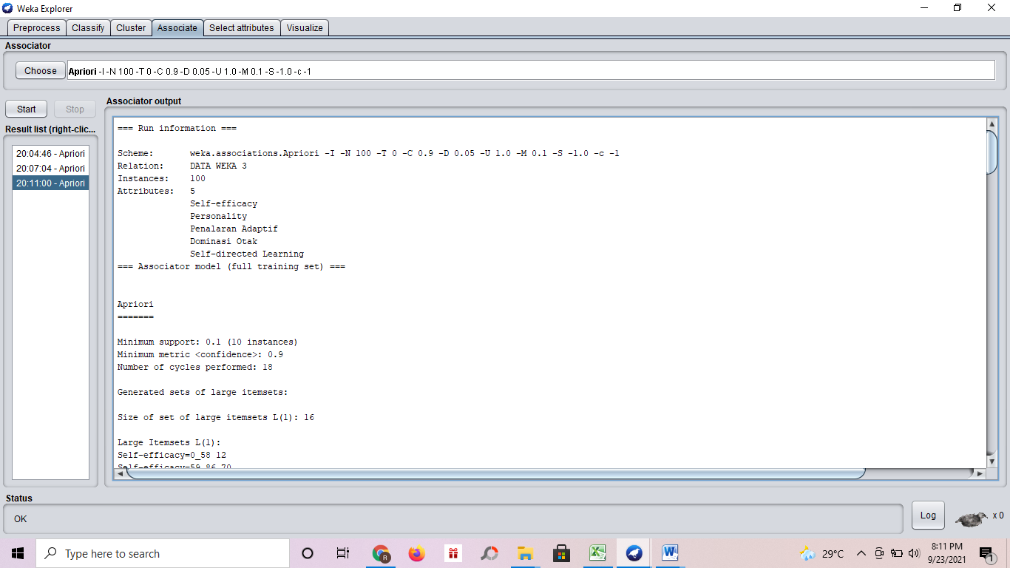

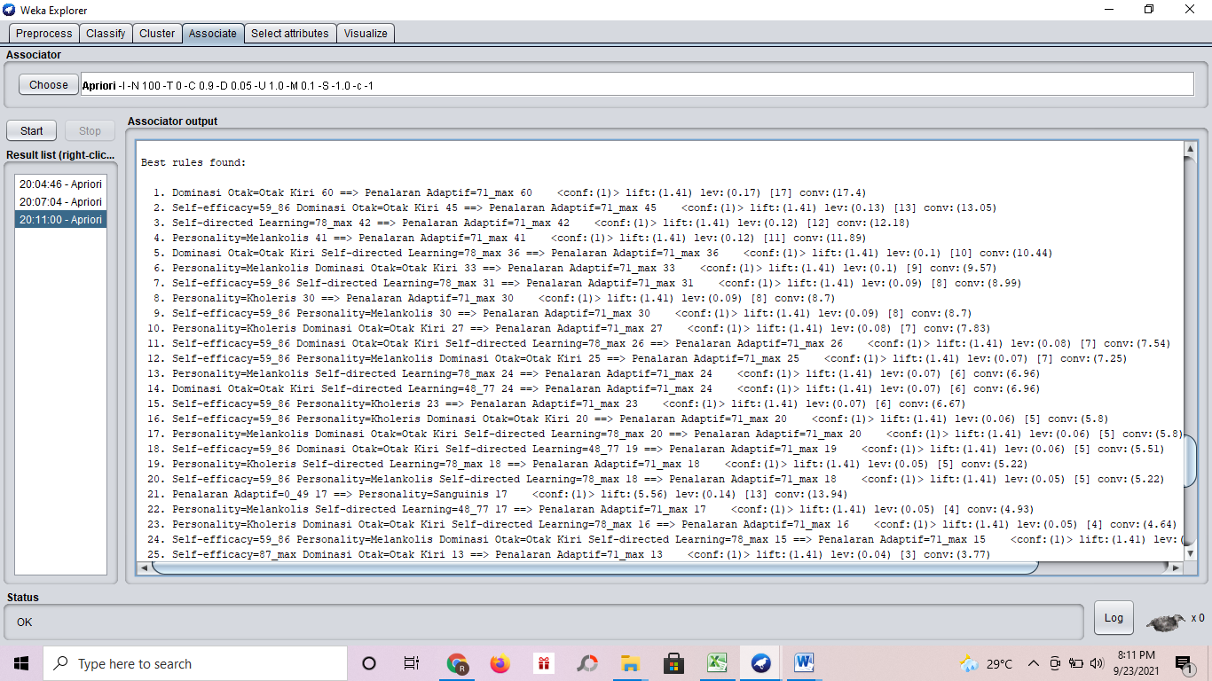

=== Run information ===

Scheme: weka.associations.Apriori -I -N 100 -T 0 -C 0.9 -D 0.05 -U 1.0 -M 0.1 -S -1.0 -c -1
Relation: DATA WEKA 3
Instances: 100
Attributes: 5
Self-efficacy
Personality
Penalaran Adaptif
Dominasi Otak
Self-directed Learning
=== Associator model (full training set) ===

Apriori
=======

Minimum support: 0.1 (10 instances)
Minimum metric <confidence>: 0.9
Number of cycles performed: 18

Generated sets of large itemsets:

Size of set of large itemsets L(1): 16

Large Itemsets L(1):
Self-efficacy=0_58 12
Self-efficacy=59_86 70
Self-efficacy=87_max 18
Personality=Sanguinis 18
Personality=Kholeris 30
Personality=Melankolis 41
Personality=Phlegmatis 11
Penalaran Adaptif=0_49 17
Penalaran Adaptif=71_max 71
Penalaran Adaptif=50_70 12
Dominasi Otak=Otak Kanan 24
Dominasi Otak=Otak Kiri 60
Dominasi Otak=Seimbang 16
Self-directed Learning=0_47 17
Self-directed Learning=78_max 42
Self-directed Learning=48_77 41

Size of set of large itemsets L(2): 37

Large Itemsets L(2):
Self-efficacy=59_86 Personality=Sanguinis 10
Self-efficacy=59_86 Personality=Kholeris 23
Self-efficacy=59_86 Personality=Melankolis 30
Self-efficacy=59_86 Penalaran Adaptif=71_max 53
Self-efficacy=59_86 Dominasi Otak=Otak Kanan 14
Self-efficacy=59_86 Dominasi Otak=Otak Kiri 45
Self-efficacy=59_86 Dominasi Otak=Seimbang 11
Self-efficacy=59_86 Self-directed Learning=0_47 10
Self-efficacy=59_86 Self-directed Learning=78_max 31
Self-efficacy=59_86 Self-directed Learning=48_77 29
Self-efficacy=87_max Penalaran Adaptif=71_max 15
Self-efficacy=87_max Dominasi Otak=Otak Kiri 13
Self-efficacy=87_max Self-directed Learning=78_max 10
Personality=Sanguinis Penalaran Adaptif=0_49 17
Personality=Sanguinis Dominasi Otak=Otak Kanan 14
Personality=Sanguinis Self-directed Learning=0_47 13
Personality=Kholeris Penalaran Adaptif=71_max 30
Personality=Kholeris Dominasi Otak=Otak Kiri 27
Personality=Kholeris Self-directed Learning=78_max 18
Personality=Kholeris Self-directed Learning=48_77 12
Personality=Melankolis Penalaran Adaptif=71_max 41
Personality=Melankolis Dominasi Otak=Otak Kiri 33
Personality=Melankolis Self-directed Learning=78_max 24
Personality=Melankolis Self-directed Learning=48_77 17
Personality=Phlegmatis Penalaran Adaptif=50_70 11
Personality=Phlegmatis Dominasi Otak=Otak Kanan 10
Penalaran Adaptif=0_49 Dominasi Otak=Otak Kanan 13
Penalaran Adaptif=0_49 Self-directed Learning=0_47 12
Penalaran Adaptif=71_max Dominasi Otak=Otak Kiri 60
Penalaran Adaptif=71_max Dominasi Otak=Seimbang 11
Penalaran Adaptif=71_max Self-directed Learning=78_max 42
Penalaran Adaptif=71_max Self-directed Learning=48_77 29
Penalaran Adaptif=50_70 Dominasi Otak=Otak Kanan 11
Dominasi Otak=Otak Kanan Self-directed Learning=0_47 14
Dominasi Otak=Otak Kanan Self-directed Learning=48_77 10
Dominasi Otak=Otak Kiri Self-directed Learning=78_max 36
Dominasi Otak=Otak Kiri Self-directed Learning=48_77 24

Size of set of large itemsets L(3): 31

Large Itemsets L(3):
Self-efficacy=59_86 Personality=Kholeris Penalaran Adaptif=71_max 23
Self-efficacy=59_86 Personality=Kholeris Dominasi Otak=Otak Kiri 20
Self-efficacy=59_86 Personality=Kholeris Self-directed Learning=78_max 13
Self-efficacy=59_86 Personality=Kholeris Self-directed Learning=48_77 10
Self-efficacy=59_86 Personality=Melankolis Penalaran Adaptif=71_max 30
Self-efficacy=59_86 Personality=Melankolis Dominasi Otak=Otak Kiri 25
Self-efficacy=59_86 Personality=Melankolis Self-directed Learning=78_max 18
Self-efficacy=59_86 Personality=Melankolis Self-directed Learning=48_77 12
Self-efficacy=59_86 Penalaran Adaptif=71_max Dominasi Otak=Otak Kiri 45
Self-efficacy=59_86 Penalaran Adaptif=71_max Self-directed Learning=78_max 31
Self-efficacy=59_86 Penalaran Adaptif=71_max Self-directed Learning=48_77 22
Self-efficacy=59_86 Dominasi Otak=Otak Kiri Self-directed Learning=78_max 26
Self-efficacy=59_86 Dominasi Otak=Otak Kiri Self-directed Learning=48_77 19
Self-efficacy=87_max Penalaran Adaptif=71_max Dominasi Otak=Otak Kiri 13
Self-efficacy=87_max Penalaran Adaptif=71_max Self-directed Learning=78_max 10
Personality=Sanguinis Penalaran Adaptif=0_49 Dominasi Otak=Otak Kanan 13
Personality=Sanguinis Penalaran Adaptif=0_49 Self-directed Learning=0_47 12
Personality=Sanguinis Dominasi Otak=Otak Kanan Self-directed Learning=0_47 10
Personality=Kholeris Penalaran Adaptif=71_max Dominasi Otak=Otak Kiri 27
Personality=Kholeris Penalaran Adaptif=71_max Self-directed Learning=78_max 18
Personality=Kholeris Penalaran Adaptif=71_max Self-directed Learning=48_77 12
Personality=Kholeris Dominasi Otak=Otak Kiri Self-directed Learning=78_max 16
Personality=Kholeris Dominasi Otak=Otak Kiri Self-directed Learning=48_77 11
Personality=Melankolis Penalaran Adaptif=71_max Dominasi Otak=Otak Kiri 33
Personality=Melankolis Penalaran Adaptif=71_max Self-directed Learning=78_max 24
Personality=Melankolis Penalaran Adaptif=71_max Self-directed Learning=48_77 17
Personality=Melankolis Dominasi Otak=Otak Kiri Self-directed Learning=78_max 20
Personality=Melankolis Dominasi Otak=Otak Kiri Self-directed Learning=48_77 13
Personality=Phlegmatis Penalaran Adaptif=50_70 Dominasi Otak=Otak Kanan 10
Penalaran Adaptif=71_max Dominasi Otak=Otak Kiri Self-directed Learning=78_max 36
Penalaran Adaptif=71_max Dominasi Otak=Otak Kiri Self-directed Learning=48_77 24

Size of set of large itemsets L(4): 15

Large Itemsets L(4):
Self-efficacy=59_86 Personality=Kholeris Penalaran Adaptif=71_max Dominasi Otak=Otak Kiri 20
Self-efficacy=59_86 Personality=Kholeris Penalaran Adaptif=71_max Self-directed Learning=78_max 13
Self-efficacy=59_86 Personality=Kholeris Penalaran Adaptif=71_max Self-directed Learning=48_77 10
Self-efficacy=59_86 Personality=Kholeris Dominasi Otak=Otak Kiri Self-directed Learning=78_max 11
Self-efficacy=59_86 Personality=Melankolis Penalaran Adaptif=71_max Dominasi Otak=Otak Kiri 25
Self-efficacy=59_86 Personality=Melankolis Penalaran Adaptif=71_max Self-directed Learning=78_max 18
Self-efficacy=59_86 Personality=Melankolis Penalaran Adaptif=71_max Self-directed Learning=48_77 12
Self-efficacy=59_86 Personality=Melankolis Dominasi Otak=Otak Kiri Self-directed Learning=78_max 15
Self-efficacy=59_86 Personality=Melankolis Dominasi Otak=Otak Kiri Self-directed Learning=48_77 10
Self-efficacy=59_86 Penalaran Adaptif=71_max Dominasi Otak=Otak Kiri Self-directed Learning=78_max 26
Self-efficacy=59_86 Penalaran Adaptif=71_max Dominasi Otak=Otak Kiri Self-directed Learning=48_77 19
Personality=Kholeris Penalaran Adaptif=71_max Dominasi Otak=Otak Kiri Self-directed Learning=78_max 16
Personality=Kholeris Penalaran Adaptif=71_max Dominasi Otak=Otak Kiri Self-directed Learning=48_77 11
Personality=Melankolis Penalaran Adaptif=71_max Dominasi Otak=Otak Kiri Self-directed Learning=78_max 20
Personality=Melankolis Penalaran Adaptif=71_max Dominasi Otak=Otak Kiri Self-directed Learning=48_77 13

Size of set of large itemsets L(5): 3

Large Itemsets L(5):
Self-efficacy=59_86 Personality=Kholeris Penalaran Adaptif=71_max Dominasi Otak=Otak Kiri Self-directed Learning=78_max 11
Self-efficacy=59_86 Personality=Melankolis Penalaran Adaptif=71_max Dominasi Otak=Otak Kiri Self-directed Learning=78_max 15
Self-efficacy=59_86 Personality=Melankolis Penalaran Adaptif=71_max Dominasi Otak=Otak Kiri Self-directed Learning=48_77 10

Best rules found:

1. Dominasi Otak=Otak Kiri 60 ==> Penalaran Adaptif=71_max 60 <conf:(1)> lift:(1.41) lev:(0.17) [17] conv:(17.4)
2. Self-efficacy=59_86 Dominasi Otak=Otak Kiri 45 ==> Penalaran Adaptif=71_max 45 <conf:(1)> lift:(1.41) lev:(0.13) [13] conv:(13.05)
3. Self-directed Learning=78_max 42 ==> Penalaran Adaptif=71_max 42 <conf:(1)> lift:(1.41) lev:(0.12) [12] conv:(12.18)
4. Personality=Melankolis 41 ==> Penalaran Adaptif=71_max 41 <conf:(1)> lift:(1.41) lev:(0.12) [11] conv:(11.89)
5. Dominasi Otak=Otak Kiri Self-directed Learning=78_max 36 ==> Penalaran Adaptif=71_max 36 <conf:(1)> lift:(1.41) lev:(0.1) [10] conv:(10.44)
6. Personality=Melankolis Dominasi Otak=Otak Kiri 33 ==> Penalaran Adaptif=71_max 33 <conf:(1)> lift:(1.41) lev:(0.1) [9] conv:(9.57)
7. Self-efficacy=59_86 Self-directed Learning=78_max 31 ==> Penalaran Adaptif=71_max 31 <conf:(1)> lift:(1.41) lev:(0.09) [8] conv:(8.99)
8. Personality=Kholeris 30 ==> Penalaran Adaptif=71_max 30 <conf:(1)> lift:(1.41) lev:(0.09) [8] conv:(8.7)
9. Self-efficacy=59_86 Personality=Melankolis 30 ==> Penalaran Adaptif=71_max 30 <conf:(1)> lift:(1.41) lev:(0.09) [8] conv:(8.7)
10. Personality=Kholeris Dominasi Otak=Otak Kiri 27 ==> Penalaran Adaptif=71_max 27 <conf:(1)> lift:(1.41) lev:(0.08) [7] conv:(7.83)
11. Self-efficacy=59_86 Dominasi Otak=Otak Kiri Self-directed Learning=78_max 26 ==> Penalaran Adaptif=71_max 26 <conf:(1)> lift:(1.41) lev:(0.08) [7] conv:(7.54)
12. Self-efficacy=59_86 Personality=Melankolis Dominasi Otak=Otak Kiri 25 ==> Penalaran Adaptif=71_max 25 <conf:(1)> lift:(1.41) lev:(0.07) [7] conv:(7.25)
13. Personality=Melankolis Self-directed Learning=78_max 24 ==> Penalaran Adaptif=71_max 24 <conf:(1)> lift:(1.41) lev:(0.07) [6] conv:(6.96)
14. Dominasi Otak=Otak Kiri Self-directed Learning=48_77 24 ==> Penalaran Adaptif=71_max 24 <conf:(1)> lift:(1.41) lev:(0.07) [6] conv:(6.96)
15. Self-efficacy=59_86 Personality=Kholeris 23 ==> Penalaran Adaptif=71_max 23 <conf:(1)> lift:(1.41) lev:(0.07) [6] conv:(6.67)
16. Self-efficacy=59_86 Personality=Kholeris Dominasi Otak=Otak Kiri 20 ==> Penalaran Adaptif=71_max 20 <conf:(1)> lift:(1.41) lev:(0.06) [5] conv:(5.8)
17. Personality=Melankolis Dominasi Otak=Otak Kiri Self-directed Learning=78_max 20 ==> Penalaran Adaptif=71_max 20 <conf:(1)> lift:(1.41) lev:(0.06) [5] conv:(5.8)
18. Self-efficacy=59_86 Dominasi Otak=Otak Kiri Self-directed Learning=48_77 19 ==> Penalaran Adaptif=71_max 19 <conf:(1)> lift:(1.41) lev:(0.06) [5] conv:(5.51)
19. Personality=Kholeris Self-directed Learning=78_max 18 ==> Penalaran Adaptif=71_max 18 <conf:(1)> lift:(1.41) lev:(0.05) [5] conv:(5.22)
20. Self-efficacy=59_86 Personality=Melankolis Self-directed Learning=78_max 18 ==> Penalaran Adaptif=71_max 18 <conf:(1)> lift:(1.41) lev:(0.05) [5] conv:(5.22)
21. Penalaran Adaptif=0_49 17 ==> Personality=Sanguinis 17 <conf:(1)> lift:(5.56) lev:(0.14) [13] conv:(13.94)
22. Personality=Melankolis Self-directed Learning=48_77 17 ==> Penalaran Adaptif=71_max 17 <conf:(1)> lift:(1.41) lev:(0.05) [4] conv:(4.93)
23. Personality=Kholeris Dominasi Otak=Otak Kiri Self-directed Learning=78_max 16 ==> Penalaran Adaptif=71_max 16 <conf:(1)> lift:(1.41) lev:(0.05) [4] conv:(4.64)
24. Self-efficacy=59_86 Personality=Melankolis Dominasi Otak=Otak Kiri Self-directed Learning=78_max 15 ==> Penalaran Adaptif=71_max 15 <conf:(1)> lift:(1.41) lev:(0.04) [4] conv:(4.35)
25. Self-efficacy=87_max Dominasi Otak=Otak Kiri 13 ==> Penalaran Adaptif=71_max 13 <conf:(1)> lift:(1.41) lev:(0.04) [3] conv:(3.77)
26. Penalaran Adaptif=0_49 Dominasi Otak=Otak Kanan 13 ==> Personality=Sanguinis 13 <conf:(1)> lift:(5.56) lev:(0.11) [10] conv:(10.66)
27. Self-efficacy=59_86 Personality=Kholeris Self-directed Learning=78_max 13 ==> Penalaran Adaptif=71_max 13 <conf:(1)> lift:(1.41) lev:(0.04) [3] conv:(3.77)
28. Personality=Melankolis Dominasi Otak=Otak Kiri Self-directed Learning=48_77 13 ==> Penalaran Adaptif=71_max 13 <conf:(1)> lift:(1.41) lev:(0.04) [3] conv:(3.77)
29. Penalaran Adaptif=0_49 Self-directed Learning=0_47 12 ==> Personality=Sanguinis 12 <conf:(1)> lift:(5.56) lev:(0.1) [9] conv:(9.84)
30. Personality=Kholeris Self-directed Learning=48_77 12 ==> Penalaran Adaptif=71_max 12 <conf:(1)> lift:(1.41) lev:(0.03) [3] conv:(3.48)
31. Self-efficacy=59_86 Personality=Melankolis Self-directed Learning=48_77 12 ==> Penalaran Adaptif=71_max 12 <conf:(1)> lift:(1.41) lev:(0.03) [3] conv:(3.48)
32. Personality=Phlegmatis 11 ==> Penalaran Adaptif=50_70 11 <conf:(1)> lift:(8.33) lev:(0.1) [9] conv:(9.68)
33. Personality=Kholeris Dominasi Otak=Otak Kiri Self-directed Learning=48_77 11 ==> Penalaran Adaptif=71_max 11 <conf:(1)> lift:(1.41) lev:(0.03) [3] conv:(3.19)
34. Self-efficacy=59_86 Personality=Kholeris Dominasi Otak=Otak Kiri Self-directed Learning=78_max 11 ==> Penalaran Adaptif=71_max 11 <conf:(1)> lift:(1.41) lev:(0.03) [3] conv:(3.19)
35. Self-efficacy=87_max Self-directed Learning=78_max 10 ==> Penalaran Adaptif=71_max 10 <conf:(1)> lift:(1.41) lev:(0.03) [2] conv:(2.9)
36. Personality=Phlegmatis Dominasi Otak=Otak Kanan 10 ==> Penalaran Adaptif=50_70 10 <conf:(1)> lift:(8.33) lev:(0.09) [8] conv:(8.8)
37. Self-efficacy=59_86 Personality=Kholeris Self-directed Learning=48_77 10 ==> Penalaran Adaptif=71_max 10 <conf:(1)> lift:(1.41) lev:(0.03) [2] conv:(2.9)
38. Self-efficacy=59_86 Personality=Melankolis Dominasi Otak=Otak Kiri Self-directed Learning=48_77 10 ==> Penalaran Adaptif=71_max 10 <conf:(1)> lift:(1.41) lev:(0.03) [2] conv:(2.9)
39. Personality=Sanguinis 18 ==> Penalaran Adaptif=0_49 17 <conf:(0.94)> lift:(5.56) lev:(0.14) [13] conv:(7.47)
40. Personality=Sanguinis Dominasi Otak=Otak Kanan 14 ==> Penalaran Adaptif=0_49 13 <conf:(0.93)> lift:(5.46) lev:(0.11) [10] conv:(5.81)
41. Personality=Sanguinis Self-directed Learning=0_47 13 ==> Penalaran Adaptif=0_49 12 <conf:(0.92)> lift:(5.43) lev:(0.1) [9] conv:(5.39)
42. Penalaran Adaptif=50_70 12 ==> Personality=Phlegmatis 11 <conf:(0.92)> lift:(8.33) lev:(0.1) [9] conv:(5.34)
43. Penalaran Adaptif=50_70 12 ==> Dominasi Otak=Otak Kanan 11 <conf:(0.92)> lift:(3.82) lev:(0.08) [8] conv:(4.56)
44. Personality=Kholeris Self-directed Learning=48_77 12 ==> Dominasi Otak=Otak Kiri 11 <conf:(0.92)> lift:(1.53) lev:(0.04) [3] conv:(2.4)
45. Personality=Kholeris Penalaran Adaptif=71_max Self-directed Learning=48_77 12 ==> Dominasi Otak=Otak Kiri 11 <conf:(0.92)> lift:(1.53) lev:(0.04) [3] conv:(2.4)
46. Personality=Kholeris Self-directed Learning=48_77 12 ==> Penalaran Adaptif=71_max Dominasi Otak=Otak Kiri 11 <conf:(0.92)> lift:(1.53) lev:(0.04) [3] conv:(2.4)
47. Personality=Phlegmatis 11 ==> Dominasi Otak=Otak Kanan 10 <conf:(0.91)> lift:(3.79) lev:(0.07) [7] conv:(4.18)
48. Penalaran Adaptif=50_70 Dominasi Otak=Otak Kanan 11 ==> Personality=Phlegmatis 10 <conf:(0.91)> lift:(8.26) lev:(0.09) [8] conv:(4.89)
49. Personality=Phlegmatis Penalaran Adaptif=50_70 11 ==> Dominasi Otak=Otak Kanan 10 <conf:(0.91)> lift:(3.79) lev:(0.07) [7] conv:(4.18)
50. Personality=Phlegmatis 11 ==> Penalaran Adaptif=50_70 Dominasi Otak=Otak Kanan 10 <conf:(0.91)> lift:(8.26) lev:(0.09) [8] conv:(4.89)
51. Personality=Kholeris 30 ==> Dominasi Otak=Otak Kiri 27 <conf:(0.9)> lift:(1.5) lev:(0.09) [9] conv:(3)
52. Personality=Kholeris Penalaran Adaptif=71_max 30 ==> Dominasi Otak=Otak Kiri 27 <conf:(0.9)> lift:(1.5) lev:(0.09) [9] conv:(3)
53. Personality=Kholeris 30 ==> Penalaran Adaptif=71_max Dominasi Otak=Otak Kiri 27 <conf:(0.9)> lift:(1.5) lev:(0.09) [9] conv:(3)

