THE IMPLEMENTATION OF BLENDED LEARNING-BASED MODEL
E-LEARNING MOODLE

¹Dona Fitriawan, ²Wardah
¹ Mathematics Education FKIP, University of Tanjungpura Pontianak
²English Education FUAD, IAIN Pontianak
¹Jalan Prof. Dr. Hadari Nawawi, 78124 Pontianak, Indonesia
²Jalan Letjend Suprapto 78122 Pontianak Indonesia
E-mail: | donafitriawan@fkip.untan.ac.id ¹⁾, wardah@iainptk.ac.id ²⁾

Received dd Month yy; Received in revised form dd Month yy; Accepted dd Month yy (9pt)

Abstract
The objectives of this study are: 1) Implementing blended learning model based on e-learning Moodle into learning; 2) whether the blended learning model based on Moodle e-learning can improve learning achievement. The type of research in this research is descriptive-explorative qualitative, which explores all the things that are in the processing of questions and answers to students' steps and explores the results of the interview survey with students. The subjects in this study were 21 class B students. The research instruments were tests, surveys, questionnaires, and interviews. The results of research and discussion show the implementation of the lecture process, face to face with zoom metting, presence in applications, assignments, and testing. From the results of the research and discussion, it is concluded that: 1) the blended learning model based on e-learning Moodle has been successfully implemented into linear learning program courses, 2) From the results of tests, questionnaires, surveys and interviews with e-based blended learning model students -learning moodle has increased their achievement and enthusiasm for learning

Keywords: blended learning, e-learning moodle, implementation.

This is an open access article under the Creative Commons Attribution 4.0 International License

INTRODUCTION
The essence of learning is a process of communication in the form of oral communication between students and educators as well as between fellow students in the context of changing attitudes and behavior. (Jihad & Haris, 2013); (Sari, 2019). Through the learning process, they together become actors in the implementation of effective learning objectives, namely learning that makes it easier for students to learn something useful such as facts, skills, values, concepts, and how to live in harmony with others, or a desired learning outcome.
The blended learning model combines two types of learning, namely e-learning or online learning with face-to-face learning. With online learning which utilizes the internet network which consists of website-based learning. This blended learning is a combination of multimedia-based technology development, CD ROM, streaming video, email, voice mail and others by combining face-to-face learning in class. Face-to-face learning gives students the opportunity to ask questions or problems related to the material taught by the teacher. This online learning or also called distance learning, where teachers / lecturers and students / students can do learning outside of school / campus even though educators and students are not in one room or not face to face. Lecturers give tutorials or teachers give assignments to students which sources of subject matter can be accessed on the internet. (Musa dalam (Abdullah, 2018); (Idris, 2018)).
The blended learning model combines or combines face-to-face learning with the help of Information and Communication Technology (ICT) with advantages, namely: 1) students interact directly with the content of learning, 2) can interact with friends, 3) discuss groups and exchanging opinions, 4) accessing e-libraries, virtual classes, 5) online assessments, 6) e-tuitions, 7) accessing and maintaining learning blogs, 8) online seminars (webinars), 9) seeing expert lecturers on YouTube, 10) online learning via video and audio, 11) virtural laboratory. (Manggabarani et al., 2016); (Wardani et al., 2018); (Rachman et al., 2019).
The composition of blended learning that is often used is the 50/50 pattern, in the time allocation available 50% face-to-face 50% online learning, some also use the 75/25 pattern, meaning 75% face-to-face meetings 25% online learning, and there are also those who apply 25/75, 25% use face-to-face learning 75% use online learning. In using this pattern, it depends on the competency analysis required, subject objectives, learner characteristics, learner characteristics and abilities and available resources. However, the main consideration in designing the composition of learning is the provision of suitable learning resources for various characteristics of learners so that learning becomes attractive, effective and efficient. In this study, a composition of 25% face to face and 75% online was used. (Amin, 2017); (Hidayat et al., 2020).
In line with the blended learning model, universities develop e-learning moodle as the medium. By using an Internet connection, the benefits of e-learning with Moodle as a learning medium can be used as a trigger to attract students' interest in the learning process. The Moodle application is functionally known as the Course Management System or Learning Management System (LMS). Moodle is short for Modular Object Oriented Dynamic Learning Environment (Azis, 2015); (Muhammad, 2017).
The elements contained in the e-learning system include questions, community, online instructors, opportunities to work together, and multimedia. The characteristics of e-learning in the learning process are utilizing electronic technology services, taking advantage of computer advantages, using independent teaching materials stored on computers, utilizing learning schedules, curricula, results of learning progress and matters related to educational administration can be seen at any time on computers, and materials designed and prepared by professional materials builders. (Raharja et al., 2011); (Irawan & Surjono, 2018).
Moodle LMS is a software that functions to provide facilities and an Internet-based learning environment. With a web interface, Moodle has features that are complete enough to present courses where teachers can upload learning materials. In this case, the application made uses the cloud computing model. Cloud computing is a model that allows ubiquitous computing to be done on-demand by accessing the network to compute resources, such as storage. Students can log in to the Moodle system, then choose the course provided or do enrollment. With this application also the activities of students in Moodle can be continuously monitored. (Rizal & Walidain, 2019); (Azis, 2015).
In connection with the need for innovation, it is necessary to develop an alternative learning, namely Moodle e-learning with the objectives of the research are: 1) implementing Moodle e-learning based blended learning model into learning; 2) whether the blended learning model based on Moodle e-learning can improve learning achievement; 3) the magnitude of the increase in learning achievement with the blended learning model based on e-learning moodle.

RESEARCH METHODS
The type of research in this research is descriptive-explorative qualitative, which explores all the things that are in the processing of the questions and the steps for the answers of students and explores the results of the interview survey with students.
The subjects in this study were 21 class B students. The research instruments were tests, surveys, questionnaires, and interviews.

RESULTS AND DISCUSSION
Result
The results obtained:
Table 1. Student Exam Results
No | Name | Score
1 | Af | 80,50
2 | Ag | 75,38
3 | Ai | 71,50
4 | Am | 75,00
5 | An | 75,00
6 | As | 75,50
7 | Az | 80,88
8 | Ca | 72,00
9 | Jf | 75,50
10 | Ks | 73,50
11 | Kt | 73,50
12 | Md | 74,75
13 | N | 75,00
14 | Na | 80,88
15 | Ni | 75,50
16 | Nu | 75,00
17 | Rp | 74,38
18 | Vi | 80,50
19 | Vn | 75,50
20 | Wh | 82,88
21 | Wi | 73,50
Sumber: siakad.untan.ac.id
From the table above then processed with SPSS 24 the results are:
Table 2. Statistical Test Results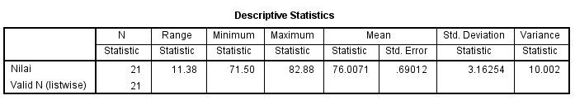
From the results of the statistical test, it is described that the mean is 76.00 with a standard deviation of 3.16 which is in accordance with the assessment target.
Discussion
Moodle is one type of LMS that is most often used in the learning process because many are considered capable of supporting the achievement of learning success. The advantages that can be obtained by using Moodle e-Learning include time and cost efficiency, ease of access and features, flexibility of study schedules, increasing independence of students in learning, increasing student motivation, ease of providing assessments, accommodating many media. This convenience and advantage is in line with the advantages of using LMS in learning. (Palandi et al., 2017); (Hakim, 2013).
Therefore, many campuses try to apply e-learning in the learning process. One of them is the Tanjungpura University Campus which is the location of research by taking linear program courses as the material to be studied using the Moodle e-learning.

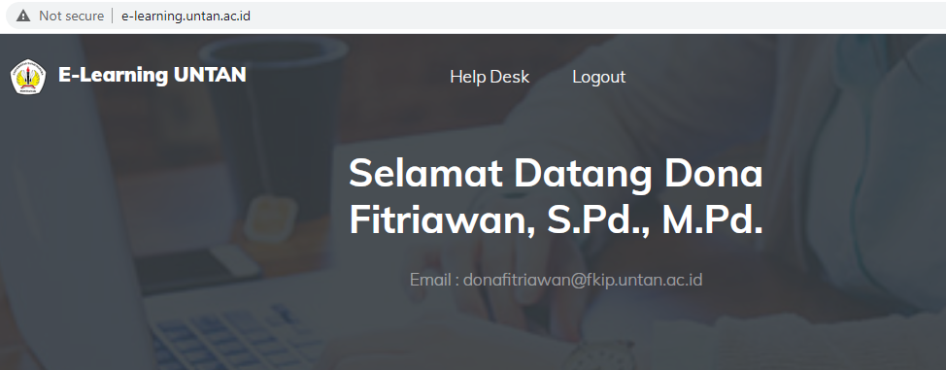
Figure 1. e-learning moodle

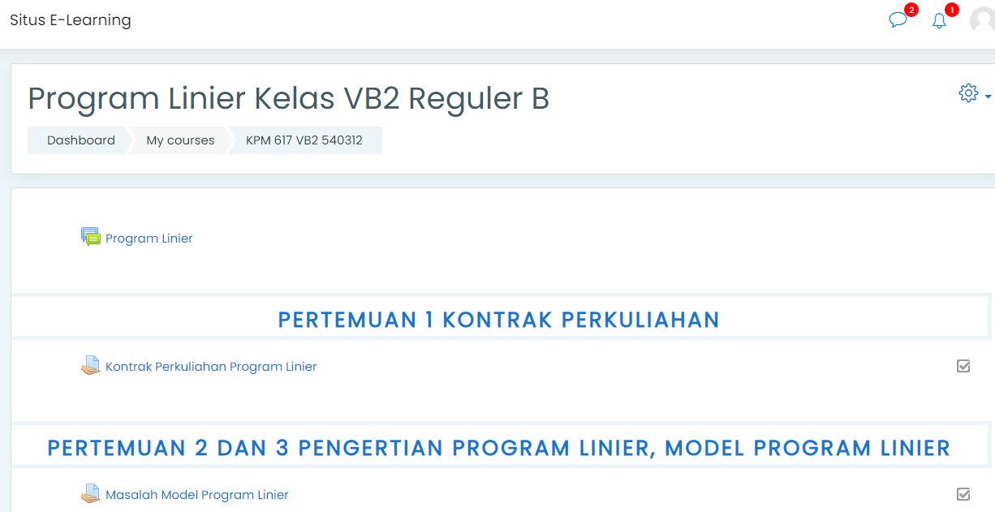
Figure 2. Blended learning based on e learning moodle in the Lecture Process

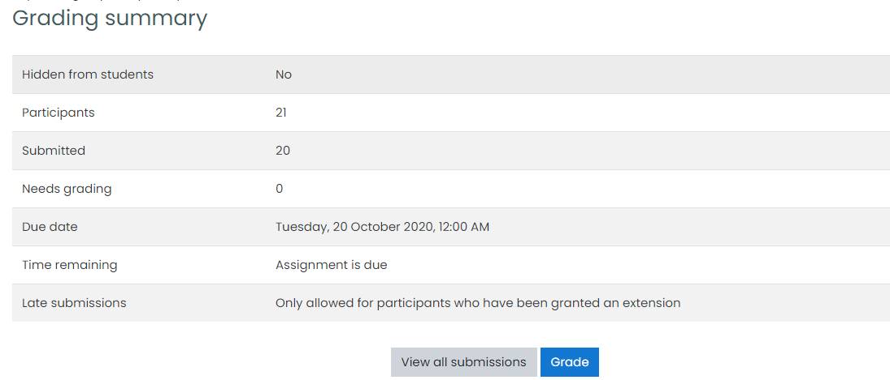
Figure 3.The Process of Assigning Tasks in Moodle e-learning
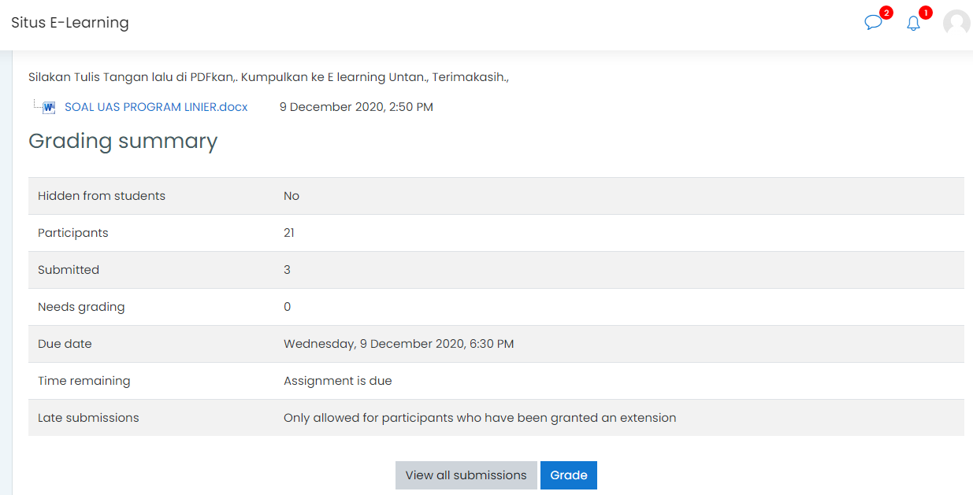 Figure 4. Process and assessment of 21 Students' exam using Moodle E-Learning

Discussion of the implementation results with the application of e-learning that has been carried out, obtained data from the results of a questionnaire about student attitudes towards linear program courses used blended learning model based on e-learning moodle obtained questionnaire data about student attitudes with satisfactory criteria. While student activities were obtained through surveys and response data to the learning process obtained through questionnaires to determine the practicality of the media. The research data on the response of students' attitudes to the blended learning model based on e-learning moodle showed that the average student response rate was 76.00%.
The research data on student activity in using the blended learning model based on e-learning Moodle shows that the activity most accessed by students is downloading teaching materials, namely 15 students, uploading assignments of 21 students and taking quizzes of 20 students and filled out a questionnaire of 20 students. This means that from a maximum of 21 students, almost all of them have been actively involved in learning.
All lecture activities use e-learning moodle, namely face-to-face using the zoom meeting in e-learning, presence in the application, the lecture process uses the application, collection of assignments in the application, even MID and UAS have been formatted in the application.

CONCLUSIONS AND SUGGESTIONS
Conclusions
From the results of the research and discussion, it is concluded that: 1) the blended learning model based on e-learning Moodle has been successfully implemented into linear learning program courses, 2) From the results of tests, questionnaires, surveys and interviews with e-based blended learning model students -learning moodle has increased their achievement and enthusiasm for learning.
Suggestions
The suggestion in this research is that lecturers and students and institutions support each other in increasing understanding of ICT continuously towards the Industrial Revolution Era 4.0.

REFERENCES
Abdullah, W. (2018). Model Blended Learning dalam Meningkatkan Efektifitas Pembelajaran. Fikrotuna, 7(1), 855–866. https://doi.org/10.32806/jf.v7i1.3169
Amin, A. K. (2017). Kajian Konseptual Model Pembelajaran Blended Learning berbasis Web untuk Meningkatkan Hasil Belajar dan Motivasi Belajar. Jurnal Pendidikan Edutama, 4(2), 51–64.
Azis, A. A. (2015). Pengembangan Media E-Learning Berbasis LMS Moodle pada Matakuliah Anatomi Fisiologi Manusia. Jurnal Pendidikan Biologi, 7(1), 1–8. http://journal2.um.ac.id/index.php/jpb/article/view/712
Hakim, A. R. (2013). Pengembangan E-Learning Berbasis Moodle sebagai Media Pengelolaan Pembelajaran. Persepsi Masyarakat Terhadap Perawatan Ortodontik Yang Dilakukan Oleh Pihak Non Profesional, 53(9), 1689–1699.
Hidayat, M. T., Junaidi, T., & Yakob, M. (2020). Pengembangan Model Pembelajaran Blended Learning dalam Meningkatkan Pemahaman Siswa Terhadap Tradisi Lisan Aceh. 25(3), 401–410.
Idris, H. (2018). Pembelajaran Model Blended Learning. Jurnal Ilmiah Iqra’, 5(1), 61–73. https://doi.org/10.30984/jii.v5i1.562
Irawan, R., & Surjono, herman dwi. (2018). Pengembangan E-Learning Berbasis Moodle dalam Peningkatan Pemahaman Lagu pada Pembelajaran Bahasa Inggris. 5(1), 1–11.
Jihad, A., & Haris, A. (2013). Evaluasi Pembelajaran. Yogyakarta: Multi Pressindo.
Manggabarani, A. F., Sugiarti, & Masri, M. (2016). Pengaruh Model Pembelajaran Blended Learning Terhadap Motivasi dan Hasil Belajar Siswa Kelas X SMA Negeri 1 Pitumpanua Kab.Wajo (Studi Pada Materi Pokok Sistem Periodik Unsur). Jurnal Chemica, 17(2), 83–93.
Muhammad, T. (2017). Perancangan Learning Management System Menggunakan Konsep Computer Supported Collaborative Learning Abstraksi This time many Universities have implemented e-learning to support learning activities . However AMIK Hass Bandung The Campus where Researchers c. Jurnal Produktif, 1, 35–63.
Palandi, J. F., Aminah, S., & Pudyastuti, Z. E. (2017). Pengembangan Aplikasi Web E-Learning Untuk Pendidikan Anti Korupsi Menggunakan Moodle. INOVTEK Polbeng - Seri Informatika, 2(2), 173. https://doi.org/10.35314/isi.v2i2.204
Rachman, A., Sukrawan, Y., & Rohendi, D. (2019). Penerapan Model Blended Learning Dalam Peningkatan Hasil Belajar Menggambar Objek 2 dDmensi. Journal of Mechanical Engineering Education, 6(2), 145–152.
Raharja, S., Prasojo, L. D., & Nugroho, A. A. (2011). Model Pembelajaran Berbasis Learning Manajement System. 41, 55–70.
Rizal, S., & Walidain, B. (2019). Pembuatan Media Pembelajaran E-Learning Berbasis Moodle Pada Matakuliah Pengantar Aplikasi Komputer Universitas Serambi Mekkah. JURNAL ILMIAH DIDAKTIKA: Media Ilmiah Pendidikan Dan Pengajaran, 19(2), 178. https://doi.org/10.22373/jid.v19i2.5032
Sari, M. (2019). Analisis Model-model Blended Learning di Lembaga Pendidikan. NATURAL SCIENCE: Jurnal Pendidikan IPA Dan Pendidikan IPA, 5(2), 835–847.
Wardani, D. N., Toenlioe, A. J. E., & Wedi, A. (2018). Daya Tarik Pembelajaran Di Era 21 Dengan Blended Learning. Jurnal Kajian Teknologi Pendidikan (JKTP), 1(1), 13–18.

