THE IMPACT OF HYBRID ELT ON EFL TEACHERS AND STUDENTS AT SECONDARY SCHOOL DURING THE COVID 19 PANDEMIC

Abstract
Pandemic Covid-19 changed various sectors including the force for the education sector to adjust and modify. This research focus to discover how EFL Teacher has adapted Hybrid Learning to become an implemented method in classes specifically, English Foreign Language (EFL) classes. This study used both quantitative and qualitative approaches to gain the teacher’s as well as students’ perspectives. As the struggles of EFL teachers and students in secondary school have been a concern before the pandemic, the discussion between secondary school teachers and students’ struggles during hybrid learning can be found in this study. This study discovers that teachers’ and students’ attitudes towards hybrid learning adjustment reflected what they need to modify during the teaching and learning process.
Keywords: EFL Teachers, Hybrid Learning, Covid 19 Pandemic, EFL Students

INTRODUCTION
Wuhan was the first-ever place where Coronavirus diseases 2019 or Covid-19 case was found. Later, on 6 March 2020, the Indonesian authorities officially announced the first case of Covid-19 in Indonesia. The transmission of the virus originated from a Japanese citizen who had been living in Malaysia to Indonesia (Tosepu et al., 2020). The Impact of the Covid-19 pandemic hit various sectors in Indonesia, indeed education is one of the sectors that is interesting to be discussed. Lately, a new era has been applied in Indonesia, schools in green zones are allowed to conduct learning and teaching sessions with strict requirements which underline the implementation of health protocols. This policy is supervised by the Ministry of education and culture.
Everyone is supposed to inevitably agree that, these days, English is the most successful language in the world (Burns, 2004). Non-English-speaking countries have extensively opened their door to permit English to be used in nearly every aspect of their lifestyles. The variety of English users improved very extensively in 2005 the estimation of the person changed into between 840 million to 1.34 billion. Interestingly, users of English as a second language outnumbered the users of English as a first language, with a comparison of 25-40% (Yusny, 2013). English has been taught in Indonesia since the era of Dutch colonialism. Though, the right moment of entry into the education sector for the locals is beyond impossible at the moment. The Dutch avoided establishing schooling in Indonesia. It is completely for themselves and a number of the essential neighborhood officials. English was first taught to Indonesians in 1914 while the junior high school had been established (Lauder, 2008).

Before the pandemic, English Language Teaching carried various challenges in its implementation. Accordingly, the success of English teaching in Indonesia cannot be separated from the students' personal (family) values, cultural backgrounds, local customs, and beliefs as well as the political direction of the current government which regulates English as a foreign language. English language teaching has faced changes in its curriculum and claimed to have brought no crucial impact on students' learning outcomes.

English as Foreign Language (EFL) is the term used to describe the status of the English Language as the aid of non-local speakers in nations where English is not the dominant or primary language (Nordquist,2020). This is not to be pressured with English as a Second Language—also referred to as English as an extra language—that's the exercise of mastering English. As the pandemic has shifted school mode, the school system has been adjusted to suit the pandemic, education funding has been reallocated and coaching and gaining knowledge of interest has been shifted to online mode. (Mirizon et al., 2020).

Hybrid learning is a teaching method in which some students attend the class physically, whilst others join the live teaching session from home. Educators (teachers) remotely teach one class at a time with students who joined from home by using video conferencing hardware and software programs (Boyarsky, 2020). The hybrid learning model encompasses asynchronous mastering elements, like online sporting events and pre-recorded video training, to aid face-to-face study room sessions. While deliberate properly, hybrid publications combine the fine components of individual and online learning while making training extra viable for lots of students. The pandemic became the main reason why schools implement hybrid learning, namely, the health protocols which encourage students to adjust to the new normal sequence before everyone comprehends the importance of implementing health protocols. EFL students surely are adjusting to the current model of hybrid learning and thus, teachers' roles and strategies should be an interesting topic to be analyzed. This study seeks answers to the impact of Hybrid implementation for English as Foreign Language teachers in secondary school. In addition, it is important to discover what language teachers' and students’ attitudes towards English as Foreign Language teachers during Hybrid Learning in secondary school are.

METHOD

Design
The primary purpose of this study is to gain data and analysis on the impacts of Hybrid EFL learning for teachers. In Addition to that, this study will seek data for students' responses to exact similar issues. Further, students' and teachers’ attitudes toward the impact will be the focus of this study. To achieve the intended goals, this study will use mixed methods. The mixed-method is the idea of combining quantitative and qualitative methods, rather than using a single method. It will yield a better understanding of the research problem. (Creswell, 2012, as cited in Şahin, Murat & Öztürk, Gökhanl, 2019).

Subject or Participant
All the data are collected and analyzed to fulfill the need of answering the research questions by applying the qualitative method as the completion of the mixed method application in this study. Minimum valid 25 numbers of students and teachers from different schools are sorted and eligible responses are examined by the completion of the survey. The survey is promoted in secondary schools in the Area of Surabaya City and Sidoarjo through social media platforms (IG Story, WhatsApp Group, WhatsApp Story, and email).

Instrument
Survey research encompasses the use of scientific sampling methods with a designed questionnaire to measure a given population's characteristics through the utilization of statistical methods (Apuke, 2017).

Data Collecting Technique
This study conducts surveys of secondary school students and teachers by using a quantitative approach. Quantitative research is likewise known as empirical research as it could be appropriately and exactly measured. The facts accumulated through the researcher may be divided into categories or put into rank, or they may be measured in phrases of devices of measurement (Ahmad & Irfan, 2019).

Data Analysis Technique
To achieve the intended goals, this study will use mixed methods to analyze collected data. This mixed method is suitable to accommodate the need to analyze the data. The mixed method is the idea of combining quantitative and qualitative methods, rather than using a single method. It will yield a better understanding of the research problem. (Creswell, 2012, as cited in Şahin, Murat & Öztürk, Gökhanl, 2019). Quantitative research is a research method that is used to generate numerical data and hard facts, by employing statistical, logical, and mathematical techniques (Apuke, 2017).

RESULT AND DISCUSSION
Results or Findings
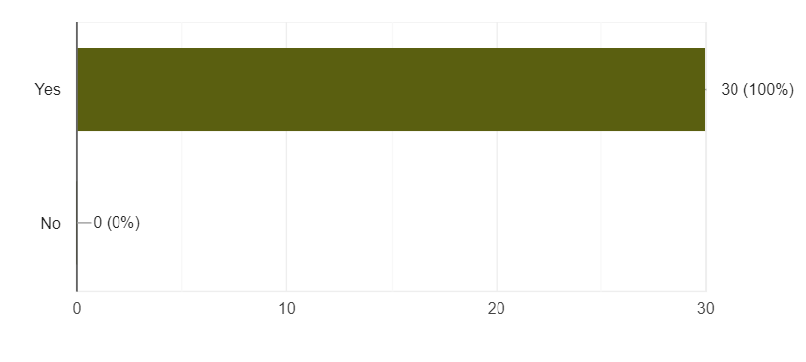
The questions have intended to clarify the real condition of hybrid EFL learning in the school where the respondent teaching at. There are 30 teachers from different schools that have responded to this survey and answered several questions. Types of questions are varied in this survey and those questions are intended to gain both qualitative and analytical responses from the respondents.

Figure 2.1

Proceeding to the duration of demanded time for teachers to adjust hybrid learning in EFL class, this study discovered that teachers' instruments are varied. Under the discussion of teachers instruments such as Subject Planner, Teaching Method, and Class Interaction, are claimed to be partially changed. It means that the impact of Hybrid learning demands a meaningful adjustment for teachers. There are complete changes in the area of the Subject Plan. The teaching method is rather interesting because it shows that the number of partial changes, as well as complete changes, are equal in number. From students' point of view, learning methods, assessment, and class interaction are mostly claimed as partially changed as well.
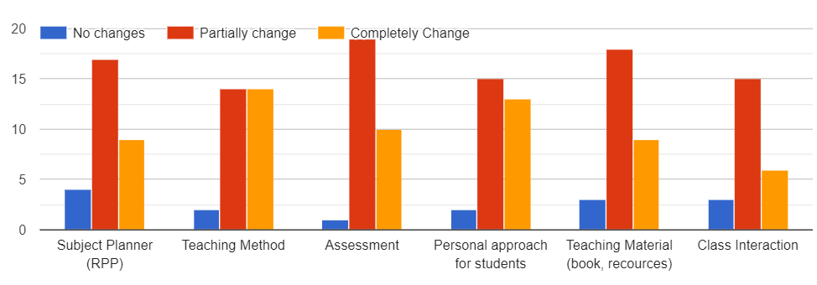Figure 2.2
School facilities are impossible to be distinguished from supporting aspects that guarantee hybrid learning in EFL classes is the foremost method to adapt during the pandemic. The questions are aimed to gain detail of teachers' and students' appraisal towards hybrid learning equipment including, laptop, internet connection, LDC, projector, speaker, motion webcam, speaker, and Wacom. Throughout the survey, respondents mostly rate internet connection as equipment that has good quality to support hybrid learning. On the other hand, Wacom has been assessed to be to the available equipment which has low quality. The moving camp has the second-lowest available equipment to support hybrid learning in EFL classes. speaker, and Wacom. Throughout the survey, respondents mostly rate internet connection as equipment that has good quality to support hybrid learning. On the other hand, Wacom has been assessed to be to the available equipment which has low quality. The moving camp has the second-lowest available equipment to support hybrid learning in EFL classes.
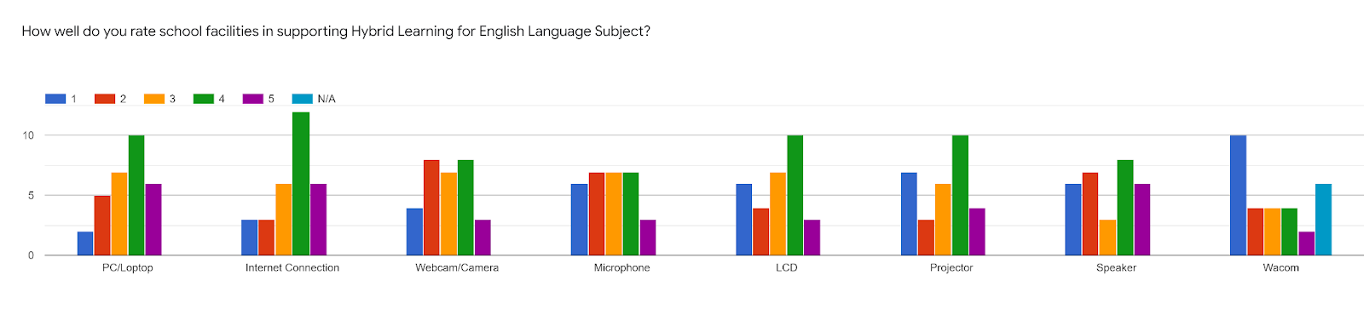 Time is one of the parameters that determine the success of adjustment and shows varied responses yet equal in divisions. There are 24.1% of the respondents have claimed that they need more than three months to adjust. Students responded to similar questions by showing that 42.9% of them claimed that they need more than three months to adjust.

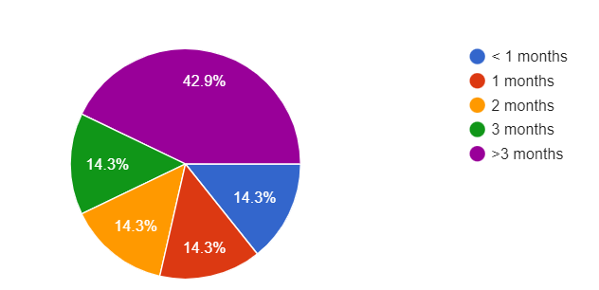
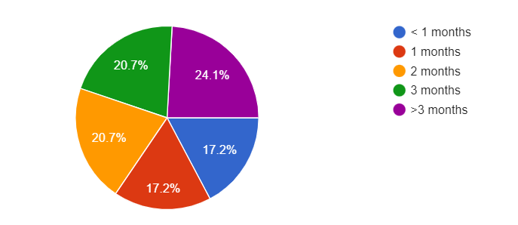

Figure 2.3 Figure 2.4

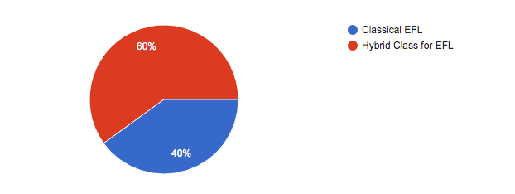
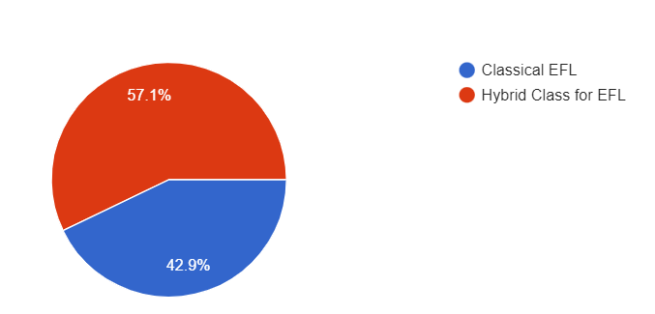
This study has further issues to be discussed and it is believed to be a significant aspect of the sudden shifting of Hybrid learning. A question related to teacher preference as they asked to choose between classical EFL or hybrid class for EFL. It turns out that 60% of respondents prefer classical EFL classes where students physically come to classes instead of allowing a hybrid scheme. Similar questions for students are given to seek their preference upon EFL class mode from their perspective. Contrary to teachers’ responses, students prefer Hybrid classes for EFL compared to Classical EFL classes as shown in the comparison below.

Figure 2.5 Figure 2.6

Discussion

The targeted response has implemented hybrid learning in EFL classes. It is in line with how the school as one of the sectors facing critical conditions needs to seek significant strategies to make sure most students' needs and rights are contented. Hybrid learning is believed to be a suitable scheme because it still provides options for students and parents to stay at home due to their uncomfortable feeling about fluctuating number of COVID-19 infections.

School facilities are indeed another challenge for teachers in implementing Hybrid Learning. As the result mentioned that some equipment needed to be prepared for a successful hybrid class that needed to be improved under the claim of their quality. That equipment may not be the main factor of successful hybrid learning, yet teachers’ attitudes rely on the facilities significantly. School facilities have always been interesting discussions for decades in the education sector. The obstacle to this sudden switch from classical classes to hybrid classes is how the school as an institution is facing a problem due to its budgeting process. Thus, the operational sector of schools might have the biggest struggle.

Looking at the teachers' perspective on time of adjustment and teaching components that mostly require at least partial adjustment is an urgent discussion. Various linking consequences mostly appear as inference, such as how teachers' resilience is indirectly assessed when the pandemic strikes worldwide are interesting. It is teachers' role to implement character building (resilience) might be looked dubious. Further, as the findings have shown that students' and teachers’ attitudes toward Hybrid Learning are dominated by partial changes, it shows that students have a significant adjustment in their timelines. The implication of completely changing the sleeping schedule might relate to students' well-being and physical health issues.

As mentioned before that there is particular contrary between teachers' and students' preferences for EFL teaching and learning. It is also possible that the cause of preferring Hybrid more than classical learning due to students' habits that is more familiar with the use of the gadget. Perversely, teachers' perspective rather chooses classical than hybrid learning.

CONCLUSION AND IMPLICATION
Conclusion
Hybrid learning implementation in EFL classes has pushed teachers to adapt to the impact. This adaptation might have been linked to unlearning or re-learn processes in understanding the whole purpose, method, and outcome of teaching and learning activity. The adaptation itself consumes various periods. Teachers' and students' responses to these rapid changes by showing certain attitudes. Modification of teaching instruments is how teachers respond to hybrid learning to make students gain proper materials in such difficult situations. Students realize that the modification somehow works and they prefer hybrid learning compared to classical EFL classes.
Limitation
This study has some limitations to the studies as the data sampling is limited to two main areas in Surabaya and Sidoarjo. Further studies can conduct a qualitative approach to gain reasoning probability to check student and teachers’ wellbeing.

REFERENCES
Ahmad, S., & Irfan, S. (2019). Hematology View Project Seroprevalence And Trends Of Viral Markers Among Blood Donors In Northern India View project. Article in Journal of Evidence-Based Medicine and Healthcare. https://doi.org/10.18410/jebmh/2019/587
Apuke, O. (2017). Quantitative Research Methods: A Synopsis Approach Some of the authors of this publication are also working on these related projects: naval power and naval history View project Powerful and Dominating Woman View project. Jebmh. https://doi.org/10.12816/0040336
Boyarsky, K. (2020, June 12). What Is Hybrid Learning? Here’s Everything You Need to Know. Resources.owllabs.com. https://resources.owllabs.com/blog/hybrid-learning
Burns, A. (2004). Teaching English from a global perspective: what are the implications in SE Asia? Researchers.mq.edu.au; Crane Publishing Company. https://researchers.mq.edu.au/en/publications/teaching-english-from-a-global-perspective-what-are-the-implicati
Nordquist, R. (2020, March 26). What is English as a foreign language? ThoughtCo.Retrieved April 21, 2022, from https://www.thoughtco.com/english-as-a-foreign-language-efl-1690597
Lauder, A. (2008). The Status and Function of English in Indonesia: A Review of Key Factors.ResearchGate.https://www.researchgate.net/publication/47407048_The_Status_and_Function_of_English_in_Indonesia_A_Review_of_Key_Factors
Mirizon, S., Bahasa, & Sastra. (2020). ELT Research in Covid-19 Pandemic Era: Policy, Problem, and Possibility. LINGUA, 21(1).
Tosepu, R., Effendy, D. S., & Ahmad, L. O. A. I. (2020). The First Confirmed Cases Of Covid-19 In Indonesian Citizens. Public Health of Indonesia, 6(2), 70–71. https://doi.org/10.36685/phi.v6i2.337
Yusny, R. (2013). Elt In Indonesian Context: Issues and Challenges. Englisia Journal, 1(1). https://doi.org/10.22373/ej.v1i1.140
Leedy, P. D., & Ormrod, J. E. (2015). Practical Research (Planning And Design (Eleventh Edition). Pearson Education Limited. https://pce-fet.com/common/library/books/51/2590_%5BPaul_D._Leedy,_Jeanne_Ellis_Ormrod%5D_Practical_Res(b-ok.org).pdf
Şahin, Murat & Öztürk, Gökhan. (2019). Mixed Method Research: Theoretical Foundations, Designs and Its Use in Educational Research. 301-310.
Busetto, L., Wick, W. & Gumbinger, C. How to use and assess qualitative research methods. Neurol. Res. Pract. 2, 14 (2020). https://doi.org/10.1186/s42466-020-00059-z

