APPENDICES

- Interview Guide
Students Interview Questions
No | Interview Questions
1. | How do you feel about the assessment methods used in your English classroom?
2. | Can you describe a memorable experience you've had with formative assessment in your classes? How did it impact to your learning?
3. | In your opinion, what makes a formative assessment effective in helping you understand and improve your English proficiency?
4. | How important is teacher’s feedback for you? Can you tell me about a time when your teacher's feedback helped you improve?
5. | Do you prefer to receive feedback on your language tasks or assignments? Do you find certain types of feedback more helpful than others?
6. | Can you share any challenges you've faced in understanding or applying feedback provided during formative assessments?
7. | How have formative assessment activities in the EFL classroom helped improve your English language skills?
8. | What do you think that teachers could do to make formative assessment more beneficial for students studying English like yourself.

Teacher Interview Questions
No | Interview Questions
1. | What formative assessment methods have you used in teaching English as a Foreign Language? Why did you use them?
2. | Can you describe your experiences with formative assessment practices in your English classroom?
3. | How does regular testing and feedback in class help your students improve their English skills?
4. | How do you believe formative assessment practices influence students' understanding and engagement with the English language?
5. | In your opinion, what are some of the key challenges or barriers to effective implementation of formative assessment in your English classroom?
6. | How do you assess the effectiveness of formative assessment practices in facilitating students' proficiency development over time?
7. | Can you describe any notable changes or improvements you have observed in students' language proficiency as a result of using formative assessment techniques?
8. | Is formative assessment practices aligned with the learning objectives and needs of your students?
9. | In what ways do you involve students in the formative assessment process? How do they respond to these opportunities for feedback and reflection?

- Transcripts
Interview Question 1
Full Transcripts of Students Interview
No | Name | Transcription
1. | Shesa (VII-D) | I think it’s very useful
2. | Zivanna (VIII-C) | It's quite fun and easy to understand the lesson.
3. | Mirza (VIII-B) | Well, I feel fine about the assessment methods used in my English classroom.
4. | Alifia Syahie (VIII-B) | It is quite difficult for me, considering I am still not very good at English, in doing so I love doing revise in kahoot and quizziz.
5. | Brianna (VIII-B) | I find it very entertaining and easier to learn. Ever since I was in primary school, I have been using kahoot, so it really brings the nostalgia back to me when our assessments are taken in a form of a fun quiz.
6. | Nafila (VII-D) | I think it's simple and not boring for me. Because, in assessment, we don't just read long and boring texts. So, I think the text is written in an interesting and short form, accompanied by pictures that illustrate it, that's why I say it's not boring.
7. | Darryl (VII-D) | Well fortunately the methods aren't boring so I’m fine with it
8. | Selina (VII-D) | Well I found the assessment method used it's alright and useful for student in learning for English
9. | Nadia (VIII-C) | For written exam, I'm fine if the question is not too much, but if the question gets too much it is kind of boring. Especially when the question requires a explanation.
10. | Chaves (VIII-C) | I’m fine with the assessment methods that teacher uses
11. | Nabila (VII-B) | I am happy because the assessment method used really helps my learning.
12. | Elmu (VII-B) | The assessment methods in my class is very good because it's so effective for me to understand more about English.
13. | Altezza (VIII-A) | it's ok
14. | Adelfio (VIII-A) | I find it difficult to use English because I am still not proficient in using or speaking English so I stay quiet most of the time
15. | Anjani (VIII-A) | It's giving heart attack moment for me, but I like how we don't have to waste many time.
16. | Almer (VIII-A) | nice
17. | Chika (VIII-A) | I sometimes feel bored and sleepy but i also fell bored and tired.
18. | Jenna (VIII-A) | Sometimes I feel bored, sometimes I also feel excited.
19. | Nika (VIII-A) | I think it's so exciting and scary that it makes my heart pound dag dig dug ser
20. | Rikza (VIII-A) | Good
21. | Rafie (VIII-A) | in my opinion I’m sometimes like the method that we use, an example like when we learn with quiz or games and not just writing and listening. I feel bored when I got much task/assignment to do,So I’m very like when we study with playing games and do quiz
22. | Ascarya (VIII-A) | Maybe this is an exciting experience, even though my group didn't get the right answer, but that's okay because this is very exciting
23. | Aiko (VIII-A) | In my opinion, the assessment methods used in my English classroom have been fun and engaging, yet they still test the knowledge that I have acquired in the past few lessons about the unit. Though, some people that might struggle more with learning English might find the assessment methods to be rather difficult because of the time limit and also because the moment we start class we automatically have to speak English, which sometimes prevent people from asking questions about the lesson in Indonesian because they aren't able to ask it in English.
24. | Aura (VIII-A) | Happy, because with the group method with friends we can discuss and will be happy when we get points
25. | Nabila (VIII-A) | Honestly it's actually really fun, especially when the teacher gives out quizzes and games that makes us race each other for the highest score.

Interview Question 2
Full Transcripts of Students Interview
No |  | Name |  | Transcription
1. | Shesa (VII-D) |  | formative assessment really impact my learning, the assessment can help me to remember the materials and I can understand more deeply about the materials
2. | Zivanna (VIII-C) |  | When we were playing the quizziz and I try to win in the first place every time and it's way more easy to get it.
3. | Mirza (VIII-B) |  | Well I remember that was about a months ago when the teacher ask to open kahoot and it was fun.
4. | Alifia Syahie (VIII-B) |  | Memorable experience, I would say where we all review the material with kahoot, it gives off gaming experience and I love reviewing with my friends and teaming up to pairs. and how did it impact with my learning, not quite helpful but from it I can use it more as memorable than helpful.
5. | Brianna (VIII-B) |  | My most memorable experience while having a formative assessment was whenever we were paired in groups. It's very interesting since I get to study every single person in my group pretty well, like their style in writing, their behaviour, and the type of person they are when collaborating with students in our class. I think working in groups really helps deepen our bond with other people, it's like a way to socialize.
6. | Nafila (VII-D) |  | For me, someone who loves literacy, my memorable experience is writing a text to describe someone or something. Because, even if we only write a little about the person or thing, we can still get a lot of new knowledge.
7. | Darryl (VII-D) |  | I have a really scary experience during a formative assessment, i was very late to submit my assessment but fortunately I've made it
8. | Selina (VII-D) |  | Well one of the memorable experience is making a role playing script for an assignment, I like making a story a lot and it helps with my writing skill
9. | Nadia (VIII-C) |  | I don't really remember specifically, but it was a lot enjoyable to have a formative assessment. That way, some explanation can be remembered longer.
10. | Chaves (VIII-C) |  | The formative assessment is helping me to check my understanding to that material
11. | Nabila (VII-B) |  | In the formative assessment, the most memorable moment was when I carried out the assessment by playing. Namely the assessment during the material The Use of Verb Be.
12. | Elmu (VII-B) |  | My memorable experience about formative assessment is when we using quizizz because it's so fun and make me getting more interested in english.
13. | Altezza (VIII-A) |  | being the top 1 on the leader board I feel superior
14. | Adelfio (VIII-A) |  | I became able to use English little by little
15. | Anjani (VIII-A) |  | My group, and I getting so stressed, because Were losing so many points, but luckly, our group not having any punishment.
16. | Almer (VIII-A) |  | Presentation and doing homework with friends
17. | Chika (VIII-A) |  | the most memorable experience I had was when we had one teammate and layed kahoot with the submarine
18. | Jenna (VIII-A) |  | The time when we played kahoot (submarine edition) as 1 class trying to work together to complete the kahoots. We had so much fun
19. | Nika (VIII-A) |  | The most impressive experience was that we answered questions, but we answered none of them correctly and we got punished
20. | Rikza (VIII-A) |  | Doing homework with my friends
21. | Rafie (VIII-A) |  | There is a lot formative test that make impact to my learning, i very excited and interesting to the lesson when the lesson use Games or Quiz for Formative Assessment
22. | Ascarya (VIII-A) |  | this is an experience that is rarely used during learning, because the formative assessment is in groups. This has a big influence on my learning, because this way it might make learning easier
23. | Aiko (VIII-A) |  | One memorable experience that i've had during my classes was when my teacher gave us an assignment to write a short story, it helped me quite a lot because I enjoy writing and it also helped me widen my vocabulary.
24. | Aura (VIII-A) |  | when we form a group, because we can help each other and discuss to answer questions
25. | Nabila (VIII-A) |  | I don't remember a specific moment in formative assessments

Interview Question 3
Full Transcripts of Students Interview
No |  | Name |  | Transcription
1. | Shesa (VII-D) |  | Formative assessment help me to remember the materials and improve my English proficiency
2. | Zivanna (VIII-C) |  | For me, it would be more effective to study it over and over until you completely understand or just learn yourself from an education English video.
3. | Mirza (VIII-B) |  | In my opinion, because how the teacher told us that the formative assessment we could play a little game in quizz or kahoot.
4. | Alifia Syahie (VIII-B) |  | Writing project, essays, because we can learn how to write properly and correctly. with essays I can re read the writing I have put together, maybe fix my grammars and understand it more.
5. | Brianna (VIII-B) |  | I find games and quizzes a way to recall on my subjects. I think that by taking these kinds of formative assessments, it helps me revise back on the things that I've learnt during the previous classes.
6. | Nafila (VII-D) |  | Sometimes in formative assessments I feel like I haven't been assessed by the teacher, and that makes me more relaxed and not feel tense like if I want to take an exam, I have to get a perfect score. And we can practice speaking and spelling more, because sometimes I spell wrong. (Even though i still have a lot mistakes, but I'm trying my best!)
7. | Darryl (VII-D) |  | Before I do an assessment I have to study much much more than usual, if i don't then i would be left confused in the entire session
8. | Selina (VII-D) |  | Sometimes my teacher gives us feedback if we did homework or a quiz.it helps me a lot.. I can know what I did wrong and i can improve because of that, and probably motivation.. so the point is like immediate feedback, motivation or engagement and continues improvement
9. | Nadia (VIII-C) |  | I think formative assessment is more efficient than summative because in formative we can discuss and have some conversation with each other directly.
10. | Chaves (VIII-C) |  | In my opinion formative assessment is really helping me to understand because we have to double check our understanding on the material
11. | Nabila (VII-B) |  | In the formative assessment, what helped me understand the lesson was that the words used were unfamiliar words. I became curious about the meaning of the word and learned new things.
12. | Elmu (VII-B) |  | What makes formative assessment more effective it's because we can do a lot conversation than summative assessment.
13. | Altezza (VIII-A) |  | It's fun and enjoyable and it's not just the teacher explaining the subjects boringly
14. | Adelfio (VIII-A) |  | Of course I understand more and more, even though I can make mistakes and get bad grades, I will keep trying
15. | Anjani (VIII-A) |  | When we need to listen to English audio, and need to answer for a Question
16. | Almer (VIII-A) |  | Quizizz
17. | Chika (VIII-A) |  | By listening and writing more
18. | Jenna (VIII-A) |  | By translating and doing some writing activities
19. | Nika (VIII-A) |  | In my opinion, I can understand a lesson when I watch a video and don't do anything that could make me panic
20. | Rikza (VIII-A) |  | Quizizz
21. | Rafie (VIII-A) |  | Because Formative assesment is fun way to learning and exciting. I like how the formative assesment give me good explain, funny picture and easy to understand.That is what makes formative assesment effective
22. | Ascarya (VIII-A) |  | maybe often play games in groups
23. | Aiko (VIII-A) |  | What makes a formative assessment effective for me is when its frequent and fun. Frequent because I can constantly remember the lesson until it becomes second nature to me as a student and fun because it doesn't drain me out so I am still engaged and not bored but my teacher can still assess my skills.
24. | Aura (VIII-A) |  | In my opinion, when studying in groups
25. | Nabila (VIII-A) |  | What makes it effective for me is providing clear objectives, feedback, opportunities for reflection, and so on.

Interview Question 4
Full Transcripts of Students Interview
No |  | Name |  | Transcription
1. | Shesa (VII-D) |  | its very important, teachers feedback helps me to get the right answer such as when i use the wrong grammar and wrong spelling
2. | Zivanna (VIII-C) |  | When all of us had to speak in front of our class to talk about our activities in holiday and she said that I have such a good English pronouns to improve it better at speaking.
3. | Mirza (VIII-B) |  | to me the teacher's feedback is important to me because it could help me to make my english better. i remembered one time that my teacher told me that i have improve my english grammar and it help me.
4. | Alifia Syahie (VIII-B) |  | The teacher's feedback is truly helpful, because feedback's are almost like critics, with that my English education has improved much.
5. | Brianna (VIII-B) |  | Feedbacks are words that teaches me to improve to become better than before. They are very important to me for my growth, especially as a teenager. One of the times where I think feedbacks helped me very well was during my speech exercises. It was a recent speech competition, and by practicing my speech over and over again in front of my teacher, it helps me become more confidence and to believe in myself even more.
6. | Nafila (VII-D) |  | One time I didn't feel like studying English, I was very lazy at that time... and the teacher gave me an assignment and I got a perfect score. The teacher gave me feedback and I felt motivated to learn English again. So, I think the teacher's response is quite important for someone who doesn't have the energy to learn English.
7. | Darryl (VII-D) |  | To be honest, my teacher's feedback isn't that neccesary, but sometime it is neccesary, one day she told me to be more active so I did it
8. | Selina (VII-D) |  | I think it's pretty important because it could help students improve on their mistakes or what they did wrong, and it could motivate them to understand more about English.
9. | Nadia (VIII-C) |  | Teacher's feedback is really important because it makes me understand more about the lesson. I think every time i asked question whenever i don't understand about the lesson, teacher's feedback is really helpful to fix the way i see what i've learned.
10. | Chaves (VIII-C) |  | Teachers feedback is really important for me because it helps me to find any false on my works or assignment
11. | Nabila (VII-B) |  | Teacher feedback is very important to me. Because I can learn from mistakes and become better. I will study more to improve my English skills.
12. | Elmu (VII-B) |  | Teacher is very important for my feedback because it's hard to do it without a teacher. One time that my teacher giving me feedback when i was to confident that my english skill is good but it isn't and my teacher give me an advice.
13. | Altezza (VIII-A) |  | uhhh i forgot
14. | Adelfio (VIII-A) |  | Teacher input is very important for my learning development
15. | Anjani (VIII-A) |  | It's so Important, Miss Hielda make sure every student to understand and remember, about what their learning in a fun way, using Quiziz or Kahoot
16. | Almer (VIII-A) |  | Its so important because if there is no teacher to teach, I don't know how to talk English
17. | Chika (VIII-A) |  | for me its not really important and i don't really remember about the time when my teacher feedback
18. | Jenna (VIII-A) |  | Half important (I'm sorry), and I don't really remember about the time that a teacher gave me a feedback because I don't have a good memory
19. | Nika (VIII-A) |  | Ustadzah said that in English lessons we all had to speak English, it made me quiet a bit, and made me speak little English, but because of the encouragement given by Queen, I wanted to learn English seriously.
20. | Rikza (VIII-A) |  | Important, when my teacher gave me advice, don't give up and gave me tips for studying
21. | Rafie (VIII-A) |  | emm i dont remember specific feedback teachers but i very like when the teacher love my job and give us appreciation like "good job rafie," give applause to Mas Rafie"
22. | Ascarya (VIII-A) |  | very important, when I have difficulty remembering English
23. | Aiko (VIII-A) |  | Teacher's feedback is extremely important for me, because not only does it help me improve in areas im not great at but also helps me set a goal for future lessons. I don't think I remember a specific moment when my teacher gave me feedback.
24. | Aura (VIII-A) |  | It's important for me, because when we feel confused about the learning material, my teacher always says that before learning at school we have to prepare what material we are studying.
25. | Nabila (VIII-A) |  | Teacher feedback is crucial for my English proficiency. Once, during a speaking activity, my teacher's guidance helped me gain confidence and improve fluency. Their insights were essential in addressing my weaknesses and enhancing my skills.

Interview Question 5
Full Transcripts of Students Interview
No |  | Name |  | Transcription
1. | Shesa (VII-D) |  | i prefer to receive on my language task, no because all of my teachers feedback is really helpful for me
2. | Zivanna (VIII-C) |  | I prefer to receive feedback on my speaking because it's the one I need to improve more by learning more about it.
3. | Mirza (VIII-B) |  | i prefer to receive my feedback when on a language tasks. No
4. | Alifia Syahie (VIII-B) |  | i prefer to have feedback in directly because by that i can immediately have the question be answered, what i need to correct.
5. | Brianna (VIII-B) |  | I prefer feedback in my language tasks, I find the type of feedbacks that points out my mistakes so that I know where I messed up.
6. | Nafila (VII-D) |  | When I was just starting junior high school, I was giving a presentation and didn't really care about how to pronounce words in English. So, after my presentation my teacher gave me feedback about my pronunciation and now, I am improving it little by little.
7. | Darryl (VII-D) |  | I'd rather to pick assignments over language tasks
8. | Selina (VII-D) |  | well I prefer assignments.. It helps me improve my English writings or something like that, but I do also think that receiving feedback is useful because it helps me improve my understanding of English and yes, I do find certain types of feedback more useful than others..
9. | Nadia (VIII-C) |  | I prefer to receive feedback on my assigment, because it helps me fix correct the mistake that i have made. A direct or face-to-face feedback is more helpful in my experience in learning.
10. | Chaves (VIII-C) |  | I prefer to receive feedback on my assignment
11. | Nabila (VII-B) |  | I like being given feedback, I can understand my mistakes and understand the limits of my abilities. I can learn more things from mistakes.
12. | Elmu (VII-B) |  | I'm prefer to receive feedback on my language tasks because feedback on my language task also help me do the language task.
13. | Altezza (VIII-A) |  | showing which one is wrong and how should i fix it
14. | Adelfio (VIII-A) |  | Giving assignments can help but if there are too many it will make me tired
15. | Anjani (VIII-A) |  | I like how we playing Kahoot together, with my classmate, It's fun so I can remember the subject that we learned. But I don't like when we get assignments with so many Question, and not having much time to answer.
16. | Almer (VIII-A) |  | Maybe depending the teacher
17. | Chika (VIII-A) |  | I prefer to receive feedback on our language tasks or assignments
18. | Jenna (VIII-A) |  | Language tasks, very helpful
19. | Nika (VIII-A) |  | I think this is the same, but I hope I don't have too much work hehehehe, sorry ustadzah. but I hope that in studying ustdzah, the presence of exciting things can encourage me to be able to speak English
20. | Rikza (VIII-A) |  | Maybe, I think it's the same depending on each child who is given input
21. | Rafie (VIII-A) |  | i prefer for receive feedback from my language speaking because when we speaking sometimes we can have wrong grammar,miss speaking and etc. so feedback and correction about speaking was very helpful for me
22. | Ascarya (VIII-A) |  | don't really like it, maybe this is more useful :)
23. | Aiko (VIII-A) |  | I don't think I have a preference when it comes to feedback, all feedback is good feedback when it comes to my improvement.
24. | Aura (VIII-A) |  | Maybe, and maybe will be useful
25. | Nabila (VIII-A) |  | I prefer both actually, specific feedback that points out my mistakes and provides guidance on how to improve is especially valuable. It helps me understand where I went wrong and what steps I can take to enhance my language skills.

Interview Question 6
Full Transcripts of Students Interview
No |  | Name |  | Transcription
1. | Shesa (VII-D) |  | I dont have any challenges i faced in understanding or applying feedback during formative assessment
2. | Zivanna (VIII-C) |  | I don't really have any because I have learnt it over and over which is helpful to remind me how.
3. | Mirza (VIII-B) |  | the mot challenging challenges that I ever face in understanding or applying feedback is that i always didn’t do at first try.
4. | Alifia Syahie (VIII-B) |  | Maybe by the time we use digital studying materials there are some errors that occurs especially my laptop, or the wifi.
5. | Brianna (VIII-B) |  | When it comes to challenges in understanding a feedback, I think there are none. I find it easy to spot my mistake from a feedback and it actually brings more confidence in me to fix what I've done wrong.
6. | Nafila (VII-D) |  | Alhamdulillah, I did not have any challenges or difficulties, because using the formative assessment i think it's easier to understand!
7. | Darryl (VII-D) |  | I faced many difficulties when I was trying to understand the feedback, it sounds hard but it is not hard at all
8. | Selina (VII-D) |  | One of my challenges is forgetting how to write or spell in English, because I kept forgetting it.
9. | Nadia (VIII-C) |  | I'm sure I had experiences to have difficulties on applying feedback, but not specifically. However in the end i managed to find a way to solve my lack of understanding
10. | Chaves (VIII-C) |  | I don’t think I have any
11. | Nabila (VII-B) |  | In formative assessment, the challenge for me is to meet the deadline, namely when the English lesson ends, sometimes I want to add more information, but because of the deadline, I only write the main points.
12. | Elmu (VII-B) |  | Challenges that i had to face is my own fear of speaking in front of public.
13. | Altezza (VIII-A) |  | no
14. | Adelfio (VIII-A) |  | The challenge in learning English is that I have to be able to speak English otherwise I will be punished
15. | Anjani (VIII-A) |  | Doing Quiziz, and Question before the English class started
16. | Almer (VIII-A) |  | A lot of homework
17. | Chika (VIII-A) |  | i have difficulties when writting because i dont know the spelling
18. | Jenna (VIII-A) |  | I don't remember any challenges I've faced in understanding, but so far I've only faced bad internet.
19. | Nika (VIII-A) |  | When we all played games as a group, I was able to understand what was being discussed because I asked my friends
20. | Rikza (VIII-A) |  | The challenge I experienced was laziness and I am now trying to get rid of my laziness
21. | Rafie (VIII-A) |  | For me the challenge is when I faced much task/ assignment/ homework and that is make me tired and lazy to doing the task. " so miss don’t give us much task please
22. | Ascarya (VIII-A) |  | may not understand the learning material
23. | Aiko (VIII-A) |  | One of the many challenges I face when applying the feedback I’ve been given is probably when other teachers contradicts the feedback given from another teacher, it confuses me sometimes which argument is correct, especially if its a subjective topic. Another challenge I usually face is when the action that has given me feedback becomes a habit, it's quite hard to apply the feedback given when it's a form of habit and I don't realize I'm doing it sometimes.
24. | Aura (VIII-A) |  | Play Quizizz, and discuss with the group
25. | Nabila (VIII-A) |  | I've generally found applying feedback from formative assessments pretty easy and a straightforward process.

Interview Question 7
Full Transcripts of Students Interview
No |  | Name |  | Transcription
1. | Shesa (VII-D) |  | Formative assessment has helped me a lot in my grammar
2. | Zivanna (VIII-C) |  | I haven't try it but I'm sure it would helped my skill in English
3. | Mirza (VIII-B) |  | it is helping me
4. | Alifia Syahie (VIII-B) |  | very much by that means i can maybe fix my grammar from my own saying, i still have problems with grammar's but by this i feel better.
5. | Brianna (VIII-B) |  | They help me recall my vocabulary and my literacy skills.
6. | Nafila (VII-D) |  | Helps my pronunciation skills. As I said before, I didn't care much about pronunciation and because of this method and the teacher's input, I became more concerned about the pronunciation of words and always want to get it right.
7. | Darryl (VII-D) |  | Basically the same as the 3rd one, I have to study more than usual so i can memorize the material much deeper into my brain
8. | Selina (VII-D) |  | well it helps me improve my english writing or spelling skills, speaking skills.. And so much more
9. | Nadia (VIII-C) |  | A formative assessment sure really help with my pronunciation and vocabulary.
10. | Chaves (VIII-C) |  | The formative assessment activities helps me to understand me the material more
11. | Nabila (VII-B) |  | The Formative Assessment was very exciting. I was assigned to make a presentation which really helped me to develop. I often look for more information on the internet and I learn new things.
12. | Elmu (VII-B) |  | Formative assessment activities help me improve my English language skills because by doing that, i got more interaction using English and it help me improve.
13. | Altezza (VIII-A) |  | because I can practice and sharpen my skills instead of learning and having the only time to practice it is the test
14. | Adelfio (VIII-A) |  | maybe that could help?
15. | Anjani (VIII-A) |  | It's helping for my spelling at English and Talk in English
16. | Almer (VIII-A) |  | Quizizz and homework
17. | Chika (VIII-A) |  | i improve my english a lot
18. | Jenna (VIII-A) |  | Very improved me
19. | Nika (VIII-A) |  | huhuhu sorry ustdzah, maybe a little because I can only understand a few English words, so when the ustadzah explained I only understood a little. sorry ustdzah
20. | Rikza (VIII-A) |  | Quite an increase
21. | Rafie (VIII-A) |  | because formative assessment is easier and funnier to understand than only writing
22. | Ascarya (VIII-A) |  | by discussing with the group
23. | Aiko (VIII-A) |  | It has helped me a lot in different areas, such as widening my vocabulary and training my writing abilities.
24. | Aura (VIII-A) |  | When during english, the student may not use Indonesian language listening story and answer questions, but It's actually difficult to put into practice because I don't speak English very well
25. | Nabila (VIII-A) |  | It has helped me a lot with my spelling and vocabulary.

Interview Question 8
Full Transcripts of Students Interview
No |  | Name |  | Transcription
1. | Shesa (VII-D) |  | I think to add more practicing activities with classmates, and maybe a feedback and motivation for all the students, and more games with classmates
2. | Zivanna (VIII-C) |  | Each student has difficulty with different methods like speaking for an example and it's up to them if they want to improve their difficulties, they could've just ask the teacher to help.
3. | Mirza (VIII-B) |  | they could add more game during the formative assessment
4. | Alifia Syahie (VIII-B) |  | By doing more strictly and tight, maybe by that students can be more focused and maybe add some more practicing homework.
5. | Brianna (VIII-B) |  | I think that it really helps whenever teachers gives formative assessment in a way of a game and when they talk deeply about the topic in class.
6. | Nafila (VII-D) |  | I think using interactive learning methods such as quizizz and kahoot can make us more interested and more enthusiastic about studying English and learn from mistakes.
7. | Darryl (VII-D) |  | Teacher's should add interactive games inside of the assessment, so student's doesn't get bored easily
8. | Selina (VII-D) |  | Maybe immediate feedback, motivate them, encourage them more on leading English, and much more.
9. | Nadia (VIII-C) |  | Maybe sometimes, teacher can play games on digital or physical, it can build a fun atmosphere in studying. I think when teacher explain from the basic is really helpful to help student to understand the lesson more.
10. | Chaves (VIII-C) |  | Maybe teachers could make formative assessment by games for example playing and learning
11. | Nabila (VII-B) |  | To make formative assessment more useful for students studying English like me is to take grades by playing, that way I can enjoy it more. In my opinion, teachers can add some unfamiliar vocabulary to broaden students' insight.
12. | Elmu (VII-B) |  | The way teacher could do formative assessment more beneficial is make it more fun so students become more interested.
13. | Altezza (VIII-A) |  | I think its good enough as of right now, but it could be improved.
14. | Adelfio (VIII-A) |  | Give fewer tasks and explain better
15. | Anjani (VIII-A) |  | Maybe They can make a memory card for us, where you wrote the question in the first page in paper, and at the second paper is the answer. So student can Learn remembering and understanding about the topic that we learned.
16. | Almer (VIII-A) |  | Give students not too much homework
17. | Chika (VIII-A) |  | By doing more assignment ( but not to much)
18. | Jenna (VIII-A) |  | More writing activities since I love writing and it improves me by seeing which one I must correct my words and assignments (non digital or digital)
19. | Nika (VIII-A) |  | do learning in groups and play exciting games, but maybe it's the same as answering the questions given by the ustadzah
20. | Rikza (VIII-A) |  | By adding ice breaking games and quizzes
21. | Rafie (VIII-A) |  | I think the teachers should make formative assessment more beneficial and enjoyable
22. | Ascarya (VIII-A) |  | make formative assessments with groups/discussions
23. | Aiko (VIII-A) |  | I think teachers can make formative assessments more brief and frequent so it doesn't take the whole class to do. And by making it frequent, teachers are able to make them shorter, yet the purpose of assessing the student's current ability is still manageable but doesn't take up the whole time of class to do.
24. | Aura (VIII-A) |  | In my opinion, Study in groups
25. | Nabila (VIII-A) |  | To make it fun and dive into every aspect of English.
Full Transcripts of Teacher Interview
No | Name |  | Transcription
1. |  | Teacher's Perspectives on Effective Formative Assessment Methods in Teaching English as a Foreign Language |  | Yeah. Okay. One of them, I already applied dictation and then the second one for speaking, I asked the student to appreciate conversation with the partner and also the That's why we are doing workshops like that.Okay, thank you so much. And then why did you use them? You told me about using dictation and then giving tasks through the worksheet and etc. Why did you use them? I give dictation because I want the student to listen to the word first and then after they heard the word, they can write down the word correctly.
2. |  | Can you describe your experiences with formative assessment practices in your English classroom? |  | Actually to measure the element of listening, I give dictation. The student should listen well to what I said and then they write the word correctly. For element speaking, I ask the student to create the dialogue first and then you listen with her or his partner in front of the class and then for writing by using worksheet assessment they do some exercises oh okay i'm curious about dictation.
3. |  | How does regular testing and feedback in class help your students improve their English skills? |  | Okay, I will give you the example one of assessment I have applied to the student, dictation assessment. After I actually write down the whole numbers, about 20 numbers, I actually change with friends. And then interns, they come in front of the classroom and tell me what. And then I text all the words, which one is wrong, which one is fine. I read this one, so the students know how to write the word well. maybe it can be learned for them and improve and maybe they know how to write the word well
4. |  | How do you believe formative assessment practices influence students' understanding and engagement with the English language? |  | Okay, by the time assessment, they should get some feedback from me and then they can understand more about the materials.
5. |  | In your opinion, what are some of the key challenges or barriers to effective implementation of formative assessment in your English classroom? |  | Yeah, actually every class have different students. So, actually for the student who can't focus well, so they will have any difficulty how to listen the word well and how to read it well. And then what else? It's like that. and also by doing some worksheets.  If the student can't master the material, actually they have difficulty how to change maybe the form of comparative because it will become superlative and also positively like that. So they will have any difficulty if they can't master the material as well.
6 |  | How do you assess the effectiveness of formative assessment practices in facilitating students' proficiency development over time? |  | For example, for speaking, directly, I correct how people pronounce the word. And then for writing, maybe I'll try to check it by giving some notes, how to write the words so they can correct it. So how about listening? How do you assess the students' listening? Listening, maybe skip. Maybe they should listen to the video and then I ask them to analyze the video by What is it by doing or by finding the word, which one is comparative degree, which one is superlative degree. So you are talking about the material in degree of comparison. So how about reading? Because in Kurikulum Merdeka, we also have a reading skill or element reading.  How do you assess the effectiveness of effective assessment in reading? Actually, the first one I give some reading text and then I ask one of them to read loudly and then I can check and correct them how to pronounce you if there is any mistake. How about their understanding about the passage? What do you do usually? Yeah, actually the first one I ask the student to read one by one of the paragraph and then I ask them what is the main idea and maybe before that I ask them any difficult word that they can find and then I'll try to discuss with others. Maybe one of them can't know the meaning of the word. I ask to the other student, maybe they can explain what is the what is the meaning of the word so we can discuss with all the students in the class.  So you check that understanding on vocabularies and then finally you also check the main idea of each paragraph. Okay, thank you so much.
7. |  | Can you describe any notable changes or improvements you have observed in students' language proficiency as a result of using formative assessment techniques? |  | Yeah, of course. Actually, every meeting, I give any kinds of games, maybe, and also cards, quizzes. So, the student can enjoy the class by doing this exercise or this game. After this, they can improve it. They know it or they are competent in English. So how do you make sure that the students have a progress in improving it? Yeah, actually I give another dictation maybe for the next meeting. how many mistakes they can have so I can be sure if the only sounds of them so they can it means that they can improve their English okay so you compare with the first meeting and the exercises of the Christian appeal and then with the next meeting.
8. |  | Is formative assessment practices aligned with the learning objectives and needs of your students? |  | Yes, of course, actually it is aligned with learning objectives. Because the student will apply the form of the ombudsman degree that I have already explained to them. And then about the student's need, it depends on the student. students in each class because each class has different students. For example, those who have anesthetic, so I will give them the games. I will put it into groups and then one of them to be the leader and then the leader will give the clues. I give this game is hangman, so the leader will tell the clues and and the other members will guess the word and then if the word is right, they'll just write down on the whiteboard.  Okay, so another technique that you use for another class except games, what kind of form of assessment? It can be quizzes or notebook. I have already applied to the class. So, do you apply quizzes and notebook for all the classes? or some classes with different learning styles. Yeah, it depends on the classes. Also, it depends on the classes.
9. |  | In what ways do you involve students in the formative assessment process? How do they respond to these opportunities for feedback and reflection? |  | We ask a student to exchange their work so the other student can test and give feedback to others. Okay, finished. Thank you. Okay, you're welcome.

- Observation Protocols

RUBRIC OF FORMATIVE ASSESSMENT OBSERVATION
Name of Teacher : Latifatin Asmaul Chusnah
Subject : English
Class/ Semester : VIII- Usman Bin Affan
Day/ Date : Tuesday/ 23rd of April 2024
Time : 07.30 - 09.30
Note: 5 students are absent (Fia sick, Rafii sick, Tata sick, Asa sick, Dafin sick)
No | Observation Questions | Implementation
No | Observation Questions | Yes | No
1. | Do teachers consistently use formative assessment throughout instruction? | √
2. | Are learning objectives clearly communicated and understood by both teachers and students? |  | √
3. | Do formative assessment activities align with curriculum standards and learning objectives? | √
4. | Are a variety of formative assessment methods used to gather information about student understanding? | √
5. | Is timely and constructive feedback provided to students based on formative assessment results? | √
6. | Do teachers actively observe student behaviors and interactions during formative assessment activities? | √
7. | Are instructional adjustments made based on formative assessment data to meet student needs? | √
8. | Is there evidence that formative assessment contributes to improved student understanding of concepts? | √
9. | Is there documentation of formative assessment data for tracking student progress over time? | √
10. | How do teachers perceive the impacts of formative assessment on student proficiency development? | Can see how well students can collaborate
11. | How do students perceive the impacts of formative assessment on their own proficiency development? | Correct the grammatical error
12. | Do teachers believe that formative assessment activities contribute to improved student understanding of concepts? | √
13. | Do students feel that formative assessment activities have helped them improve their English language skills? | √
14. | Have teachers noticed any changes or improvements in student language proficiency due to participation in formative assessment? | √
15. | Have students observed any changes or improvements in their own language proficiency due to participation in formative assessment? | √
16. | Do teachers and students believe that formative assessment practices align with the learning objectives and needs of the students? | √
17. | How do teachers involve students in the formative assessment process, and how do students respond to these opportunities? | By asking students to practice the dialogue in fron of the classroom

RUBRIC OF FORMATIVE ASSESSMENT OBSERVATION

Name of Teacher : Latifatin Asmaul Chusnah
Subject : English
Class/ Semester : VII- Abdur Rahman Bin Auf
Day/ Date : Monday/ 29^{h} of April 2024
Time : 12.45 - 13 45
Note the class had first session at 09.30 - 10.00 but the researcher couldn’t observe because she had her own class
No | Observation Questions | Implementation
No | Observation Questions | Yes | No
1. | Do teachers consistently use formative assessment throughout instruction? | √
2. | Are learning objectives clearly communicated and understood by both teachers and students? |  | √
3. | Do formative assessment activities align with curriculum standards and learning objectives? | √
4. | Are a variety of formative assessment methods used to gather information about student understanding? | √
5. | Is timely and constructive feedback provided to students based on formative assessment results? | √
6. | Do teachers actively observe student behaviors and interactions during formative assessment activities? | √
7. | Are instructional adjustments made based on formative assessment data to meet student needs? | √
8. | Is there evidence that formative assessment contributes to improved student understanding of concepts? | √
9. | Is there documentation of formative assessment data for tracking student progress over time? | √
10. | How do teachers perceive the impacts of formative assessment on student proficiency development? | Teacher monitor students progress closely
11. | How do students perceive the impacts of formative assessment on their own proficiency development? | Students notice improvement in the pronunciation
12. | Do teachers believe that formative assessment activities contribute to improved student understanding of concepts? | √
13. | Do students feel that formative assessment activities have helped them improve their English language skills? | √
14. | Have teachers noticed any changes or improvements in student language proficiency due to participation in formative assessment? | √
15. | Have students observed any changes or improvements in their own language proficiency due to participation in formative assessment? | √
16. | Do teachers and students believe that formative assessment practices align with the learning objectives and needs of the students? | √
17. | How do teachers involve students in the formative assessment process, and how do students respond to these opportunities? | Asking students to create the dialogue with partner, students practice in front of the class

Total of students: 21
Radit and Cia are absent
Radit Lomba KMNR, Chia Acara keluarga

- Teacher greets students
- Teacher checks students readiness
- Review the previous material about Comparative Degree
- Teacher doesn’t explain the learning Objective
- Teacher doesn’t explain the benefit of learning Degree of Comparison
- Students are creating dialogue with the partner. With a friend next to him/ her
- Teacher goes around the class to help students who need the help
- Teacher plays the spinning wheel then students practice the dialogue based on the chance
- Teacher gives direct feedback during presenting the dialogue
- Teacher concludes what they have already learned today
- Teacher ends the classroom

RUBRIC OF FORMATIVE ASSESSMENT OBSERVATION

Name of Teacher : Latifatin Asmaul Chusnah
Subject : English
Class/ Semester : VIII- Usman Bin Affan
Day/ Date : Tuesday/ 23rd of April 2024
Time : 07.30 - 09.30
Note: 5 students are absent (Fia sick, Rafii sick, Tata sick, Asa sick, Dafin sick)
No | Observation Questions | Implementation
No | Observation Questions | Yes | No
1. | Do teachers consistently use formative assessment throughout instruction? | √
2. | Are learning objectives clearly communicated and understood by both teachers and students? |  | √
3. | Do formative assessment activities align with curriculum standards and learning objectives? | √
4. | Are a variety of formative assessment methods used to gather information about student understanding? | √
5. | Is timely and constructive feedback provided to students based on formative assessment results? | √
6. | Do teachers actively observe student behaviors and interactions during formative assessment activities? | √
7. | Are instructional adjustments made based on formative assessment data to meet student needs? | √
8. | Is there evidence that formative assessment contributes to improved student understanding of concepts? | √
9. | Is there documentation of formative assessment data for tracking student progress over time? | √
10. | How do teachers perceive the impacts of formative assessment on student proficiency development? | Can see how well students can collaborate
11. | How do students perceive the impacts of formative assessment on their own proficiency development? | Correct the grammatical error
12. | Do teachers believe that formative assessment activities contribute to improved student understanding of concepts? | √
13. | Do students feel that formative assessment activities have helped them improve their English language skills? | √
14. | Have teachers noticed any changes or improvements in student language proficiency due to participation in formative assessment? | √
15. | Have students observed any changes or improvements in their own language proficiency due to participation in formative assessment? | √
16. | Do teachers and students believe that formative assessment practices align with the learning objectives and needs of the students? | √
17. | How do teachers involve students in the formative assessment process, and how do students respond to these opportunities?

RUBRIC OF FORMATIVE ASSESSMENT OBSERVATION
Name of Teacher : Latifatin Asmaul Chusnah
Subject : English
Class/ Semester : VIII- Usman Bin Affan
Day/ Date : Tuesday/ 30th of April 2024
Time : 07.30 - 09.30
Note: 5 students are absent (Fia sick, Rafii sick, Tata sick, Asa sick, Dafin sick)
No | Observation Questions | Implementation
No | Observation Questions | Yes | No
1. | Do teachers consistently use formative assessment throughout instruction? | √
2. | Are learning objectives clearly communicated and understood by both teachers and students? |  | √
3. | Do formative assessment activities align with curriculum standards and learning objectives? | √
4. | Are a variety of formative assessment methods used to gather information about student understanding? | √
5. | Is timely and constructive feedback provided to students based on formative assessment results? | √
6. | Do teachers actively observe student behaviors and interactions during formative assessment activities? | √
7. | Are instructional adjustments made based on formative assessment data to meet student needs? | √
8. | Is there evidence that formative assessment contributes to improved student understanding of concepts? | √
9. | Is there documentation of formative assessment data for tracking student progress over time? | √
10. | How do teachers perceive the impacts of formative assessment on student proficiency development? | Students gain confidence in their language skill
11. | How do students perceive the impacts of formative assessment on their own proficiency development? | Enhance their ability to speak fluently
12. | Do teachers believe that formative assessment activities contribute to improved student understanding of concepts? | √
13. | Do students feel that formative assessment activities have helped them improve their English language skills? | √
14. | Have teachers noticed any changes or improvements in student language proficiency due to participation in formative assessment? | √
15. | Have students observed any changes or improvements in their own language proficiency due to participation in formative assessment? | √
16. | Do teachers and students believe that formative assessment practices align with the learning objectives and needs of the students? | √
17. | How do teachers involve students in the formative assessment process, and how do students respond to these opportunities?

RUBRIC OF FORMATIVE ASSESSMENT OBSERVATION

Name of Teacher : Latifatin Asmaul Chusnah
Subject : English
Class/ Semester : VII- Ali bin Abi Thalib
Day/ Date : Tuesday/ 24th of April 2024
Time : 07.30 - 09.30
No | Observation Questions | Implementation
No | Observation Questions | Yes | No
1. | Do teachers consistently use formative assessment throughout instruction? | √
2. | Are learning objectives clearly communicated and understood by both teachers and students? |  | √
3. | Do formative assessment activities align with curriculum standards and learning objectives? | √
4. | Are a variety of formative assessment methods used to gather information about student understanding? | √
5. | Is timely and constructive feedback provided to students based on formative assessment results? | √
6. | Do teachers actively observe student behaviors and interactions during formative assessment activities? | √
7. | Are instructional adjustments made based on formative assessment data to meet student needs? | √
8. | Is there evidence that formative assessment contributes to improved student understanding of concepts? | √
9. | Is there documentation of formative assessment data for tracking student progress over time? | √
10. | How do teachers perceive the impacts of formative assessment on student proficiency development? | Students gain confidence in their language skill
11. | How do students perceive the impacts of formative assessment on their own proficiency development? | Enhance their ability to speak fluently
12. | Do teachers believe that formative assessment activities contribute to improved student understanding of concepts? | √
13. | Do students feel that formative assessment activities have helped them improve their English language skills? | √
14. | Have teachers noticed any changes or improvements in student language proficiency due to participation in formative assessment? | √
15. | Have students observed any changes or improvements in their own language proficiency due to participation in formative assessment? | √
16. | Do teachers and students believe that formative assessment practices align with the learning objectives and needs of the students? | √
17. | How do teachers involve students in the formative assessment process, and how do students respond to these opportunities?

RUBRIC OF FORMATIVE ASSESSMENT OBSERVATION

Name of Teacher : Latifatin Asmaul Chusnah
Subject : English
Class/ Semester : VII- Ali bin Abi Thalib
Day/ Date : Tuesday/ 8th of May 2024
Time : 07.30 - 09.30
No | Observation Questions | Implementation
No | Observation Questions | Yes | No
1. | Do teachers consistently use formative assessment throughout instruction? | √
2. | Are learning objectives clearly communicated and understood by both teachers and students? |  | √
3. | Do formative assessment activities align with curriculum standards and learning objectives? | √
4. | Are a variety of formative assessment methods used to gather information about student understanding? | √
5. | Is timely and constructive feedback provided to students based on formative assessment results? | √
6. | Do teachers actively observe student behaviors and interactions during formative assessment activities? | √
7. | Are instructional adjustments made based on formative assessment data to meet student needs? | √
8. | Is there evidence that formative assessment contributes to improved student understanding of concepts? | √
9. | Is there documentation of formative assessment data for tracking student progress over time? | √
10. | How do teachers perceive the impacts of formative assessment on student proficiency development? | Students gain confidence in their language skill
11. | How do students perceive the impacts of formative assessment on their own proficiency development? | Enhance their ability to speak fluently
12. | Do teachers believe that formative assessment activities contribute to improved student understanding of concepts? | √
13. | Do students feel that formative assessment activities have helped them improve their English language skills? | √
14. | Have teachers noticed any changes or improvements in student language proficiency due to participation in formative assessment? | √
15. | Have students observed any changes or improvements in their own language proficiency due to participation in formative assessment? | √
16. | Do teachers and students believe that formative assessment practices align with the learning objectives and needs of the students? | √
17. | How do teachers involve students in the formative assessment process, and how do students respond to these opportunities?

- Greeting students
- Praying together
- Checking students attendance
- Reviewing the previous material
- Explaining the learning Objective (Applying Degree of Comparison in sentences)
- Creating dialogue using Positive, Comparative and Superlative Degree (teacher gives 20 minutes)
- Students are presenting the dialogue in front of the classroom, then they propose some question to some students to check their understanding what they are presenting
- Teacher divides students into some groups (4 groups). Teacher chooses the leader of each group.
- Teacher invites students to play Hang Man. Teacher gives the clue and the students guess the answer. Of course, it is related to degree of comparison
Example of the answer is
She is walking faster than me
The teacher gives clue like: The pronoun of Zivanna, tobe for she, verb ing from run, comparative degree from fast,
- One student from each group stand up and give clue. The other students from the same group guess the word so it can be complete sentences related to Degree of Comparison. The total of the words in sentence around 8 - 10
- Students only get 2 minutes to guess the answer. If the member of group can answer/ guess compltely so they get 100. if they ca not guess completely so the score will be counted from the total of words
- Each group has twice opportunity to comeforward and give clue
- The most score will be counted as the winner
- Teacher ends the class
- Observation Photo Documentation
Students are playing kahoot!
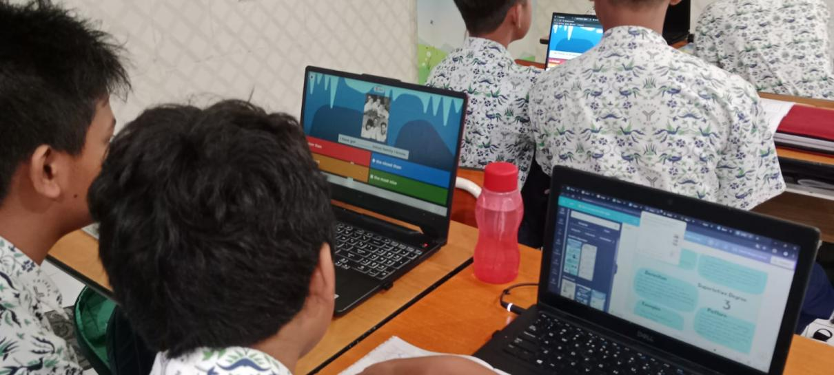
Teacher is checking students’ progress on Degree of Comparison
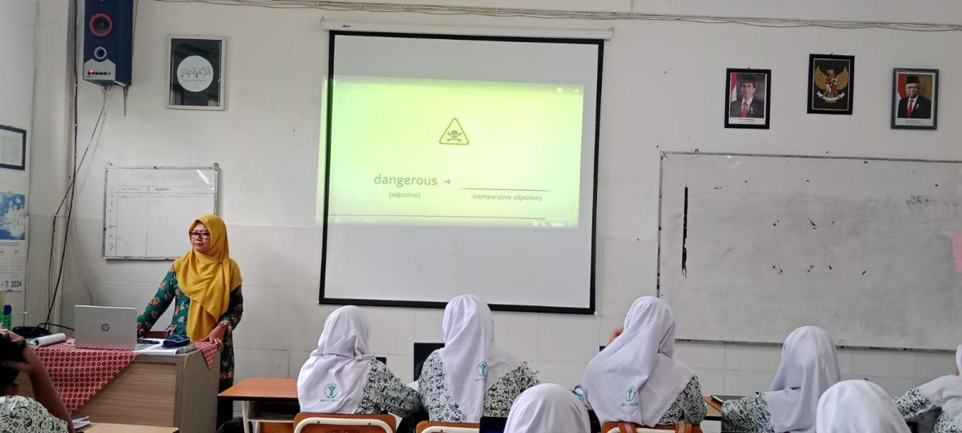

Students are writing what teacher dictates
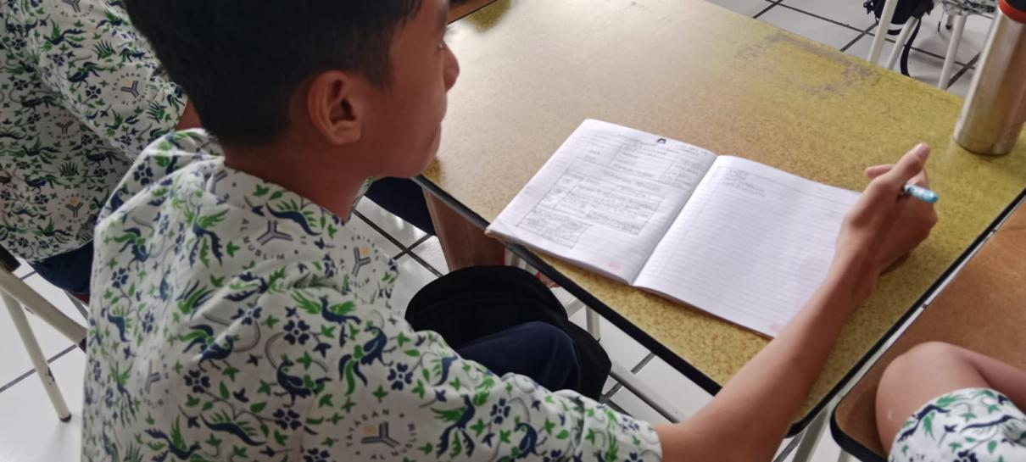
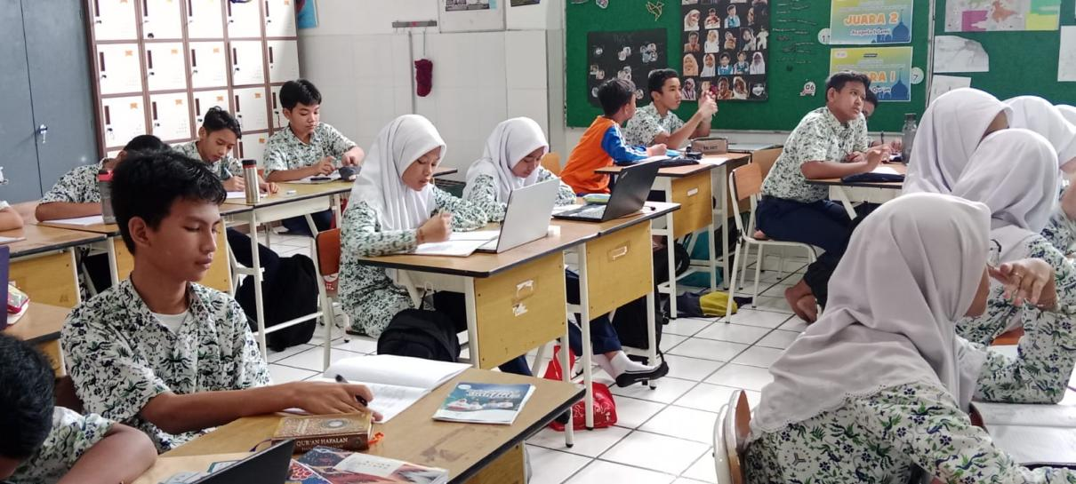
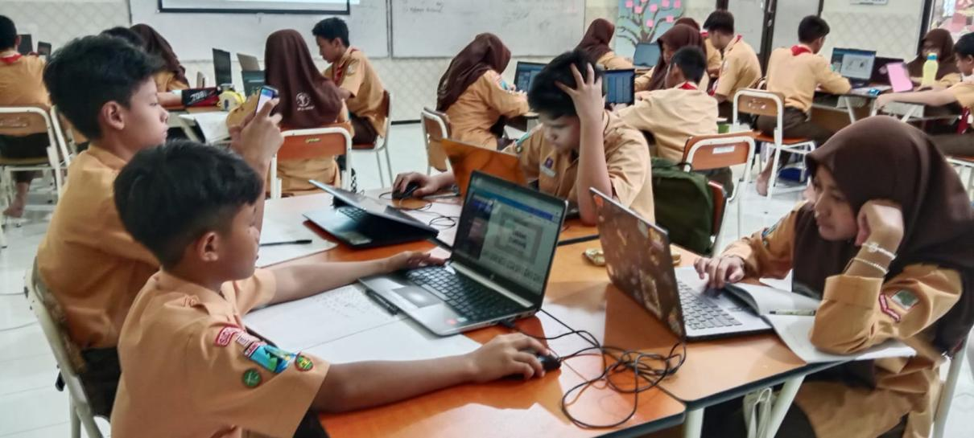

- Interview Documentation
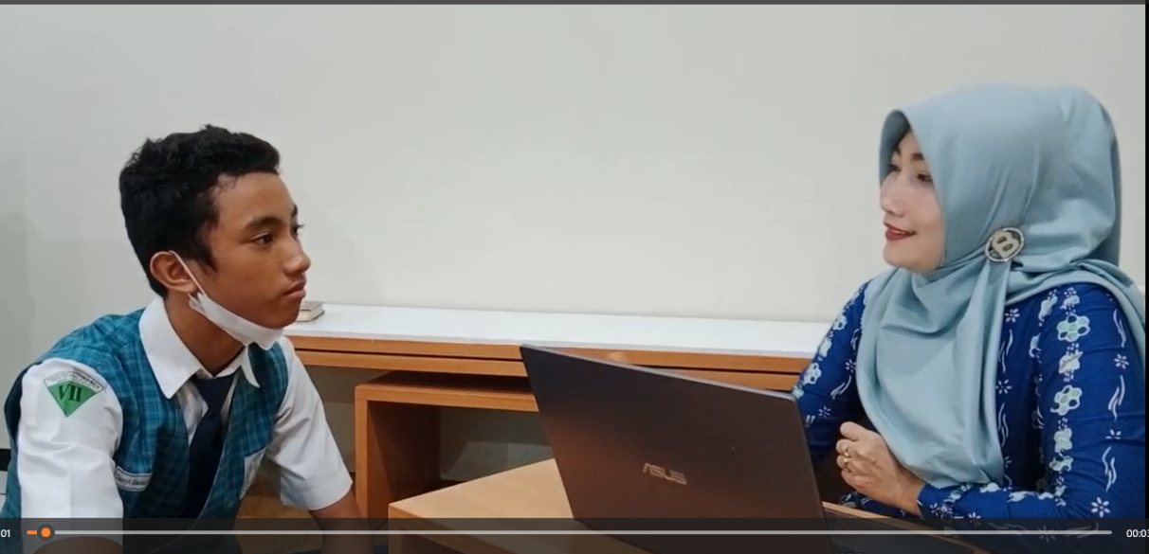
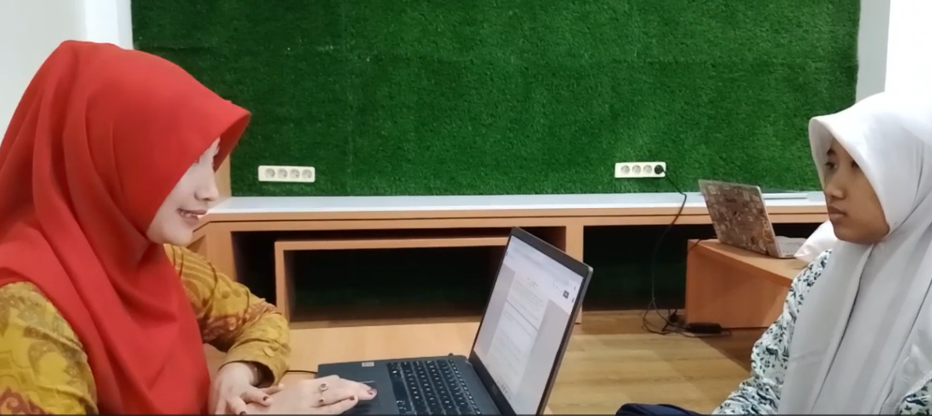
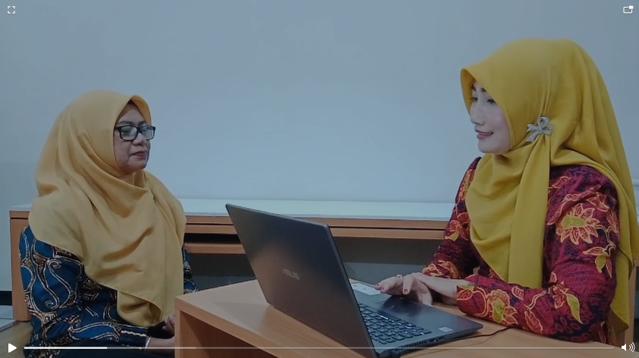

- Participants’ Demographic
Demographic Characteristics of Study Participants
No | Name of Students | Date of Birth | Gender | Class
1 | Khaliesa Amalia Putri A. | Surabaya, 3rd of March 2011 | Female | VII-D
2 | Zivanna Anindya Putri I. | Jakarta, 6th of August 2010 | Female | VIII-C
3 | Muhammad Ghaisan Mirza A. | Pati, 10th of June 2009 | Male | VIII-B
4 | Alifia Syahie | Bekasi, 30th of April 2009 | Female | VIII-B
5 | Brianna Kalifa Hamel | Surabaya, 28 December 2009 | Female | VIII-B
6 | Nafila Zulfa Kamila | Surabaya, 23rd of July 2011 | Female | VII-D
7 | Darryl Danendra Priyadi | Surabaya, 11th of April 2011 | Male | VII-D
8 | Selina Syanika Syauqi | Surabaya, 4th of May 2011 | Female | VII-D
9 | Mutiara Nadia Kasih | Batam, 1st of January 2010 | Female | VIII-C
10 | Chaves Abdibuana | Sidoarjo, 23rd of May 2010 | Male | VIII-C
11 | Azka Nabilah Hasna | Surabaya, 12th of October 2011 | Female | VII-B
12 | Muhammad Aryan Dhazafri | Madiun, 28th of August 2011 | Male | VII-B
13 | - Chesta Altezza |  | Male | VIII-A
13 | Adelfio Ilham Zaafiero | Malang, 20th of July 2010 | Male | VIII-A
15 | Anjani Karisa Maheswari | Surabaya, 10th of February 2010 | Male | VIII-A
16 | Muhammad Almer Andhika | Sidoarjo, 3rd of December 2009 | Male | VIII-A
17 | Chika Zalikha Humira | Sidoarjo, 6th of June 2010 | Female | VIII-A
18 | Jenna Azzahra Karindra | Sidoarjo, 7th of November 2009 | Female | VIII-A
19 | Srikandi Wahyunika Putri | Trenggalek, 26th of April 2009 | Male | VIII-A
20 | Rikza Aufa Hananian | Sidoarjo, 4th of December 2009 | Male | VIII-A
21 | Rafie Raditya Ali | Surabaya, 9th of November 2009 | Male | VIII-A
22. | Ascarya Nafi Laninda | Surabaya, 21st of November 2009 | Male | VIII-A
23. | Aiko Alidanisha Pitana | Jepang, 16th of September 2009 | Male | VIII-A
24. | Auraningrum Ramadhani | Sidoarjo, 22nd of August 2009 | Male | VIII-A
25. | Nabila Rahma Putri | Surabaya, 25th of December 2009 | Male | VIII-A

