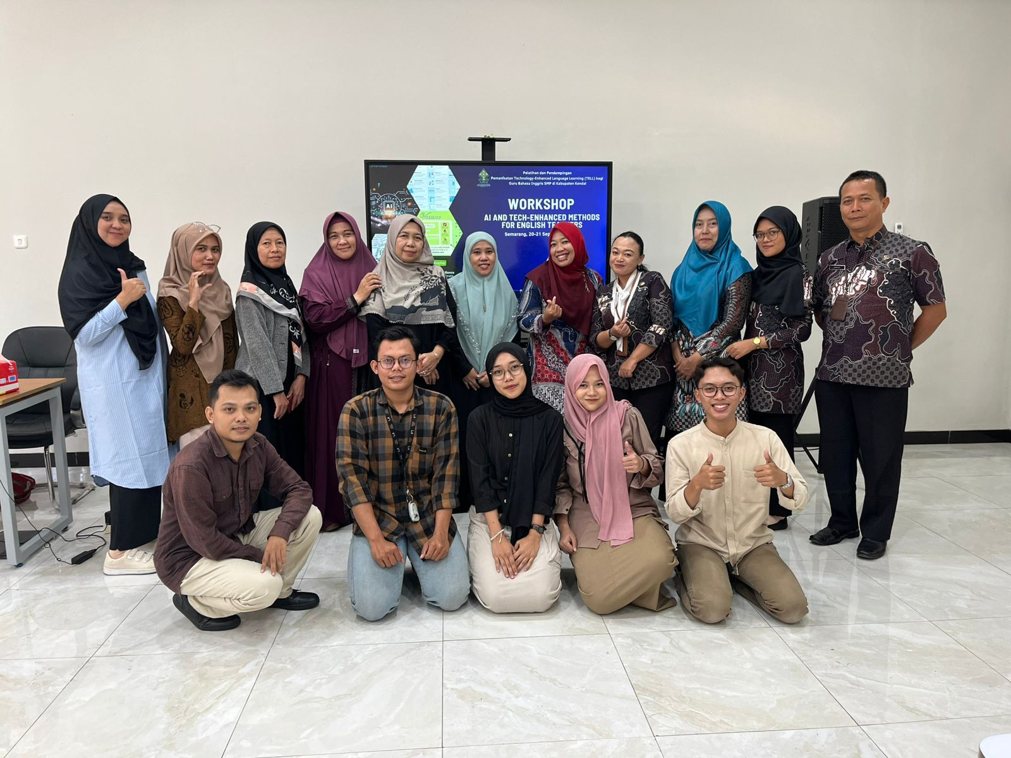

- Documentation of the implementation of Tell workshops and training for teachers, conducted at the beginning of the research so that teachers know what will be applied in the learning process.

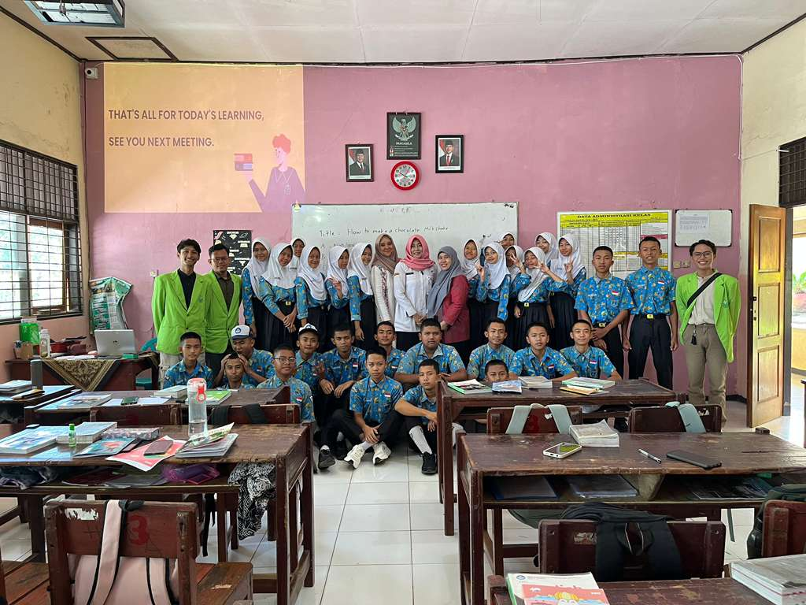

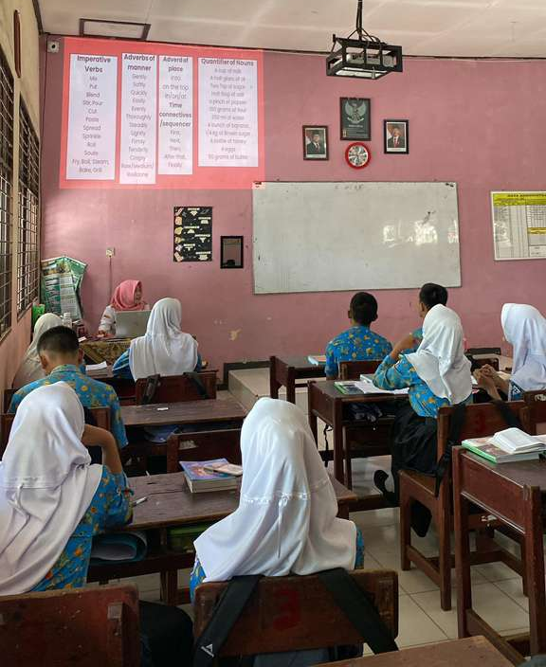
- Classroom observations after the training, researchers observed how teachers taught and applied technology in learning.

