Premise : Journal of English Education and Applied Linguistics
PJEE
e-ISSN: 2442-482x, p-ISSN: 2089-3345
https://fkip.ummetro.ac.id/journal/index.php/english
DOI: 10.24127/pj.v%vi%i.xxxx
-----------------------------------------------------------------------------------------------------------------
HARNESSING CANVA THROUGH THE LENS OF MIDWIFERY STUDENTS: INSIGHTS ON SPEAKING SKILL DEVELOPMENT IN EFL
by
Author 1
Author 2

- Corresponding author

(Received: ;Reviewed1: ;Reviewed2: : Accepted: ;Published: .
Abstract:
This study explores effectiveness of Canva as a learning tool to increase the English speaking skills of midwifery students, focusing on the students’ perspectives regarding the implementation of this application in the classroom. Speaking is a vital skill for academic and professional communication, yet many students struggle due to low confidence and limited practice opportunities. The research aims to evaluate students' viiews on using Canva to enhance their speaking skills. A qualitative study was used, with data collecting technique through a questionnaire, and analyzed using descriptive statistics to summarize the students' responses. The findings reveal that Canva’s interactive features significantly increased students' speaking confidence and engagement in EFL classrooms. Additionally, the study suggests that Canva’s flexibility allows students to practice speaking anytime and anywhere, making it an effective tool for enhancing speaking proficiency. The integration of Canva into English language teaching holds potential for improving language skills while fostering creativity and self-expression. The results of this study suggest that Canva be incorporated into language learning curricula to maximize students’ speaking potential and motivation.
Keywords: Canva, English speaking skill, midwifery students, EFL

INTRODUCTION
Development of information and communication technology (ICT) is related to the advancement of knowledge in the education. This development is utilized to improve the quality of education (Wahyuni, 2023). In the future, information technology is expected to not only serve as a supporting tool but also as a prior means to enhance educational success and help face global competition(Al-ansi et al., 2021). Furthermore, ICT makes the education sector more dynamic and adaptable to the changing times, providing opportunities for both teachers and students to be active and interactive in the study (Rahmawati et al., 2024; Wahyuni, 2023). This also applies to English language learning a compulsory subject that must be mastered. There are four essential skills in English: listening, speaking, reading, and writing (Wahyuni, 2020; Wahyuni & Nur Utami, 2022). These four skills are very important and closely interconnected (Harmer, 2007). However, the most crucial and key skill for successful language learning is speaking.
Speaking skills in English are crusial for mastering English as a Foreign Language (EFL), serving as a tool for communication and information exchange (Sudarmaji et al., 2021; Wahyuni, 2023). In today’s era of globalization, oral communication skills in English have become increasingly important, especially for students from professional backgrounds such as midwifery, who will eventually engage in international and interdisciplinary healthcare practices. Effective communication with patients, foreign medical professionals, and during professional conferences requires midwifery students not only to understand medical terminology in English but also to express ideas and explain procedures confidently and clearly (Zuzana, 2016). This highlights the necessary of English proficiency for students in the midwifery department.
Unfortunately, the reality in the field shows that many students still face serious gaps in speaking skills. Factors such as lack of practice in speaking, anxiety or nervousness when speaking in public (Wahyuni, 2023), limited vocabulary, low self-confidence, the perception that English is not yet important, and even difficulties in pronunciation are significant issues for midwifery students (Chand, 2021; Geria, 2022; Mukminin et al., 2018; Prihandini et al., 2021). In addition, teaching approaches that are overly focused on grammar and reading comprehension have further exacerbated this situation. In many EFL classrooms, speaking is often the least emphasized skill in practical terms, due to time constraints and limited resources. These conditions add to the various factors that influence English language learning.
In response to these challenges, educators have begun exploring alternative technology-based approaches that can help the learning process more engaging, interactive, and meaningful. One platform that has started gaining attention in the educational context is Canva, a digital graphic design application that is highly popular among the younger generation (Pelangi, 2020). Canva enables students to create various media such as posters, video presentations, and infographics (Fitria et al., 2021; Junaedi, 2021). It can be used as tools in speaking activities. With its intuitive interface and collaborative features, Canva is considered effective in fostering creativity and boosting students’ confidence in expressing ideas both visually and verbally.
Previous studies have highlighted the potential of using digital technology to support the development of learning outcome. For instance,(Pratama & Hikmat, 2024) research about Improving Student’s Motivation and Learning Outcomes through Canva in English Learning at Middle Schools. They found that the use of Canva as a learning media can increase students' learning motivation and learning outcomes. The second is from (Hadi et al., 2021) with the tittle Teaching Writing Through Canva Application To Enhance Students’ Writing Performance. The result of this study Canva Application is an effective media to facilitate students to improve their writing performance. The third, (Siswanjaya, 2021) with his research tittle “Penggunaan Canva Pada Pembelajaran Berbasis Proyek Untuk Meningkatkan Keterampilan Dan Motivasi Menulis Siswa”. He found that the implementing of project based learning and the use of Canva can improve students’ motivation and writing skill. And the last, (Rahmatullah et al., 2020) who have the tittle of research “Media Pembelajaran Audio Visual Berbasis Aplikasi Canva”. His finding on the research showed it is easier for students to master labor material using audio-visual learning media based on the Canva application with very good criteria. Thus, the media developed can be used in online and offline learning.
However, most of these studies have focused on primary education contexts such as junior high school and also senior high school, with limited research specifically examining the use of Canva, while in this research the researcher used canva as the learning media in English language learning for midwifery students. Another different is skill that be much attention in thus previous research is writing, while in this research is speaking. This gap forms the main rationale for this study. Currently, there is a significant lack of research that specifically explores how Canva can be utilized in speaking instruction within midwifery programs, even though this context is highly relevant given the specific communication needs in the healthcare field. Furthermore, few studies have addressed students’ perspectives directly regarding their experiences using Canva to improve their English speaking skills. This is crucial, as understanding students’ perceptions can serve as a foundation for developing more effective and relevant technology-integrated learning models.
In light of this phenomenon, this study aims to investigate how Canva is utilized to enhance the speaking skills of midwifery students and to explore their perceptions and experiences specifically those of midwifery students regarding the use of Canva in English language learning activities in EFL classrooms. Therefore, the research question addressed in this study is: What are the students’ views on the effectiveness of Canva in supporting their English speaking skill development?

METHOD
This research employs a descriptive qualitative design, aiming to investigate students’ perspectives on the effectiveness of Canva in facilitating the development of their English speaking skills. The study was conducted at AKBID Wahana Husada Bandar Jaya, with midwifery students as the participants.
Design
This research is qualitative research. The design of this study is descriptive qualitative research, which aims to explain, describe, and elaborate on the phenomenon being studied in depth (Ary et al., 2010; Booth et al., 2008). In this study, the researcher will explore students' views on the implementation of Canva in English language learning in the classroom.
Subject or Participant
The participants in this study are all first-year midwifery students in Akademi Kebidanna Wahana Husada Bandar Jaya, with a total of 16 students. They were selected using total sampling, meaning that the entire population of first-year midwifery students was included in the study. The participants in this study possess a basic level of English proficiency, which aligns with their current stage of language learning in the midwifery program.
Instrument
The instrument used in this research is a questionnaire, employing a Likert scale (Ary et al., 2010). The researcher distributed the questionnaire in the form of a Google Form. The purpose of this questionnaire is to determine students' interest in speaking skill learning using the Canva application. Prior to administering the questionnaire to participants, the researcher first identified the aspects and indicators of assessment that would be evaluated by the students. Once the relevant aspects to be assessed were determined, the researcher developed the questionnaire items in alignment with these aspects and indicators, as outlined in the table. Subsequently, validity and reliability tests were conducted, with the researcher employing the split-half reliability method, which was calculated using SPSS 22 software. Once satisfactory results were achieved, with the desired significant values, the test was then administered to the students. Below is the blueprint of the questionnaire used in this study.
Table 1. Blueprint the aspect of the questionnaire
Research question | Aspect Canva | Indicators | Number | Question types
What are the students’ views on the effectiveness of Canva in supporting their English speaking skill development? | Knowledge | Introduction of Canva | 1,2 | Closed : rating scale
 | Design | The design of Canva | 3,4,5 | Closed : rating scale
 | Content | The content provided in the Canva | 6,7,8,9 | Closed : rating scale
 | Benefits for learning | Analyzing the effect of Canva for Learning English | 10,11,12,13 | Closed : rating scale
 | Benefits for speaking | Canva for speaking Skill | 14,15,16,17, 18, 19,20 | Closed : rating scale
 | Benefit for Tehnologi | Increasing Students skill in operate the Canva | 21,22,23,24,25 | Closed : rating scale
Adapted from : (Zahranisa et al., 2024) and developed by the researcher
Data Collecting Technique
Data collection is a crucial step in conducting effective research. The selection of an appropriate technique ensures the acquisition of valid and relevant data. In this research, the data collection technique was carried out by administering a questionnaire to the students at the end of the English learning sessions that incorporated the use of the Canva application.
Data Analysis Technique
The data analysis technique used in this study is descriptive statistics, conducted with the assistance of SPSS software. The data were obtained from the questionnaire responses distributed to the students and subsequently analyzed using SPSS.

RESULT AND DISCUSSION
In this point, the researcher will elaborate the result of data which collect by questioner and its result in the data analysis using SPSS. After that the researcher will give you more explanation in the discussion section bellow.

Results or Findings
In the results section, the main findings derived from the analyzed data will be presented. Based on the previously developed questionnaire blueprint, the research findings will report data for each measured aspect, namely: knowledge, design, content, benefit for learning, and benefit for speaking. The following are the results of the questionnaire data analysis.
Table 2. Statistics Analysis of Questionnaire
Statistics
 |  | x1.1 | x1.2 | x2.1 | x2.2 | x2.3 | x3.1 | x3.2 | x3.3 | x3.4 | x4.1 | x4.2 | x4.3 | x4.4 | x5.1
N | Valid | 8 | 8 | 8 | 8 | 8 | 8 | 8 | 8 | 8 | 8 | 8 | 8 | 8 | 8
N | Missing | 0 | 0 | 0 | 0 | 0 | 0 | 0 | 0 | 0 | 0 | 0 | 0 | 0 | 0
Std. Error of Mean |  | .189 | .189 | .189 | .189 | .164 | .125 | .463 | .183 | .125 | .189 | .412 | .125 | .164 | .000
Std. Deviation |  | .535 | .535 | .535 | .535 | .463 | .354 | 1.309 | .518 | .354 | .535 | 1.165 | .354 | .463 | .000
Minimum |  | 4 | 4 | 4 | 4 | 4 | 3 | 1 | 4 | 3 | 4 | 1 | 4 | 3 | 4
Maximum |  | 5 | 5 | 5 | 5 | 5 | 4 | 5 | 5 | 4 | 5 | 4 | 5 | 4 | 4

Statistics
 |  | x5.2 | x5.3 | x5.4 | x5.5 | x5.6 | x5.7 | x6.1 | x6.2 | x6.3 | x6.4 | x6.5
N | Valid | 8 | 8 | 8 | 8 | 8 | 8 | 8 | 8 | 8 | 8 | 8
N | Missing | 0 | 0 | 0 | 0 | 0 | 0 | 0 | 0 | 0 | 0 | 0
Std. Error of Mean |  | .227 | .125 | .350 | .125 | .164 | .183 | .327 | .500 | .479 | .250 | .250
Std. Deviation |  | .641 | .354 | .991 | .354 | .463 | .518 | .926 | 1.414 | 1.356 | .707 | .707
Minimum |  | 3 | 3 | 1 | 3 | 3 | 3 | 3 | 1 | 1 | 3 | 3
Maximum |  | 5 | 4 | 3 | 4 | 4 | 4 | 5 | 5 | 4 | 5 | 5

The results of this research describe students' perspectives on the implementation of Canva in English language classes, specifically among midwifery students, with a focus on improving their speaking skills. Data obtained from the questionnaire reveals several key findings, which are categorized into the following aspects: knowledge, design, content, utilization in English classes, application for speaking skills, and the enhancement of technology use.

1. Knowledge of Canva
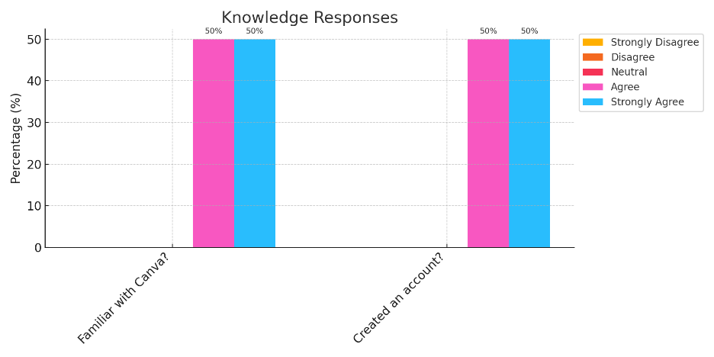
The first question in the questionnaire addressed the students’ prior knowledge of the Canva application. The results show that 50% of midwifery students were already familiar with Canva, and 50% of them had an existing Canva account before this research was conducted. These findings indicate that most students were already aware of Canva and Canva is a popular application among college students.
2. The Design of Canva
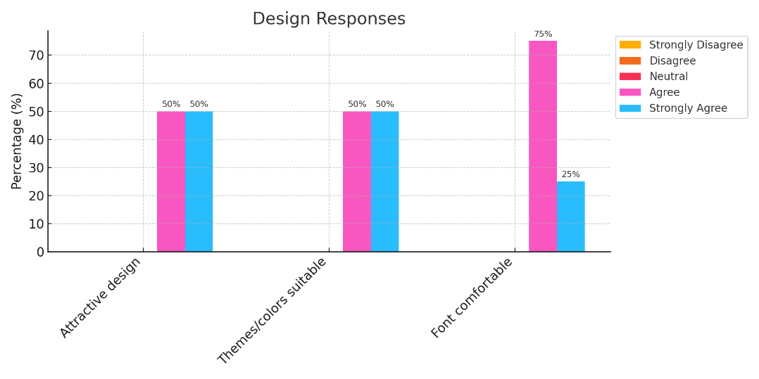
The results of students’ perceptions regarding the design of the Canva application were generally positive among midwifery students. The data shows that 50% of students found Canva’s design to be interesting, and another 50% stated that the themes and colors used in the application are suitable for learning. Additionally, 75% of students felt that the fonts used in Canva are appropriate and comfortable to read. These findings suggest that an attractive and simple design can encourage users to engage with the application, thereby supporting the effectiveness of Canva’s implementation in the learning process.
3. Content of Canva
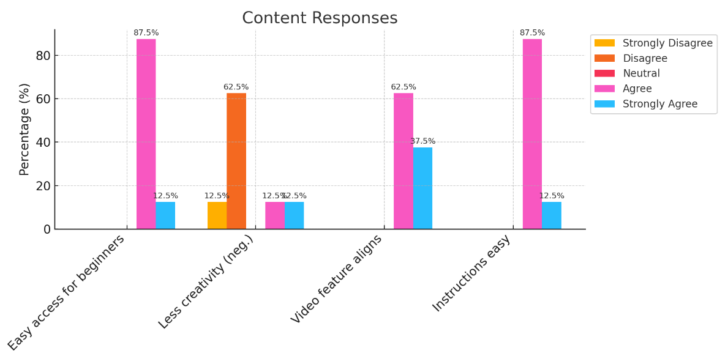
Most students (87.5%) felt that the features in Canva are easy to access, even for new users. However, nearly half of the students (62.5%) agreed with the statement that Canva can sometimes limit their creativity, as they tend to rely on the pre-designed templates and instructions provided by the application. This finding suggests that while Canva simplifies content creation, it may pose a challenge in encouraging students to develop original materials independently (Author, Year). Furthermore, 62.5% of students agreed that the video presentation feature in Canva is relevant to the materials provided by their lecturer, and 87.5% stated that the instructions within the application are easy to follow.
4. Benefits for Learning: Analyzing the Effect of Canva on Learning English
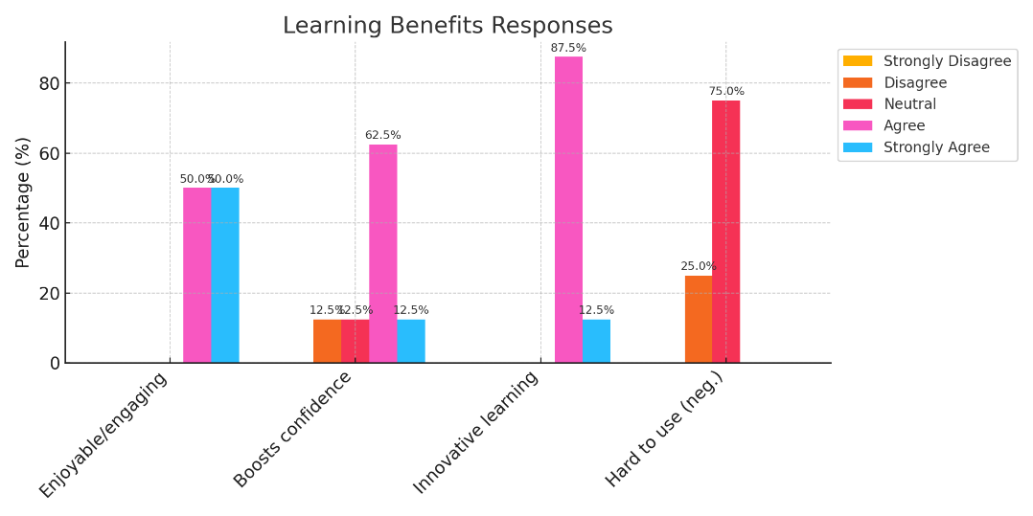
The research findings show that Canva provides significant benefits in learning English, with 50% of students stating that using the application is enjoyable and exciting. Furthermore, the majority of students (62.5%) felt more confident in speaking English after using Canva. In addition, 87.5% of the students agreed that the application creates a more innovative learning environment, allowing them to be creative with the various available features.
5. Benefits for Speaking Skills: Canva for Speaking Skills
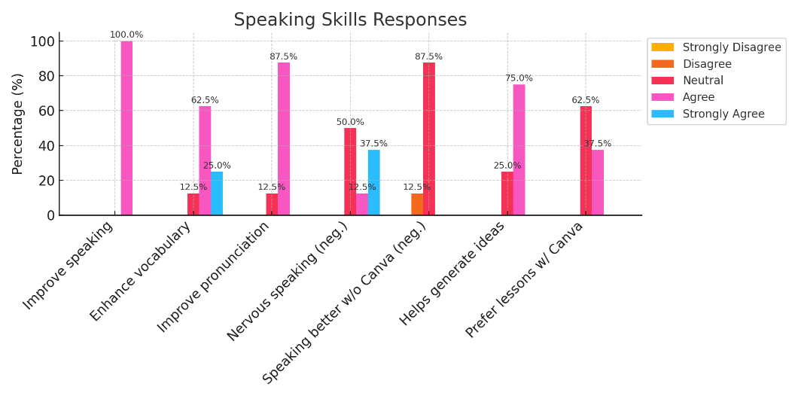
The use of Canva has proven to have a significant impact on students’ English speaking skills. All students (100%) agreed that the application provided them with opportunities to enhance their speaking abilities. A majority of students (87.5%) reported improvements in their pronunciation, while 62.5% noted an increase in their vocabulary. These findings reflect the positive effect of Canva in helping students recall and apply vocabulary in conversation, thereby enhancing their overall speaking skills (Febriyanti & Haryanto, 2024)speaking challenge
. This aligns with social cognitive theory, which suggests that tools offering visual and interactive feedback, such as Canva, can support students in strengthening their speaking proficiency (Ilham et al., 2023).
6. Benefits for Technology: Increasing Students’ Skills in Operating Canva
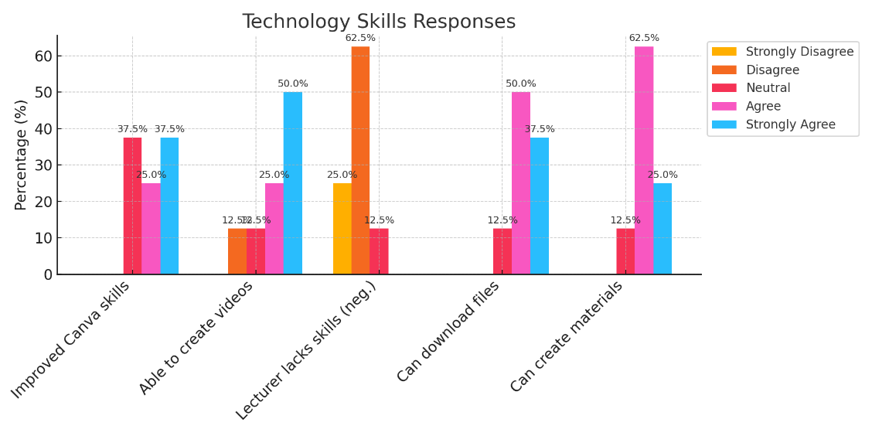
In addition to the benefits observed in speaking skills, the use of Canva also enhanced students’ technological abilities. A total of 37.5% of students felt that their skills in using the application improved after the training, and 50% reported being able to create videos using Canva. Moreover, the majority of students (87.5%) stated that they could easily download materials in various formats such as video, PDF, image, and PowerPoint. These findings highlight the importance of developing students’ digital competencies in the era of technology-driven education (Borisov et al., 2020).

Discussion
This research aimed to explore the potential of Canva in enhancing midwifery students’ English speaking skills within an EFL context. The findings of this study align with and expand upon previous research on the use of digital technologies in education. Previous studies have demonstrated the positive impact of digital tools such as Canva in improving learning outcomes across various aspects of education, including motivation, writing skills, and multimedia learning (Lumbantoruan et al., 2024; Murtadho et al., 2023). The findings of this study contribute to the growing body of literature by emphasizing the application of Canva in enhancing English speaking skills, particularly for midwifery students.
1. Knowledge of Canva and Its Accessibility
The study found that 50% of students were already familiar with Canva, and 50% had an account before the study began. This familiarity suggests that the use of Canva is not limited to niche groups, but is widespread among students in higher education. Similar findings were reported by (Pratama & Hikmat, 2024) who noted that Canva’s accessibility and widespread usage contributed to its success in enhancing student motivation and learning outcomes in middle school English classrooms. By leveraging students' existing familiarity with the tool, educators can effectively incorporate Canva into their teaching practices without requiring extensive training.
2. The Design of Canva: Enhancing Engagement and Learning
The design of Canva was another key factor influencing student engagement and learning outcomes. The majority of students in this study found Canva’s design to be appealing, with 50% considering its color schemes and themes to be suitable for learning. This aligns with previous research by (Rahmatullah et al., 2020), who emphasized the importance of multimedia learning tools in increasing student engagement. Rahman’s study found that audio-visual media, such as those created with Canva, made it easier for students to master complex content, which is consistent with the findings of this research, where students felt more motivated to engage in speaking practice through the interactive and visually stimulating elements of Canva. It relate with the statement of (Wijayanti, 2022) Canva is convenient access because it provides all for the teaching and learning like the video, images, colors and many more.
Furthermore, 75% of students reported that the fonts used in Canva were comfortable and readable, reinforcing the significance of user-friendly design in educational technology. This aligns with (Siswanjaya, 2021) research, which highlighted how the use of clear and aesthetically pleasing design elements in project-based learning can enhance students’ motivation and skill development. The design elements in Canva, such as customizable templates and fonts, contribute to a conducive learning environment, which is crucial for students’ success in both language learning and overall educational engagement.
3. Content of Canva: A Double-Edged Sword for Creativity
While Canva offers a wide range of pre-designed templates and instructional content, the findings of this study revealed a concern among 62.5% of students that the reliance on templates might limit their creativity. This challenge mirrors the findings of (Hadi et al., 2021) who noted that while Canva is effective in improving students' writing performance, it can also constrain their ability to produce entirely original work if overused (Fauzi, 2024). However, it is important to note that these templates serve a dual purpose—they not only assist in organizing content but also provide a foundation for students to build upon.
In the context of speaking skills, the ability to use templates for video presentations and other multimedia content was particularly beneficial for students. 62.5% of students in this study agreed that the video presentation feature was useful in connecting their work with the materials provided by their lecturers. This ability to create dynamic and personalized video presentations further supports the idea that Canva can facilitate interactive and creative learning experiences, particularly for language acquisition, as students can present their speaking skills in various formats.
4. The Impact on Speaking Skills: Building Confidence and Competence
The most significant finding of this research was the improvement in students' speaking skills, with 100% of students reporting that Canva provided them with opportunities to enhance their speaking abilities. These findings echo those of (Pratama & Hikmat, 2024), who found that the use of Canva in middle school English classrooms not only improved motivation but also contributed to better learning outcomes. The ability to create and present multimedia projects, such as video presentations, allowed students to practice their pronunciation, expand their vocabulary, and increase their confidence in using English in real-life contexts.
The connection between interactive tools and language proficiency is well-documented in the literature. (Tunner et al., 1989) Social cognitive theory suggests that the use of interactive tools like Canva can boost students’ self-efficacy, motivating them to engage more actively in the learning process. This study found that students who used Canva to practice their speaking skills were more confident and capable of recalling vocabulary and applying it in conversations, which directly contributed to their improved speaking proficiency. Additionally, 87.5% of students reported improvements in their pronunciation, and 62.5% noticed an increase in their vocabulary. This aligns with the findings of (Rahmatullah et al., 2020), who highlighted the value of visual and audio-visual tools in helping students retain and apply knowledge more effectively. Canva’s ability to combine visual elements with audio-visual presentations offers students a multifaceted approach to language learning, which enhances both their speaking abilities and their overall understanding of the language.
To better understand how Canva was implemented in the speaking class of this research, it is the specific steps and student projects involved in the learning process (Vargas et al., 2022). During the learning sessions, students were guided step-by-step in using Canva to design speaking materials by the lecturer. In the first step, students are tasked with creating a presentation slide based on the material provided by the instructor, which focuses on procedure texts. After the instructor has thoroughly explained the topic and ensured the students' understanding, students proceed to design their slides with visually appealing elements. Once the presentation slides are ready, the next step is to select the “Video” option from the toolbar located at the bottom-left corner of the screen.
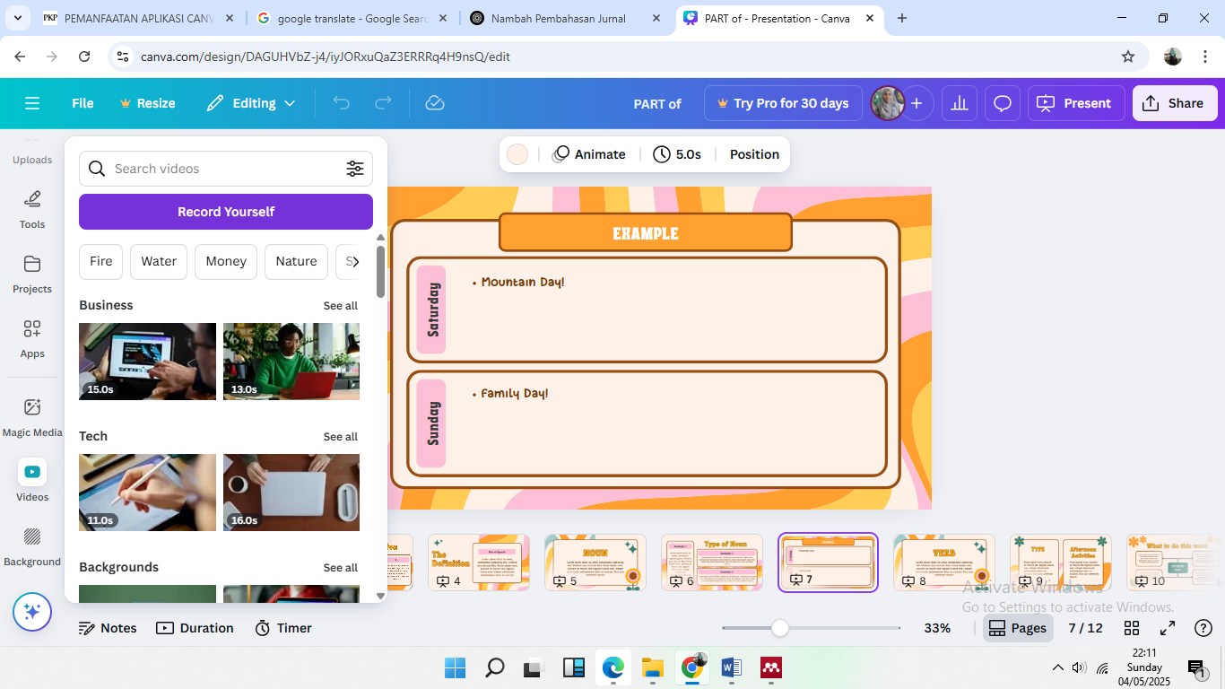
Afterward, students click on “Record Yourself,” which opens a screen where their face will appear on the presentation slide, allowing them to record both their voice and video. The students continue recording until they finish explaining the procedure text clearly and confidently. Once the recording is complete, students click on “Save and Exit,” and the video automatically appears on the presentation slide.
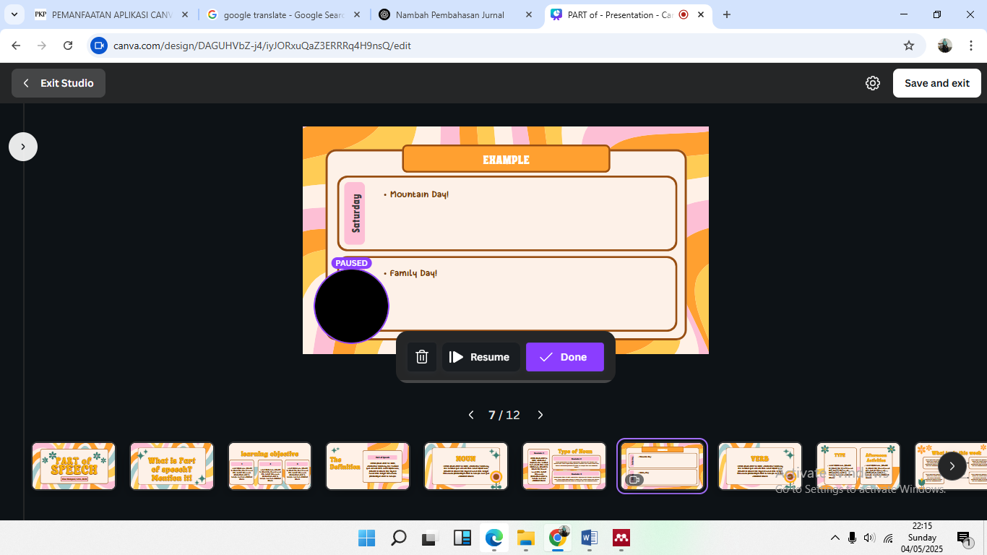
Finally, the students download their video in MP4 format, and the video presentation is ready for submission or sharing.
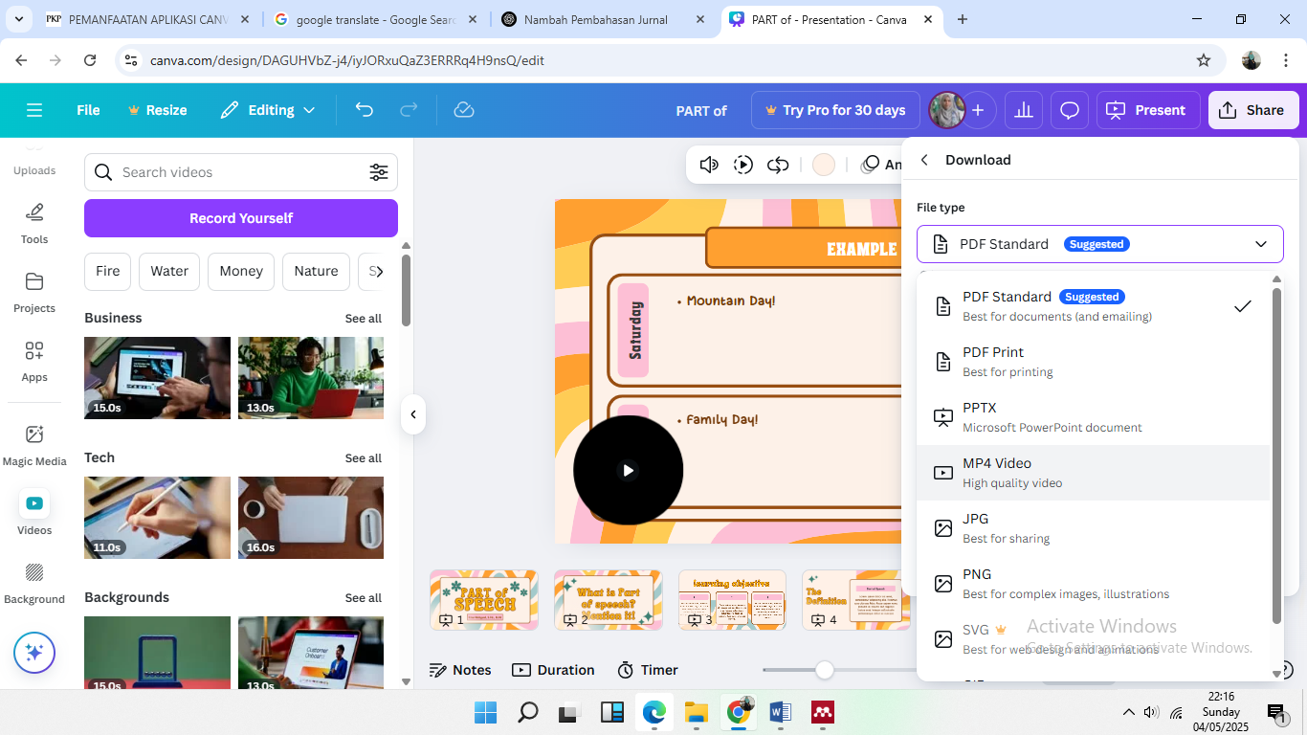
To support the explanation above, below shows a screenshot of some student’s video project created using Canva and they uploaded in Instagram.
 |  | 

5. Technological Competence: A Key to Success in the Digital Age
In addition to enhancing language skills, the use of Canva also improved students' technological competence. 37.5% of students reported that their ability to use Canva had increased after the training, and 50% felt confident in creating video presentations using the application. This increase in digital literacy is particularly important in today’s education system, where technology plays an increasingly significant role in both academic and professional success. (Siswanjaya, 2021) emphasized the importance of developing students' technological skills in project-based learning environments, and this study supports his assertion. Canva’s ease of use and versatility allow students to not only enhance their language skills but also acquire essential digital competencies that are necessary in today’s tech-driven world. As digital literacy continues to be a critical component of higher education (Wahyuni & Nur Utami, 2022), tools like Canva provide an effective way to integrate technology into language learning while simultaneously preparing students for the demands of the modern workforce.
In conclusion, the findings of this study support the effectiveness of Canva in enhancing midwifery students' English speaking skills within an EFL context. The tool’s user-friendly design, interactive features, and multimedia capabilities contribute to improved student engagement, confidence, and speaking proficiency . These results are consistent with previous research by (Hadi et al., 2021; Pratama & Hikmat, 2024; Rahmatullah et al., 2020; Siswanjaya, 2021) who have highlighted the potential of Canva to improve various aspects of language learning. As education continues to evolve in the digital age, the integration of tools like Canva into the curriculum will play a pivotal role in fostering both language proficiency and digital literacy among students.

CONCLUSION AND IMPLICATION)
Conclusion
This study aims to evaluate midwifery students’ opinions on the use of the Canva application to enhance their English speaking abilities in English as a Foreign Language (EFL) classes. The finding of this research is as the analysis of the questionnaire data indicates that using Canva has a positive impact on improving midwifery students’ speaking skills, particularly those at the basic English proficiency level. Canva’s interactive features were shown to boost students’ confidence and engagement in learning. Additionally, Canva offers students the flexibility to practice speaking anytime and anywhere, which greatly supports their gradual skill development. Furthermore, Canva encourages creativity and self-expression in students’ communicative use of English. Based on these findings, it is recommended that Canva be integrated more broadly into English language instruction, especially in programs with students of basic English proficiency. To strengthen the evidence base, future research should involve multiple institutions and employ more comprehensive methods to gain a deeper understanding of Canva’s effectiveness in foreign-language teaching contexts.

Limitation
This research is limited by its participant scope only midwifery students from a single higher-education institution and by its reliance on a closed-ended questionnaire as the sole data-collection instrument. Moreover, because participants are at a basic proficiency level, they may face difficulties fully understanding and expressing their views in written form.

Implication
The implications of these findings suggest that the use of Canva can enrich the English learning process, particularly in enhancing students' speaking skills. Utilizing technology-based applications like Canva enables more interactive and engaging English instruction, which can foster greater student participation. Therefore, integrating Canva into English language learning in higher education can serve as an effective alternative to increase student engagement.

ACKNOWLEDGEMENT
Papers

BIO-PROFILE:
The Author

REFERENCES

Al-ansi, A. M., Garad, A., & Al-ansi, A. (2021). ICT-Based learning during Covid-19 outbreak: advantages, opportunities and challenges. Gagasan Pendidikan Indonesia, 2(1), 10–26. https://doi.org/10.30870/gpi.v2i1.10176
Ary, D., Jacobs, L. C., Sorensen, C., & Razavieh, A. (2010). Introduction to Research in Education Eight Edition (Eight Edit). Wadsworth Cengage Learning.
Booth, W. C., Colomb, G. G., & Williams, J. M. (2008). The Craft of Research (Vol. 16, Issue 1). The University of Chicago Press.
Borisov, O. I., Karamova, O. V., Naidenova, E. M., Osipova, I. V., Pavlova, A. V., Gibadullin, A. A., & Sadriddinov, M. I. (2020). Development of digital competencies among students of higher educational institutions. Journal of Physics: Conference Series, 1691(1). https://doi.org/10.1088/1742-6596/1691/1/012098
Chand, G. B. (2021). Challenges Faced by Bachelor Level Students While Speaking English. IJELTAL (Indonesian Journal of English Language Teaching and Applied Linguistics), 6(1), 45. https://doi.org/10.21093/ijeltal.v6i1.853
Fauzi, I. (2024). The Effectiveness of Using Canva as Assisted Language Learning Media to Improve Undergraduate Students’ Writing Skill. Globish: An English-Indonesian Journal for English, Education, and Culture, 13(2), 230. https://doi.org/10.31000/globish.v13i2.10148
Febriyanti, E., & Haryanto, H. (2024). The Effectiveness Of Canva Application In Fun English Learning To Improve The Students’ English Vocabulary (An Experimental Study For Grade XI Of SMK Balekambang Jepara). Journal on Education, 6(4), 19501–19513. https://doi.org/10.31004/joe.v6i4.5870
Fitria, V. A., Habibi, A. R., Hakim, L., & Islamiyah, M. (2021). Using Canva to Support Online Learning Media for Students at Mahardika Karangploso Vocational School in Malang during the Pandemic. Mujtama’ Jurnal Pengabdian Masyarakat, 1(2), 75–82.
Geria, A. A. J. A. (2022). Challenges Faced Students in Speaking English in Indonesia: A Literature Study. Jurnal Penelitian Mahasiswa Indonesia, Nomor 2 20, 1–4.
Hadi, S. M., Izzah, L., & Paulia, Q. (2021). Teaching Writing Through Canva Application to Enhance Students’ Writing Performance. JOLLT Journal of Languages and Language Teaching, 9(2), 228–235. https://doi.org/https://doi.org/10.33394/jollt.v%vi%i.3533
Harmer, J. (2007). The Practice Of English Language Teaching. In Pearson Longman (4th ed.). Pearson Longman. https://doi.org/10.1080/03626784.1987.11075294
Ilham, S., Vázquez-Cano, E., & Novita, L. (2023). Use of Canva Application as a Learning Media. Al-Hijr: Journal of Adulearn World, 1(1), 9–18. https://doi.org/10.55849/alhijr.v1i1.499
Junaedi, S. (2021). Aplikasi Canva Sebagai Media Pembelajaran Daring untuk Meningkatkan Kemampuan Kreatifitas Mahasiswa Pada Mata Kuliah English For Information Communication And Technology. Bangun Rekaprima, 07(2), 80–89. https://doi.org/https://doi.org/10.32497/bangunrekaprima.v7i2.3000
Lumbantoruan, I., Simanjuntak, E. B., Simbolon, N., Sirait, A. P., & Usman, K. (2024). Pengembangan Media English Vocabulary Card Berbasis Canva untuk Meningkatkan Kosa Kata Bahasa Inggris di Kelas V SD Negeri 105273 Helvetia. Jurnal Pendidikan Tambusai, 8(3), 40524–40532.
Mukminin, M., Habibi, A., Asyrafi, A., Makmur, F., & Marzulina, M. (2018). If our English isn’t a language, what is it?” Indonesian EFL Student Teachers’ Challenges Speaking English. 23, 129–145. https://nsuworks.nova.edu/tqr/vol23/iss1/9
Murtadho, M. I., Rohmah, R. Y., Jamilah, Z., & Furqon, M. (2023). The Role Of Digital Literacy In Improving Students’ Competence In Digital Era. AL-WIJDÃN Journal of Islamic Education Studies, 8(2), 253–260. https://doi.org/10.58788/alwijdn.v8i2.2328
Pelangi, G. (2020). Pemanfaatan Aplikasi Canva Sebagai Media Pembelajaran Bahasa san Sastra Indonesia Jenjang SMA/MA. Jurnal Sasindo Unpam, 8(2), 79–96. https://doi.org/https://doi.org/10.32493/sasindo.v8i2.79-96
Pratama, F. R., & Hikmat, M. H. (2024). Improving Student’s Motivation and Learning Outcomes through Canva in English Learning at Middle Schools. Journal of English Language Teaching and Linguistics, 9(3), 241–255. https://doi.org/doi: http://dx.doi.org/10.21462/jeltl.v9.i3.1381
Prihandini, A., Sudana, D., & Kurniawan, E. (2021). Online Games to Improve English Vocabulary Awareness in Daily Speech. Proceedings of the Fifth International Conference on Language, Literature, Culture, and Education (ICOLLITE 2021), 595(Icollite), 136–142. https://doi.org/10.2991/assehr.k.211119.022
Rahmatullah, R., Inanna, I., & Ampa, A. T. (2020). Media Pembelajaran Audio Visual Berbasis Aplikasi Canva. Jurnal Pendidikan Ekonomi Undiksha, 12(2), 317–327. https://doi.org/https://doi.org/10.23887/jjpe.v12i2.30179
Rahmawati, L., Ambulani, N., Desty Febrian, W., Widyatiningtyas, R., & Sukma Rita, R. (2024). Pemanfaatan Aplikasi Canva Dalam Penyusunan Media Pembelajaran Berbasis Teknologi. Communnity Development Journal, 5(1), 129–136.
Siswanjaya. (2021). Penggunaan Canva Pada Pembelajaran Berbasis Proyek Untuk Meningkatkan Keterampilan dan Motivasi Menulis Siswa. Jurnal Didaktika Pendidikan Dasar, 5(2), 421–442. https://doi.org/10.26811/didaktika.v5i2.259
Sudarmaji, I., Anwar, A. A. A., & Mulyana, A. (2021). Developing students’ speaking skills through flipped classroom model on high school students. Semantic Scholar, 5(2), 188–200. https://doi.org/10.33369/jeet.5.2.188-200
Tunner, J. F., Day, E., & Crask, M. R. (1989). Protection motivation theory. Journal of Business Research, 19(4), 267–276. https://doi.org/10.1016/0148-2963(89)90008-8
Vargas, I. M., Cabrera, C. I. G., Cortez, C. A. A., Apaza, I. M. A., & Reátegui, M. D. (2022). The canva platform and meaningful learning in regular basic education. International Journal of Health Sciences, 6(May), 643–658. https://doi.org/10.53730/ijhs.v6ns7.11213
Wahyuni, R. (2020). Vocabulary Games To Increase STudents Vocabulary Mastery At Different Level of Learning Interest. Seminar Nasional Penelitian Dan Pengabdian Kepada Masyarakat, 2, 39–46. https://repository.ummetro.ac.id/snppm2/halaman/6
Wahyuni, R. (2023). ICT to overcome the students’ speaking anxiety. Premise: Journal of English Education, 12(3), 810. https://doi.org/10.24127/pj.v12i3.7418
Wahyuni, R., & Nur Utami, S. (2022). The Effect of E-Learning Toward Students’ Learning Interest At Pandemi Covid ’19 Era in Rural Area. Jurnal SIGEH, 1(1), 125–135. https://doi.org/https://doi.org/10.36269/sigeh.v2i2.1100
Wijayanti, E. (2022). Teaching English by Using Canva : Students ’ and Lecturers ’ Voice. ENGLISH FRANCA: Academic Journal of English Language and Education, 6(2), 411–428. https://doi.org/10.29240/ef.v6i2.5709
Zahranisa, A., Puspita, R. D., & Unaenah, E. (2024). Pengembangan media audio visual berbasi aplikasi canva pada pembelajaran Bahasa Inggris menggunakan insppiring quiz untuk siswa kelas IV di SDIT ASHIBGOH. Jurnal Pendidikan Matematika, 5(2), 61–70.
Zuzana, Š. (2016). Communication and Interpersonal Skills Enhancement in Midwifery : Review. Central European Journal of Nursing and Midwifery, 7(3), 504–510. https://doi.org/10.15452/CEJNM.2016.07.0021

