Nama :
Kelas :
Tulislah satu kalimat dalam Bahasa Inggris berdasarkan gambar yang tersedia. Gunakan kata-kata yang tersedia di samping masing-masing gambar.
Contoh (Bahasa Indonesia)
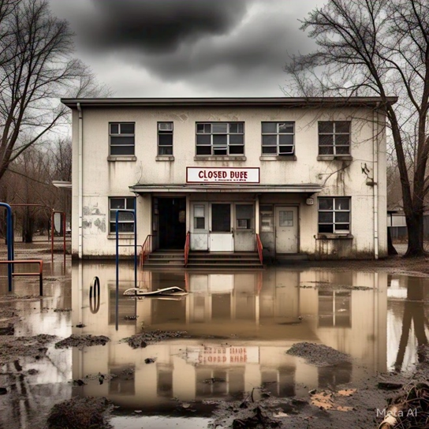 | Sekolah – libur – banjir.  Contoh jawaban: Hari ini sekolah diliburkan karena banjir.

SOAL 1 -7.
 | 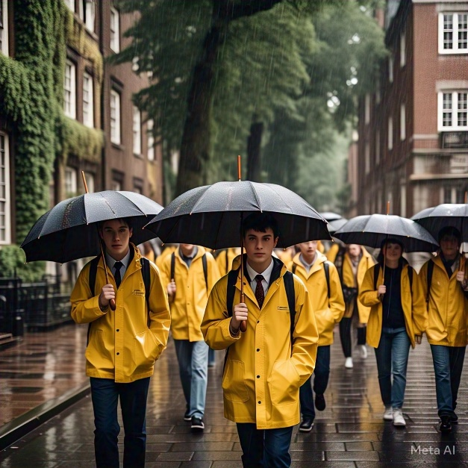 | The students – umbrella – rain.  Jawaban:
 |  | Boy – stomachache – ate many snacks.  Jawaban:
 | 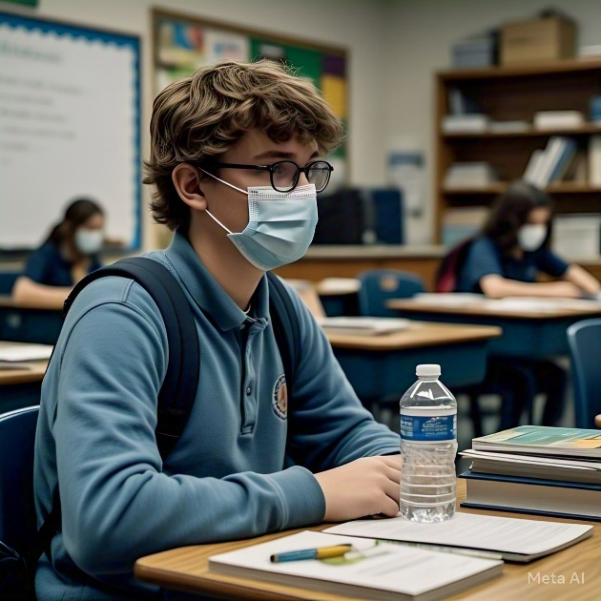 | The student – a mask – flu.  Jawaban:
 | 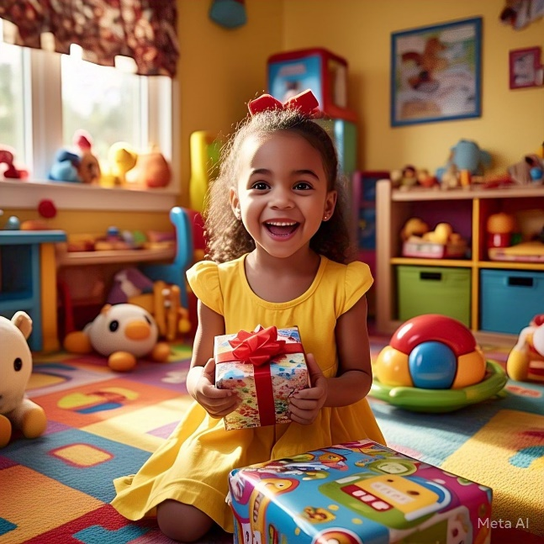 | Young girl – happy – received gifts.  Jawaban:
 |  | Adi – sleepy – did not sleep well last night.  Jawaban:
 |  | The student – anxious – has a lot of homework.  Jawaban:
 | 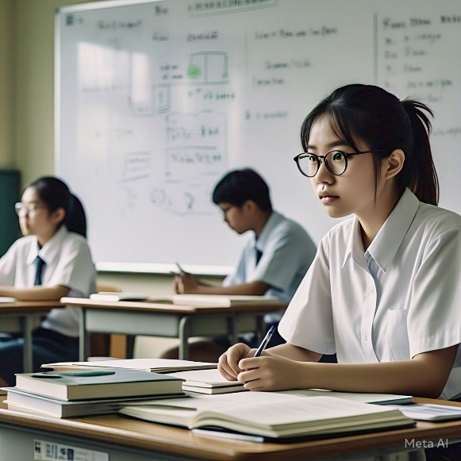 | Ani – smart – focus during lessons.  Jawaban:
 |  | The parents – happy – their son won a competition.  Jawaban:
 |  | A father – a toy for his son – wants to make him happy.  Jawaban:
 |  | Man – muscular body – workout regularly.  Jawaban:
 |  | The group – perfect score – work hard.  Jawaban:
 |  | People – umbrella – rain.  Jawaban:

